**Title: HAPPY HOLIDAY CASE STUDY (COMPONENT-2 PART-2)**

**Module Name: DATABASE SYSTEMS**

**Student Name: SANSKRITI LAMICHHANE**

**Student id: 77297941**

**TASK3 : IMPLEMENTATION OF MASTER DETAIL PAGES AND FORMS**

**PART1: MASTER DETAIL PAGE**

MASTER DETAIL PAGE1:

OWNER & CARAVAN MASTER DETAIL

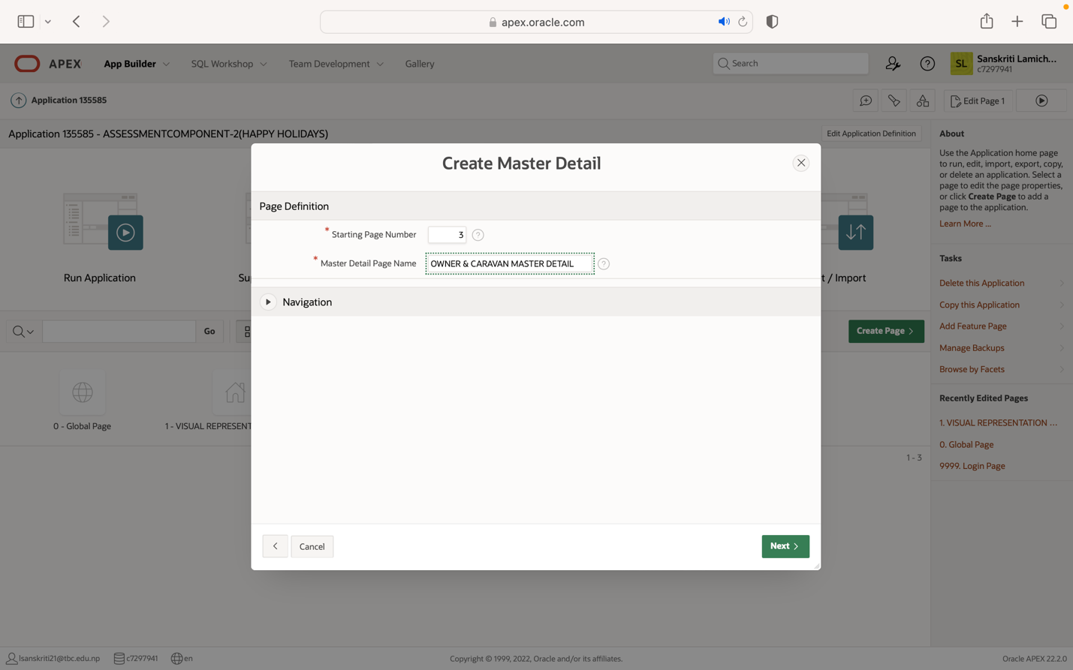

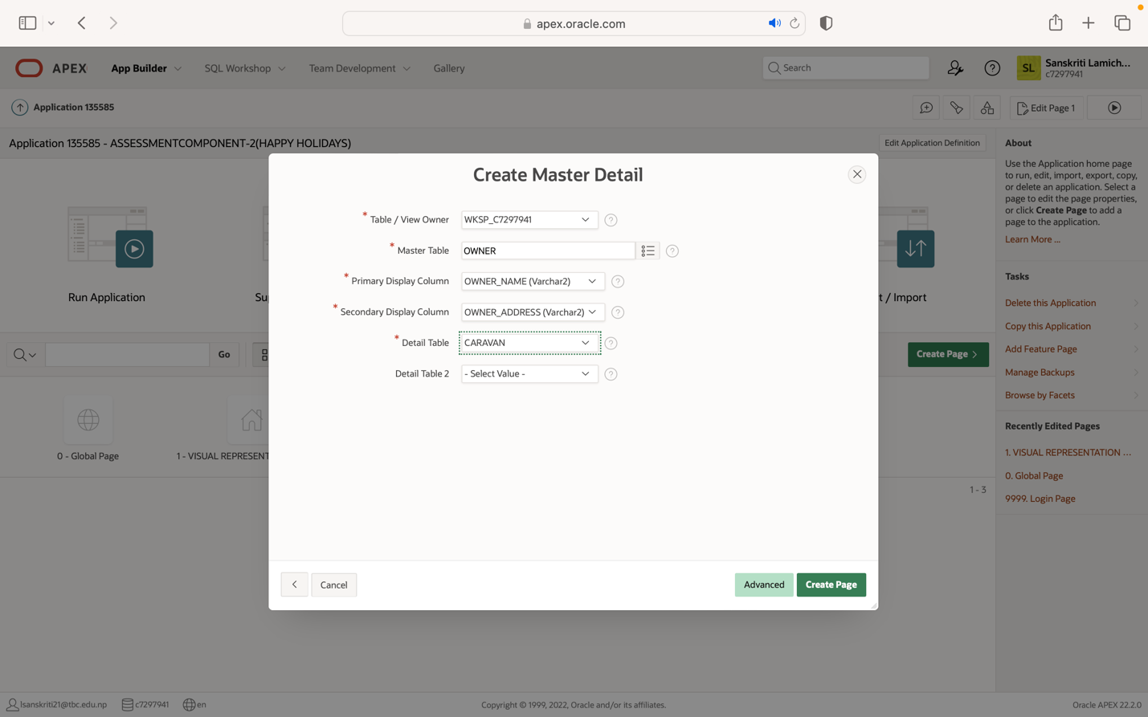

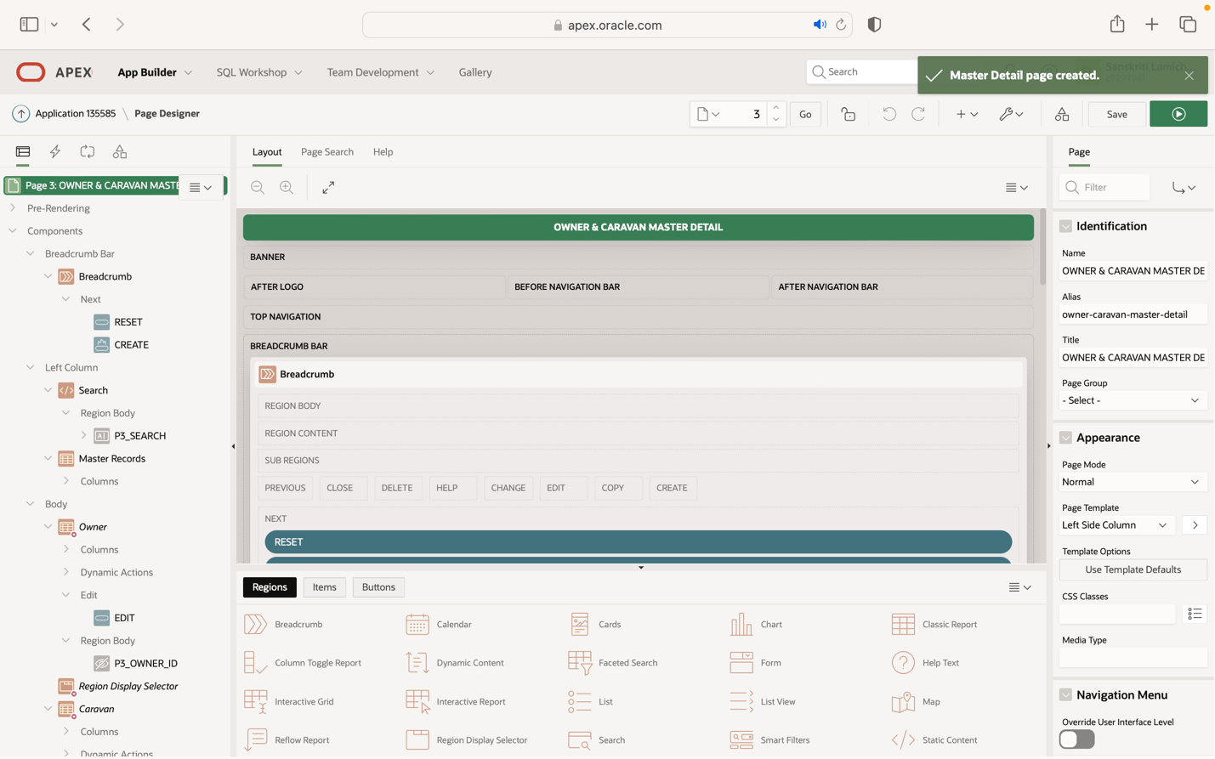

**PERFORMING CRUD OPERATIONS ON OWNER & CARAVAN MASTER DETAIL:**

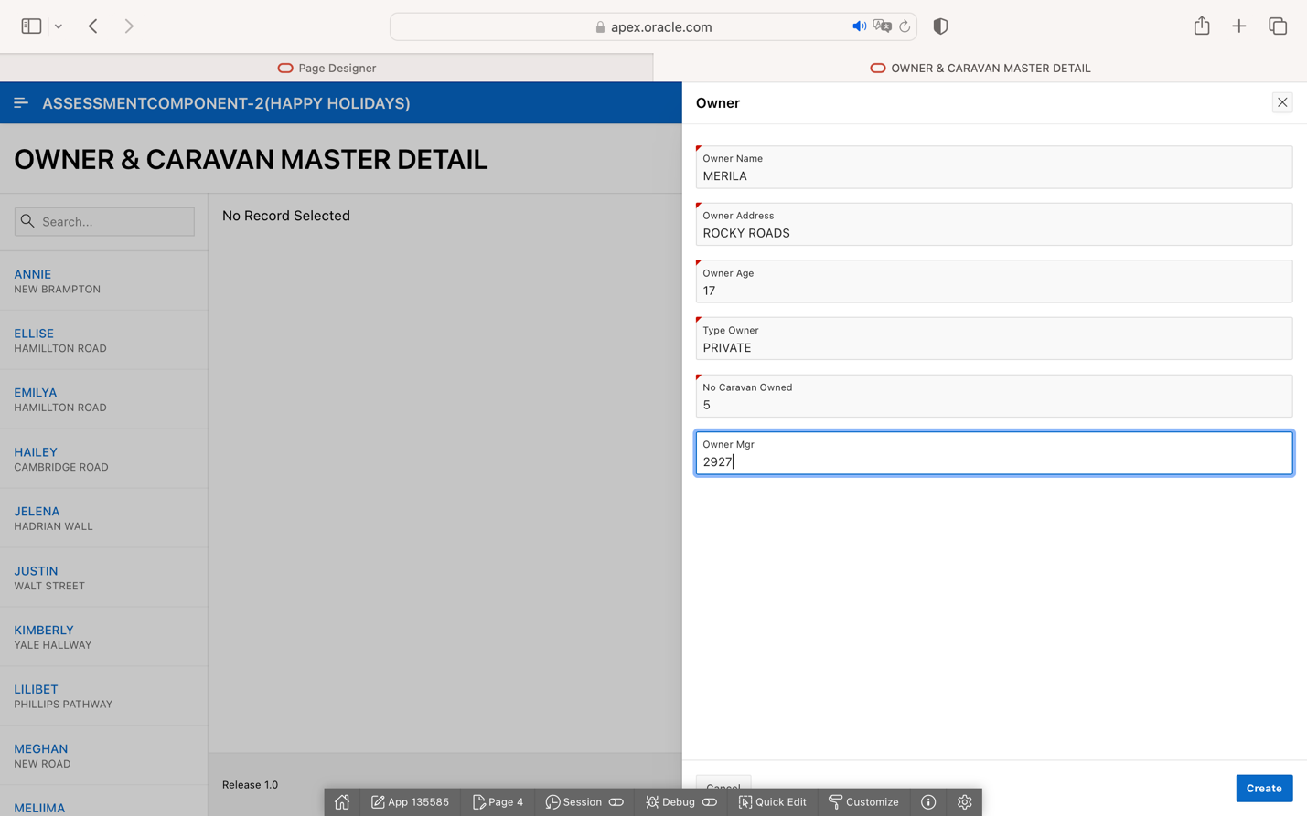

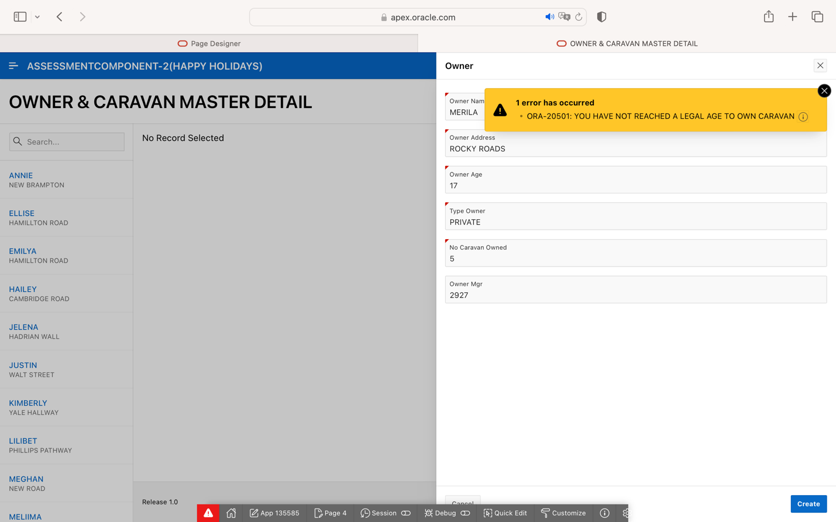

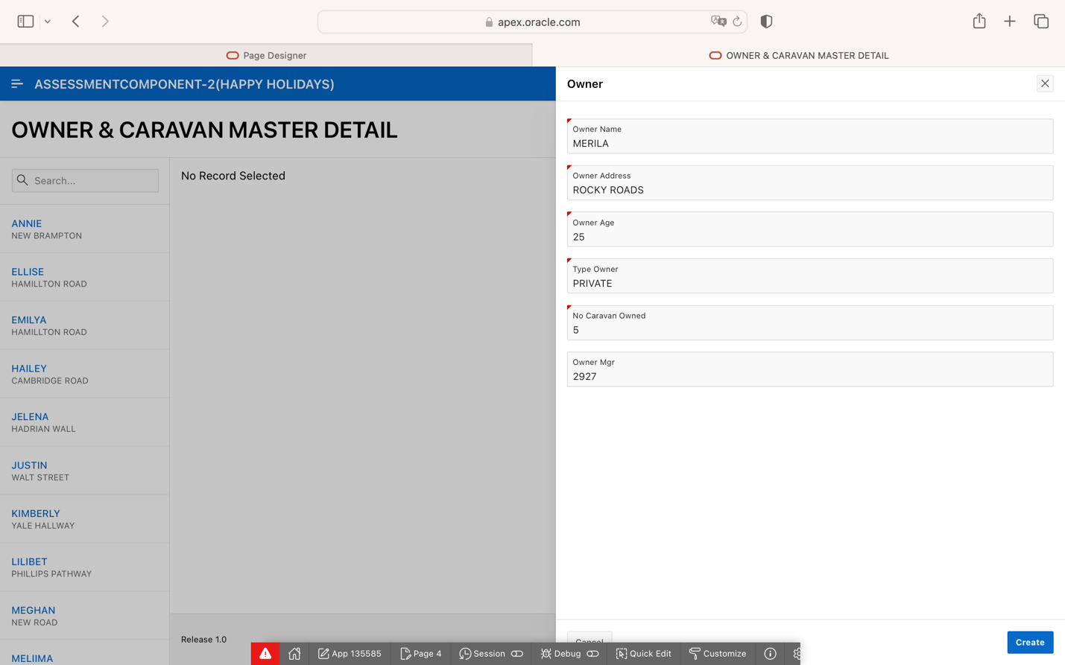

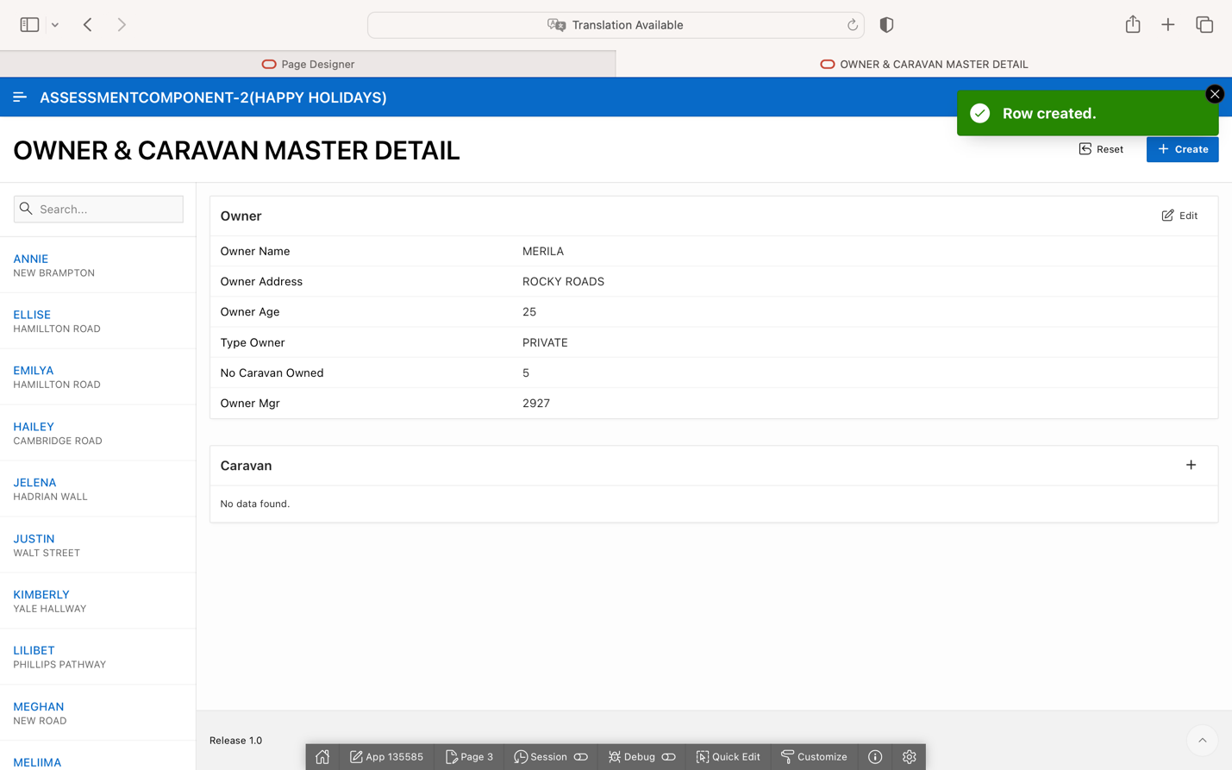

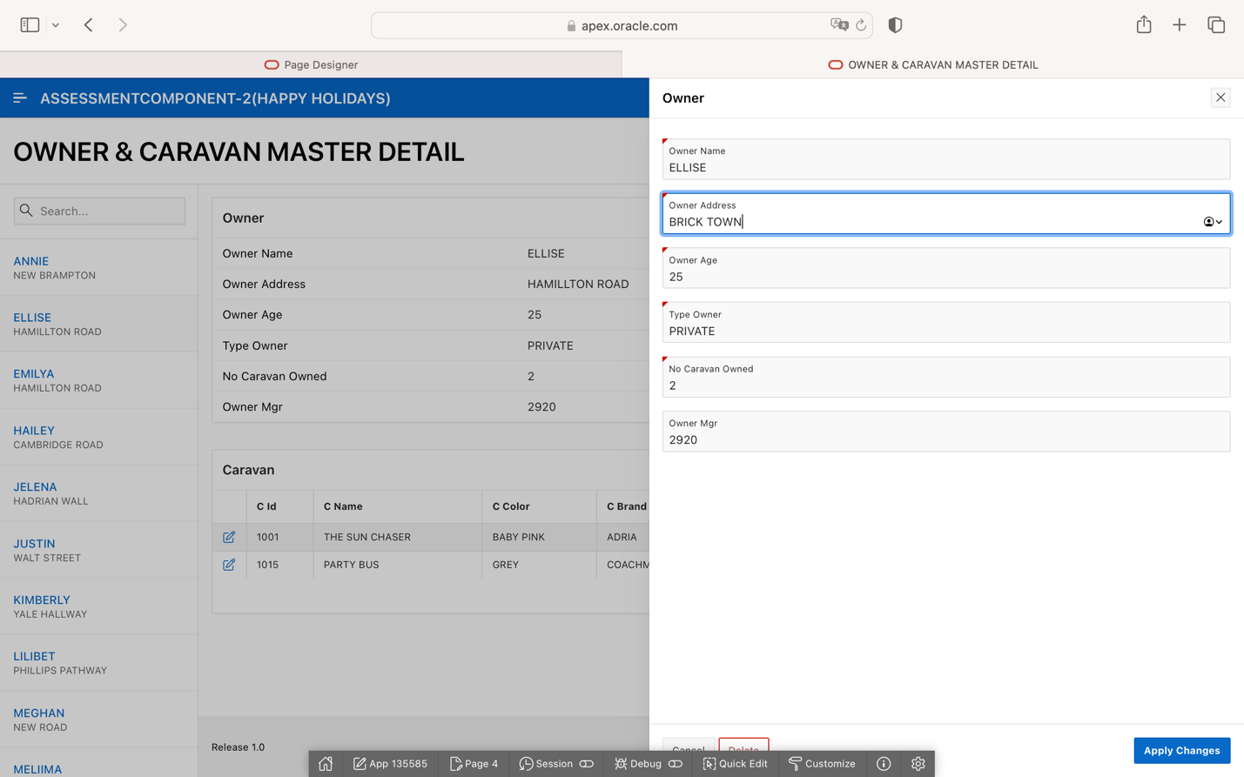

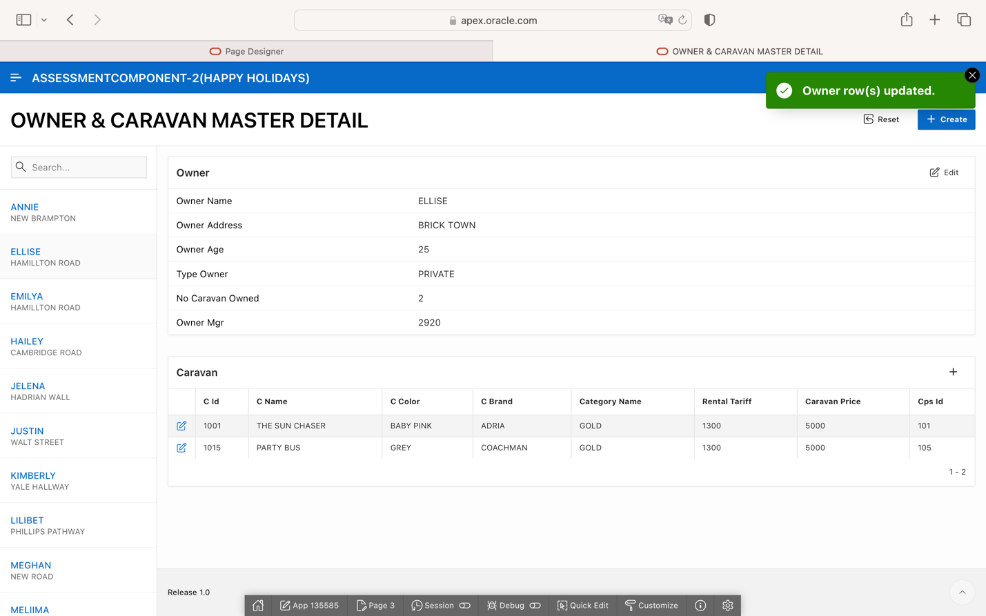

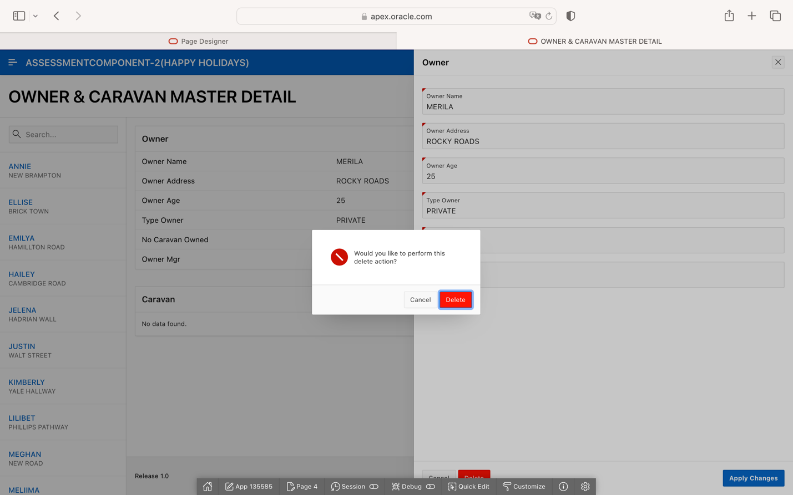

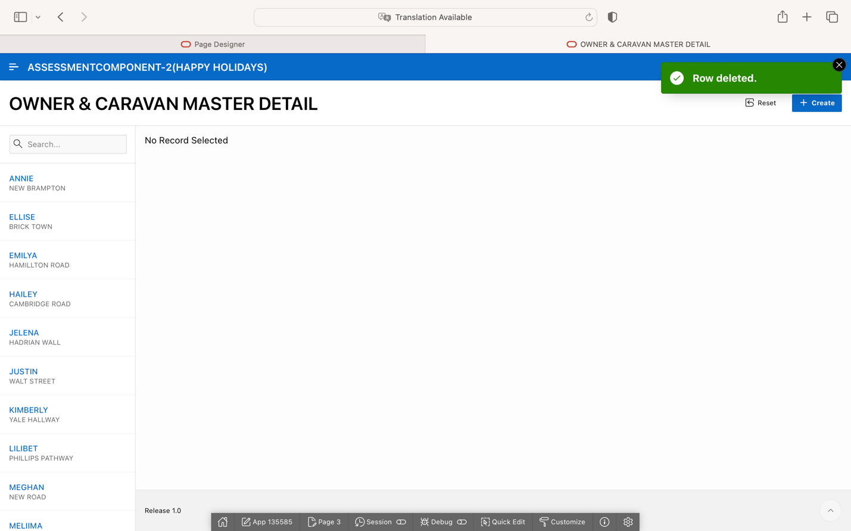

MASTER DETAIL:2

CARAVAN &BOOKING MASTER DETAIL

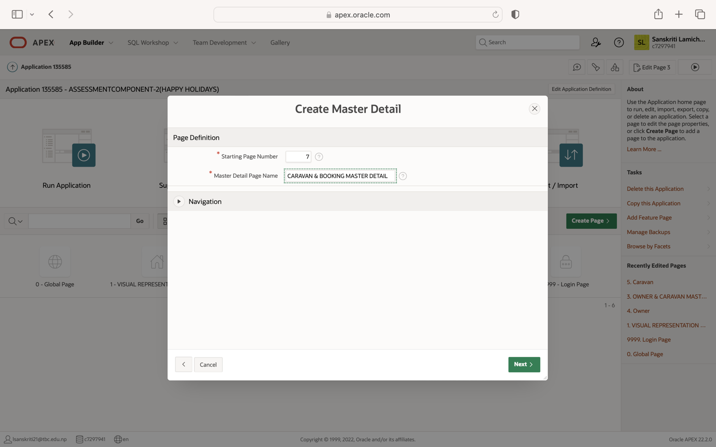

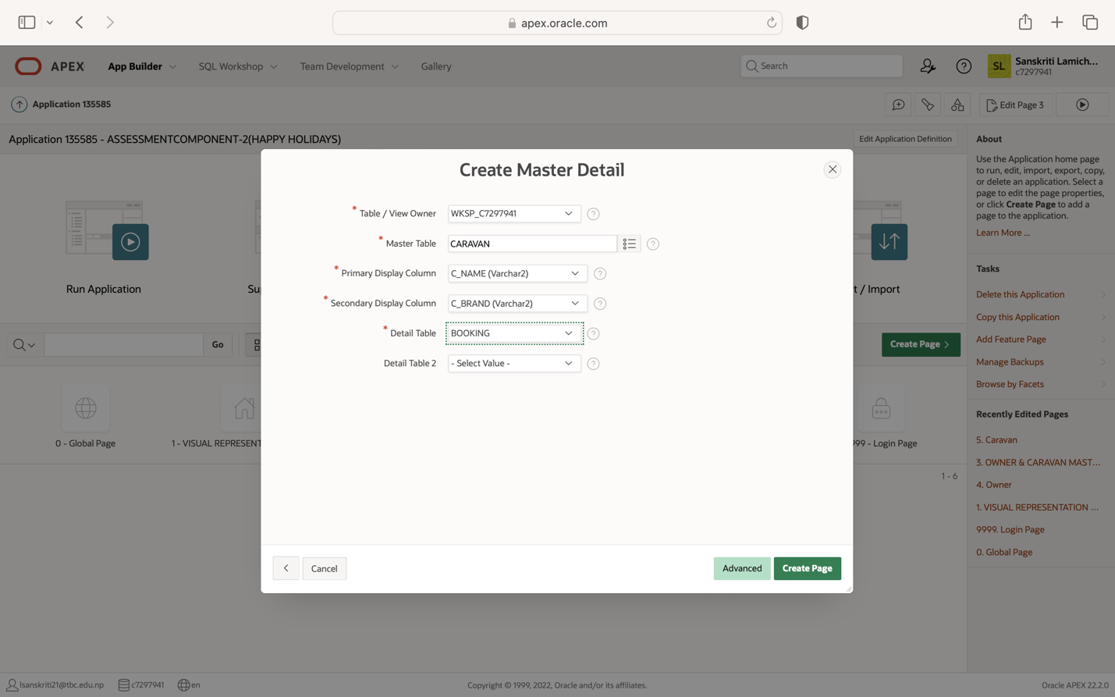

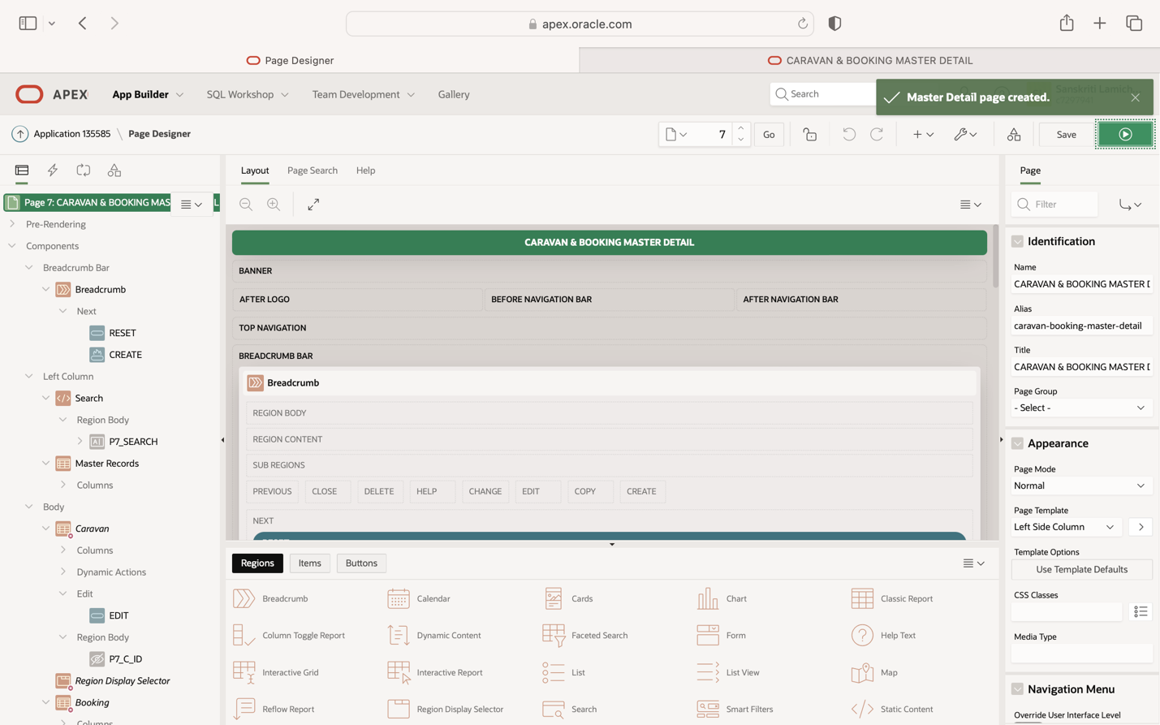

**PERFROMING CRUD OPERATION IN CARAVAN & BOOKING MASTER DETAIL:**

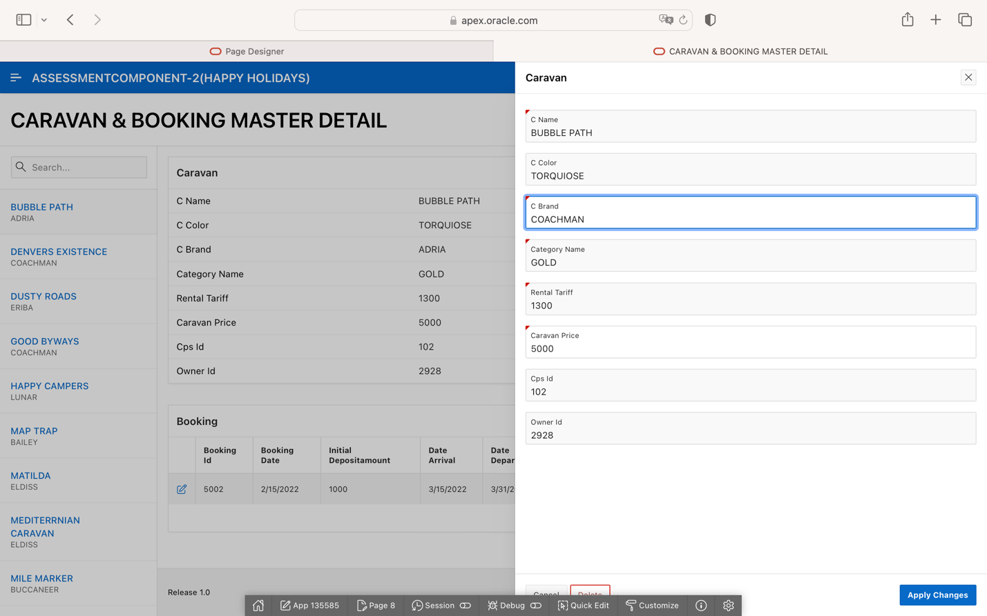

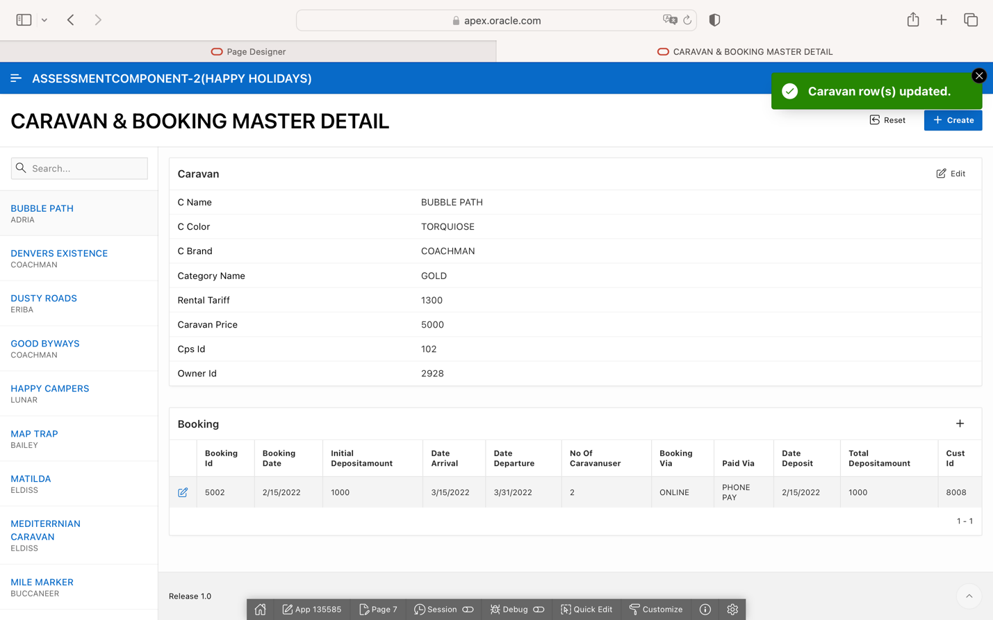

MASTER DETAIL:3

CARAVAN PARK SITE & STAFF MASTER DETAIL

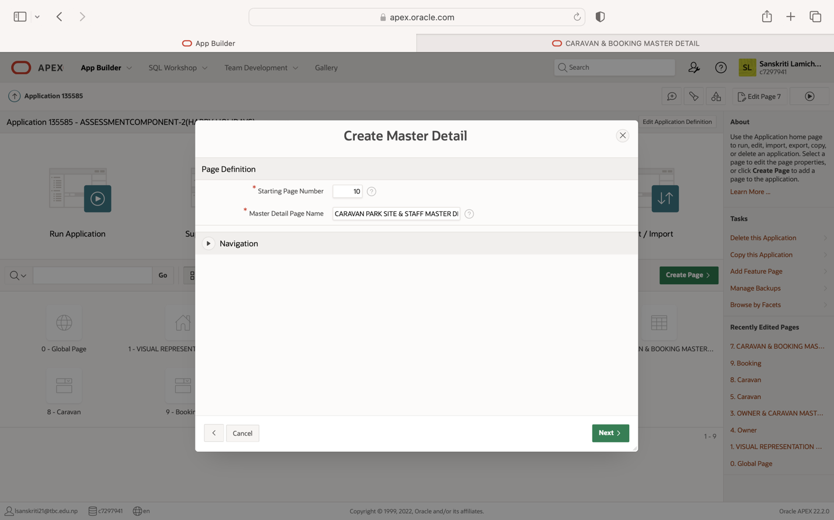

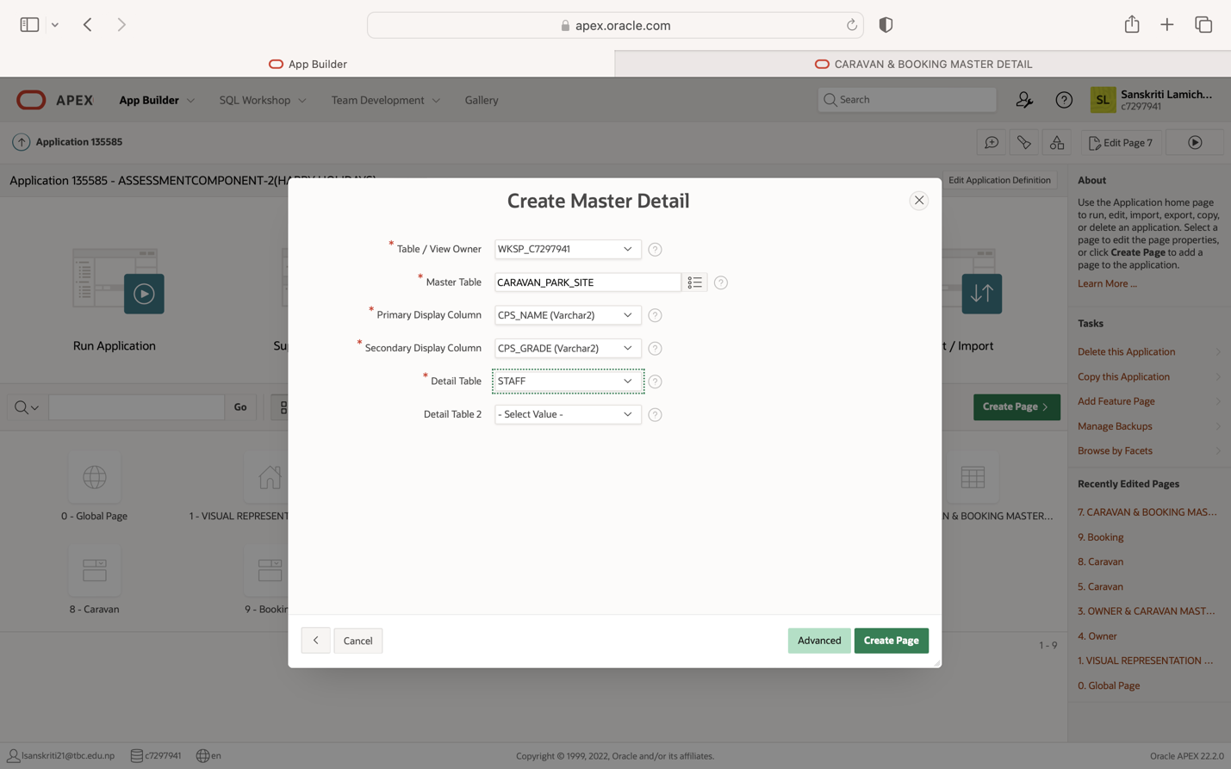

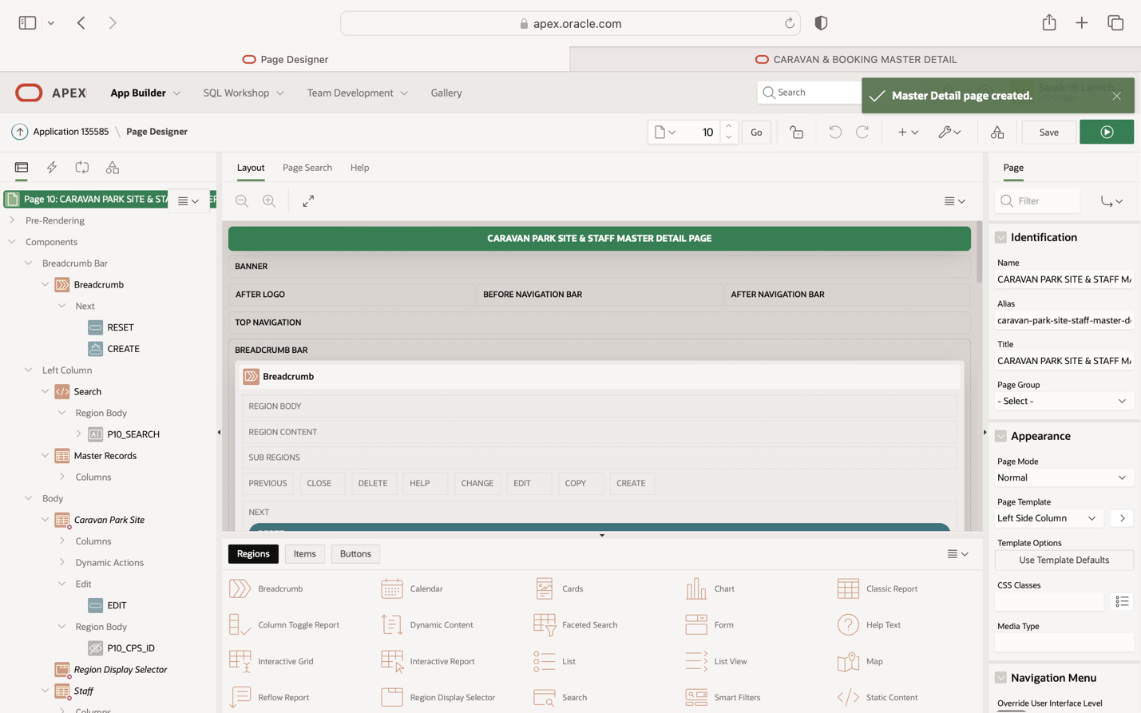

**PERFORMING CRUD OPERATION IN CARAVAN PARK SITE & STAFF MASTER DETAIL:**

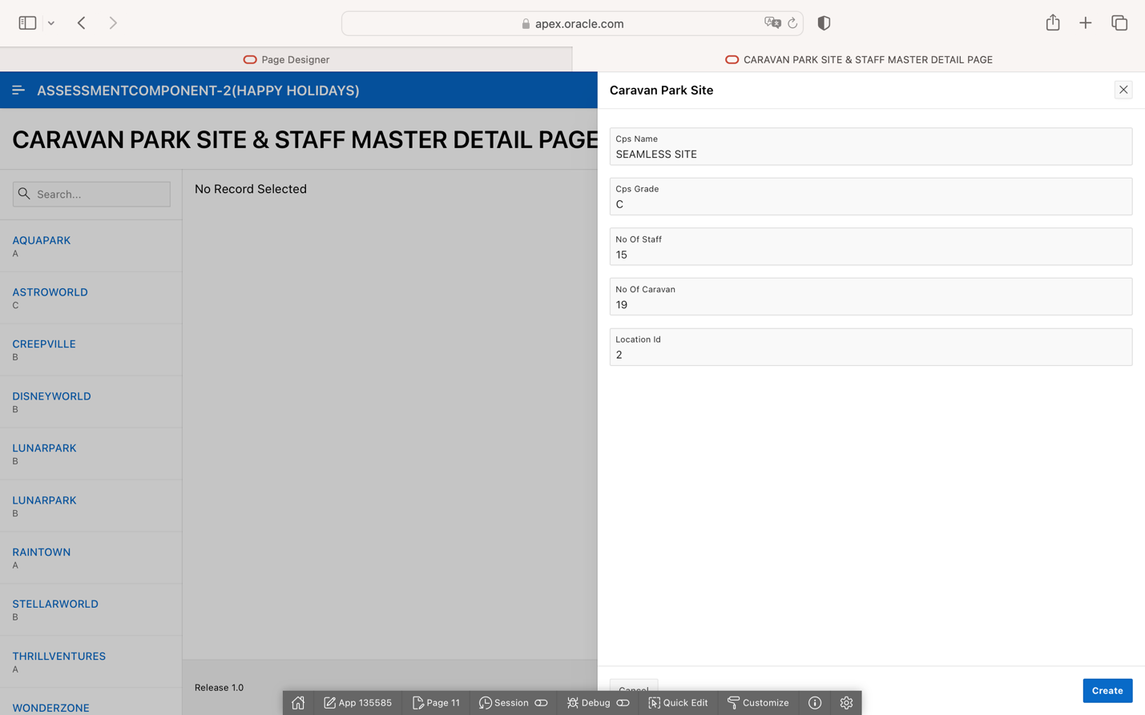

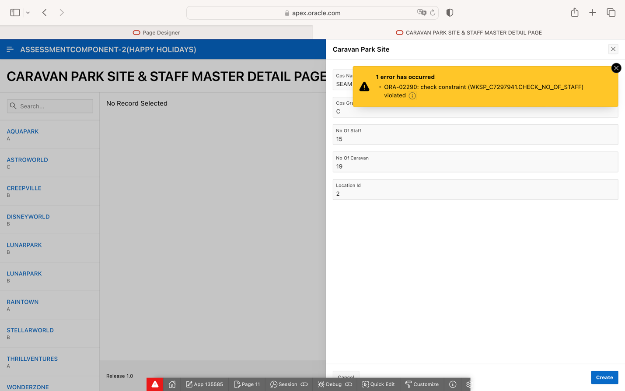

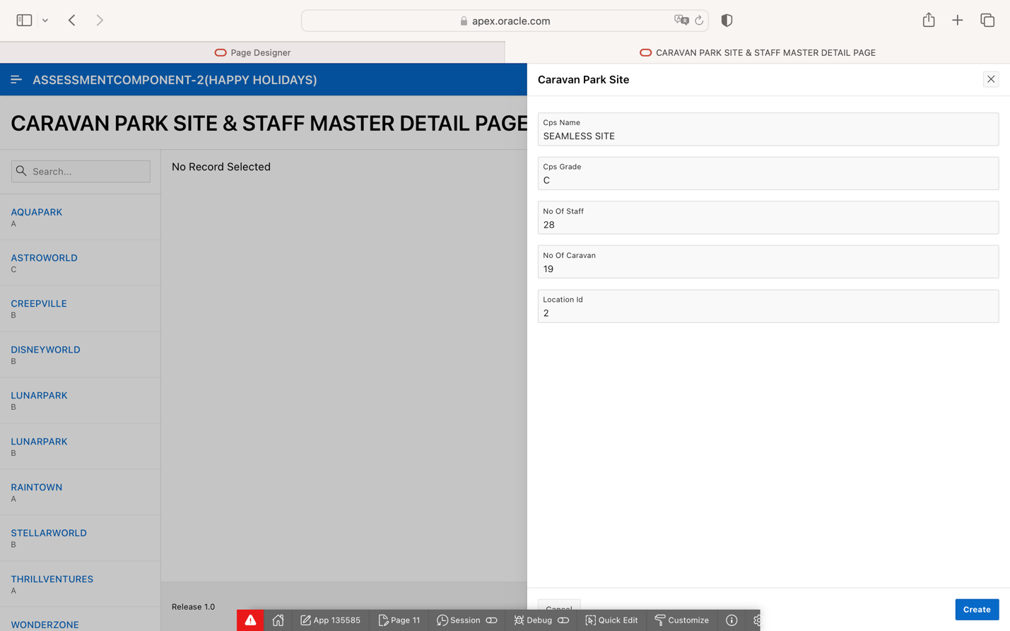

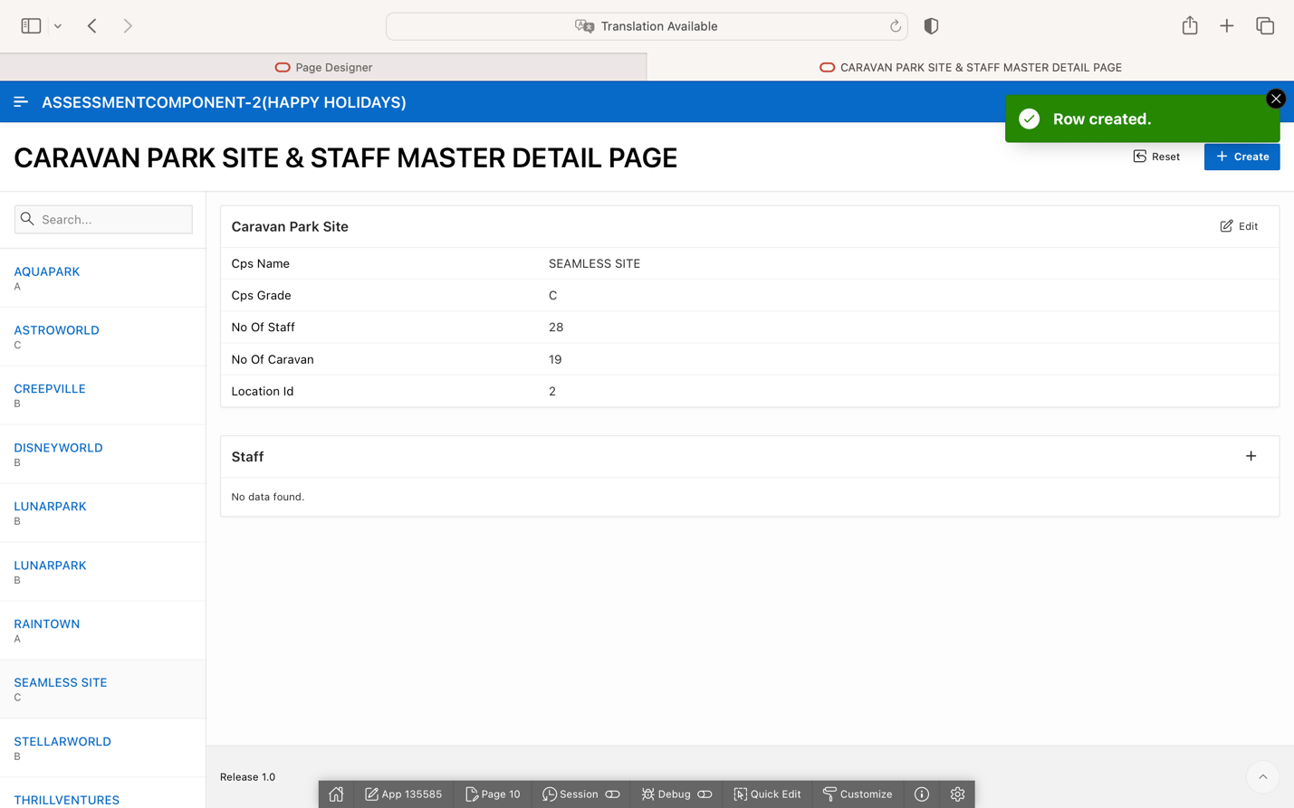

**TASK:4 CREATING TRIGGERS FOR BOOKING, CUSTOMER, OWNER AND STAFF TABLE**

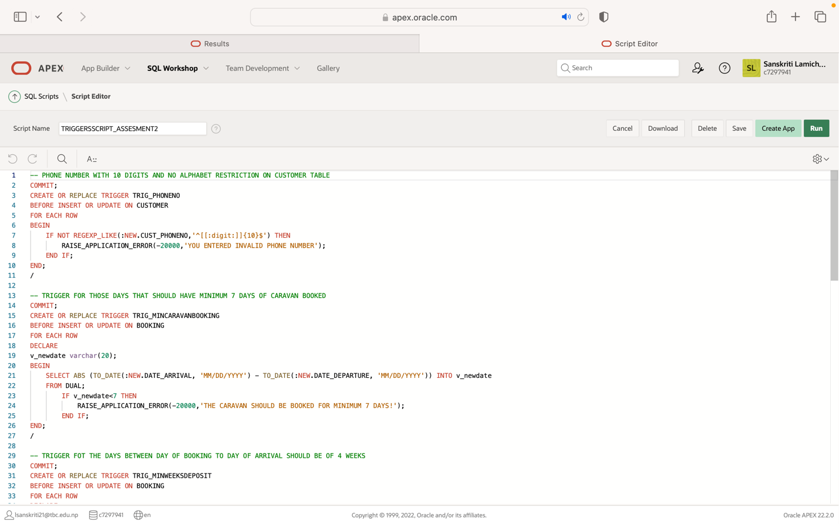

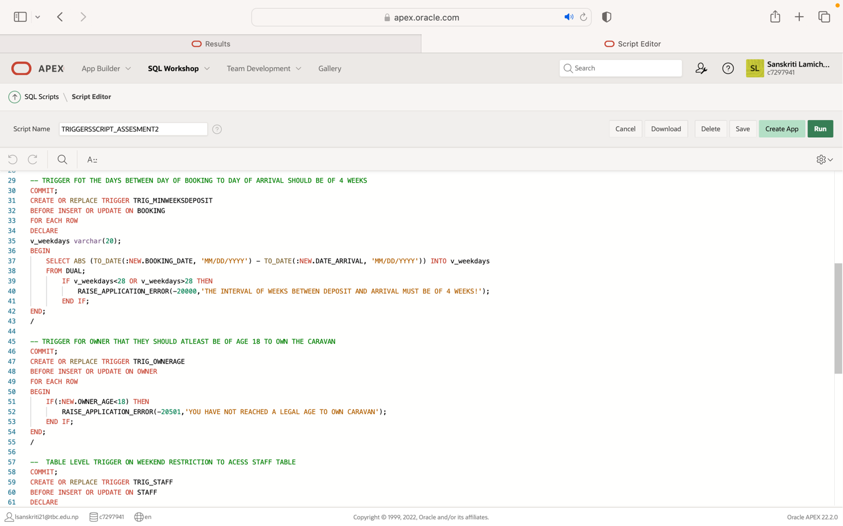

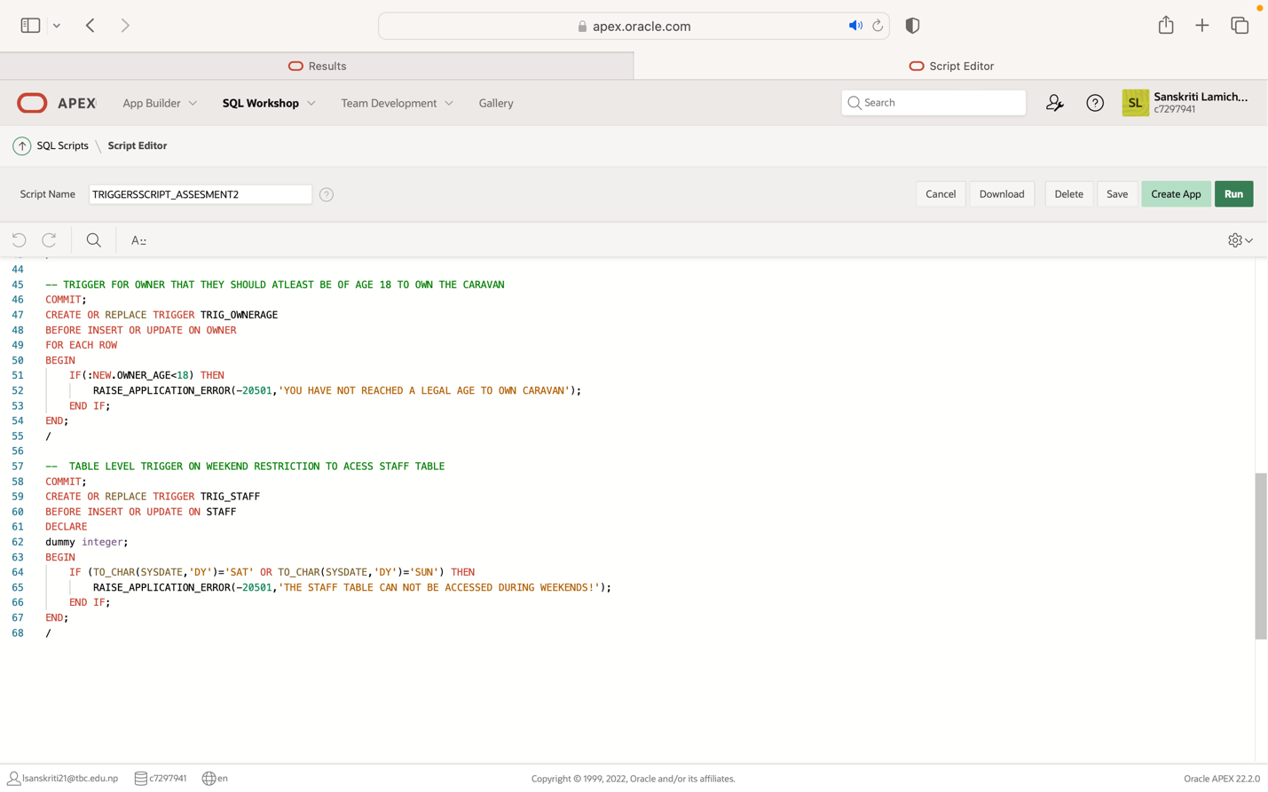

**CHECKING THE EERORS FOR TRIGGER:**

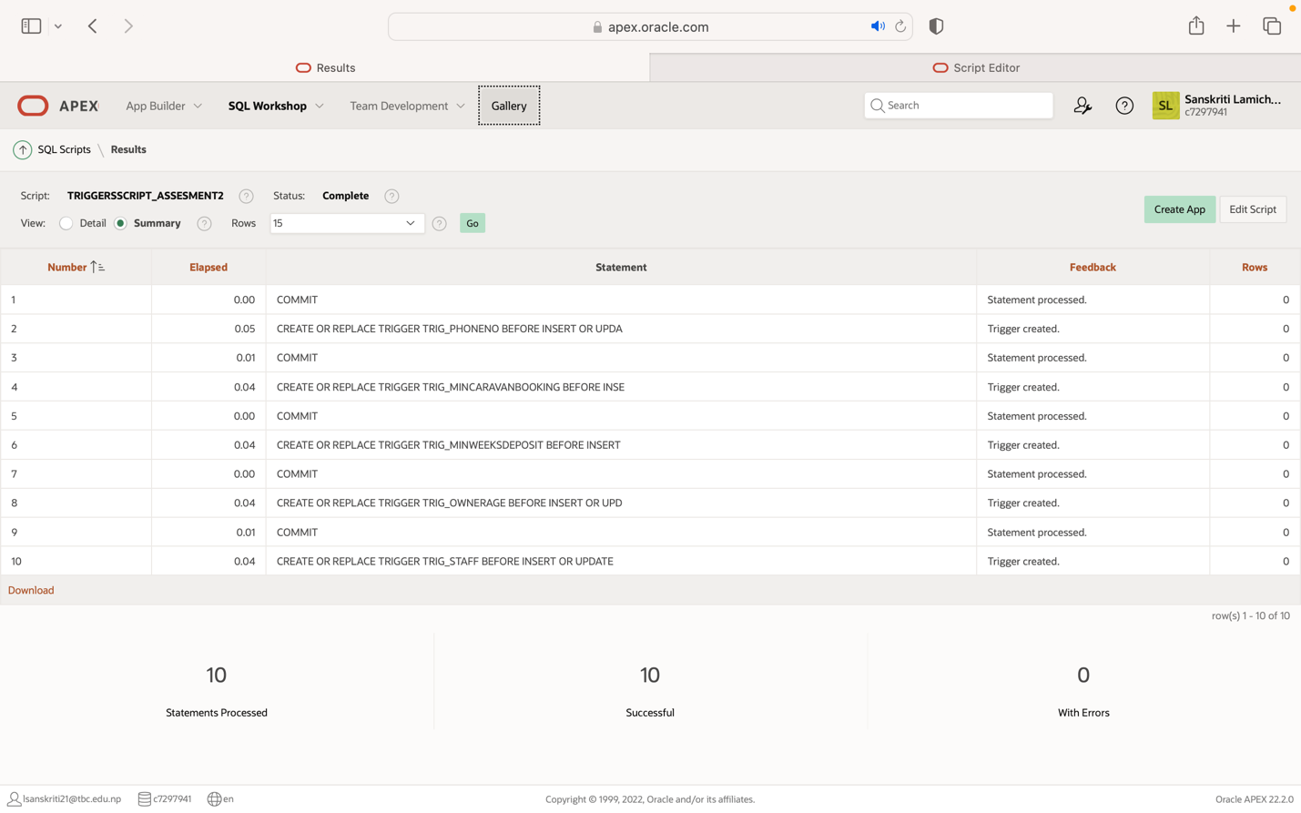

**VALIDATING TRIGGERS VIA FORMS:**

**FORMS**

**BOOKING FORM:**

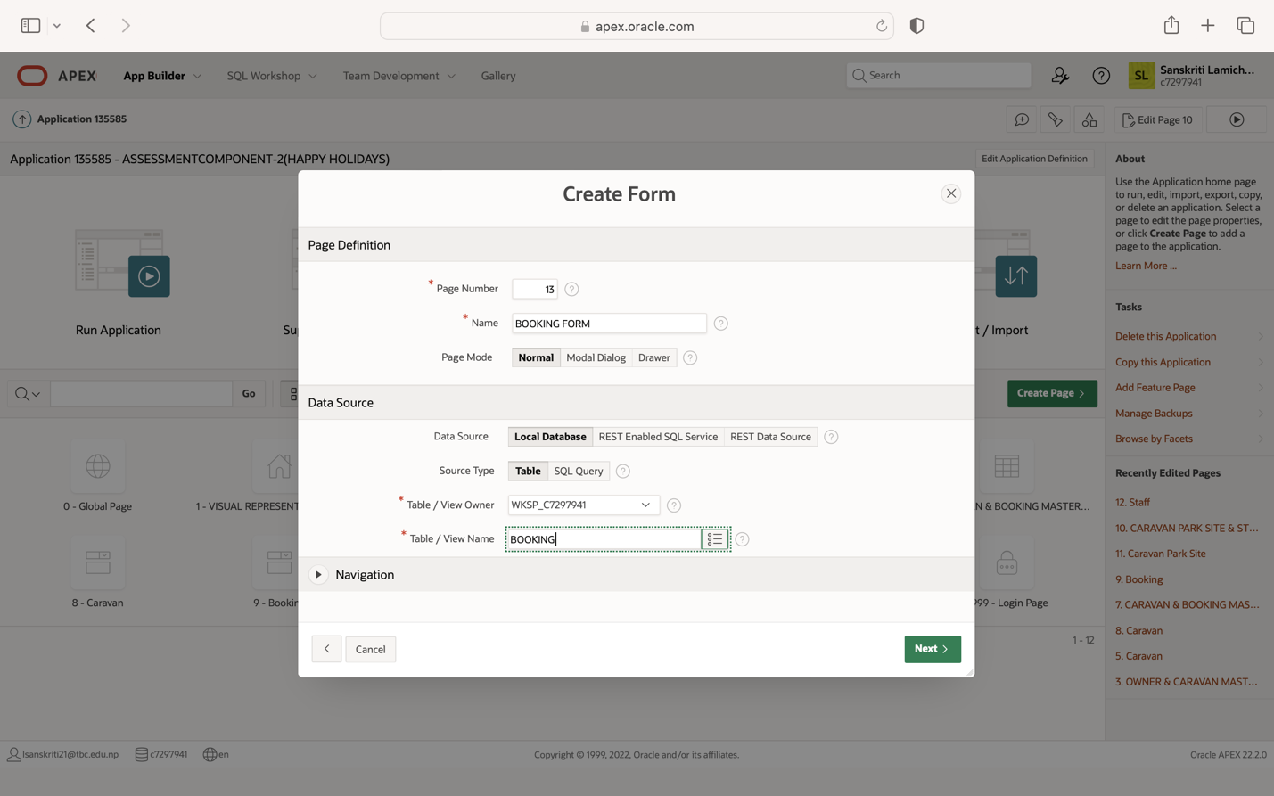

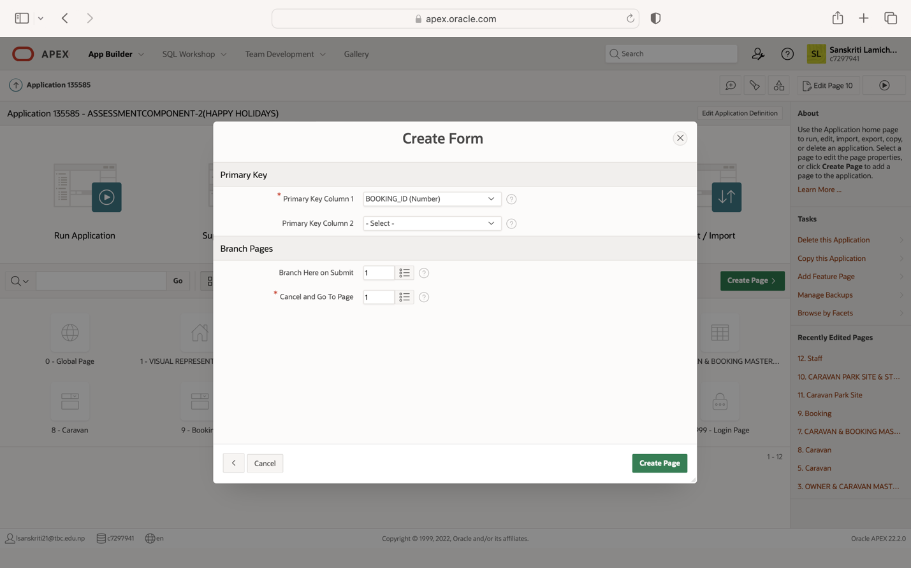

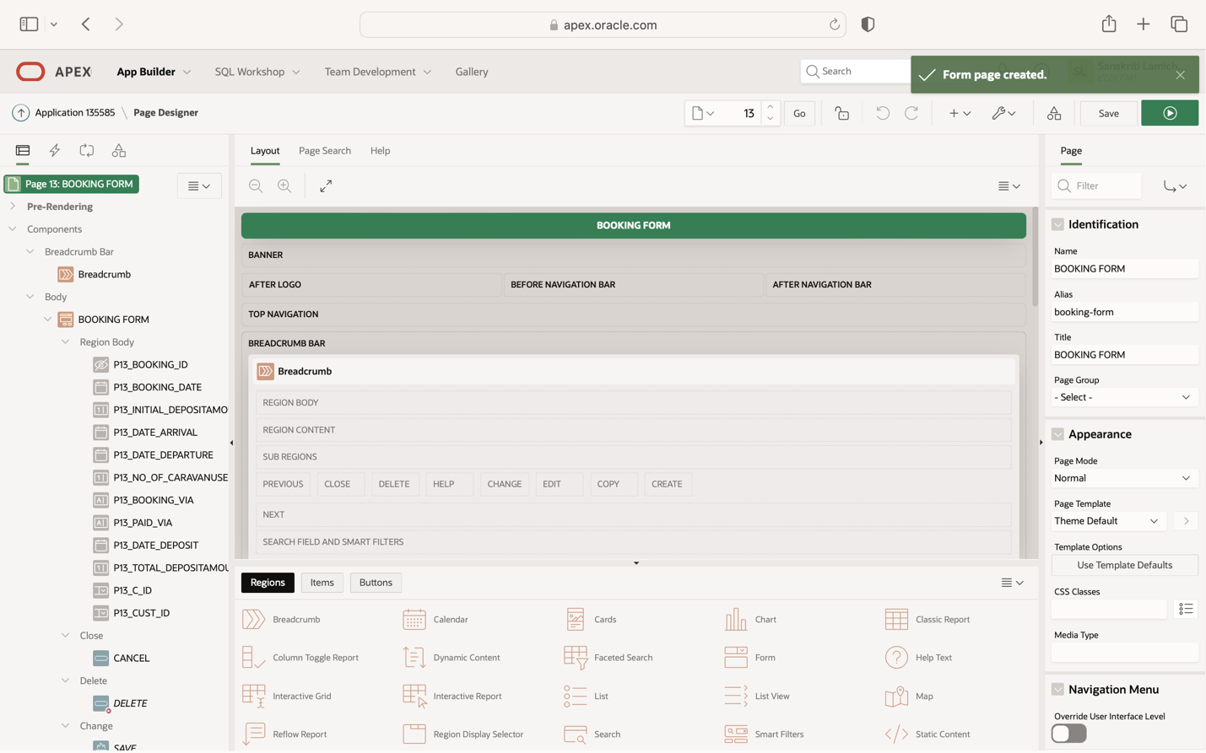

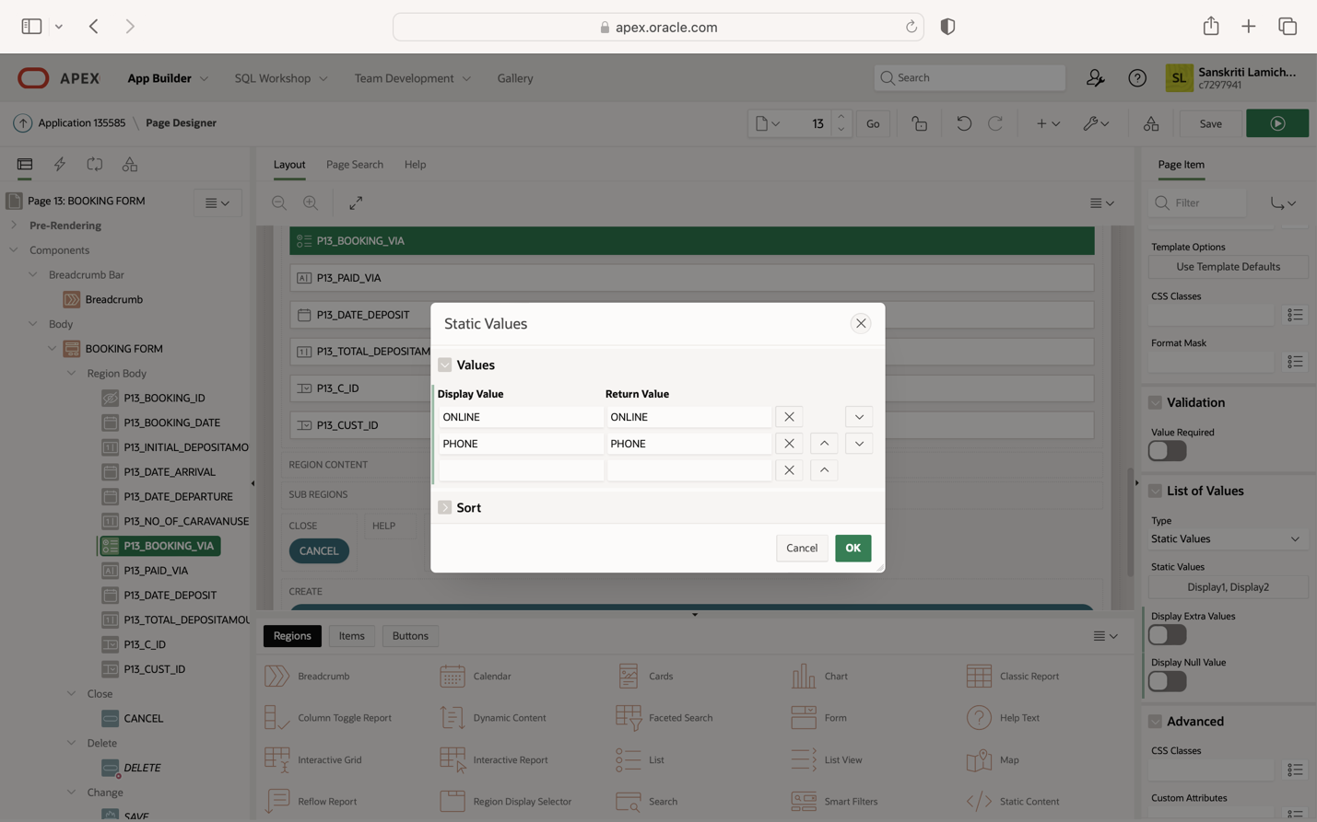

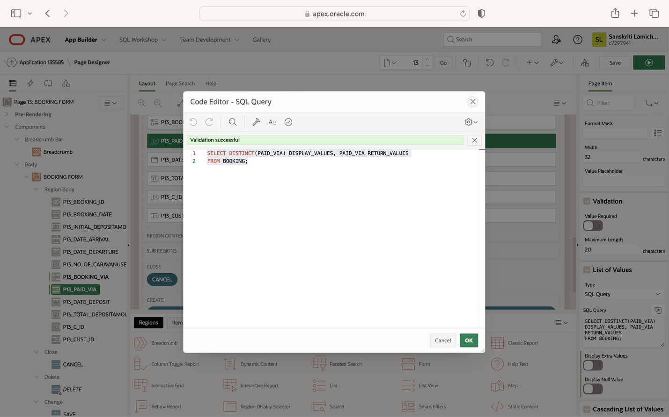

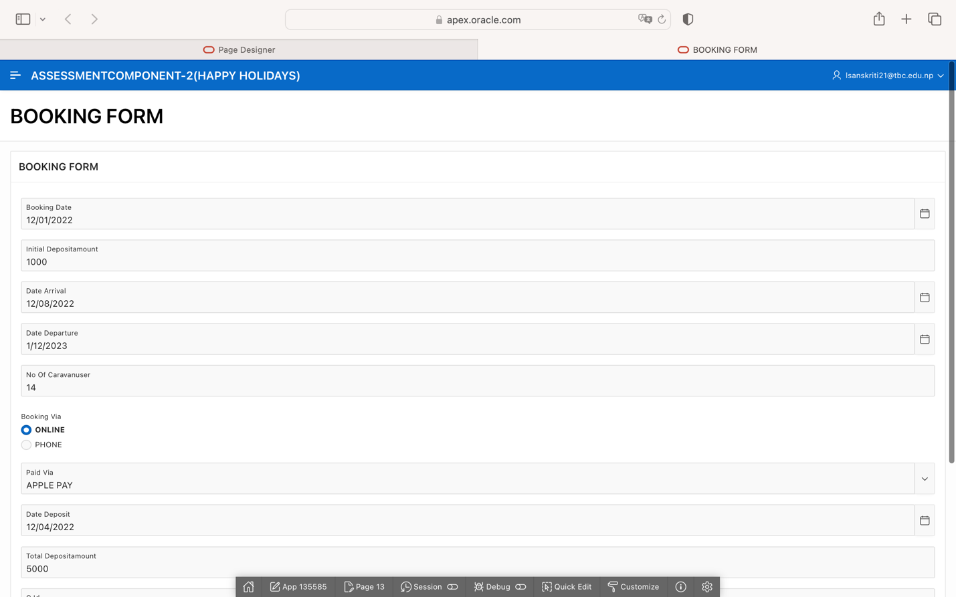

**TRIGGER FIRED DUE TO INVALID INSERTION:**

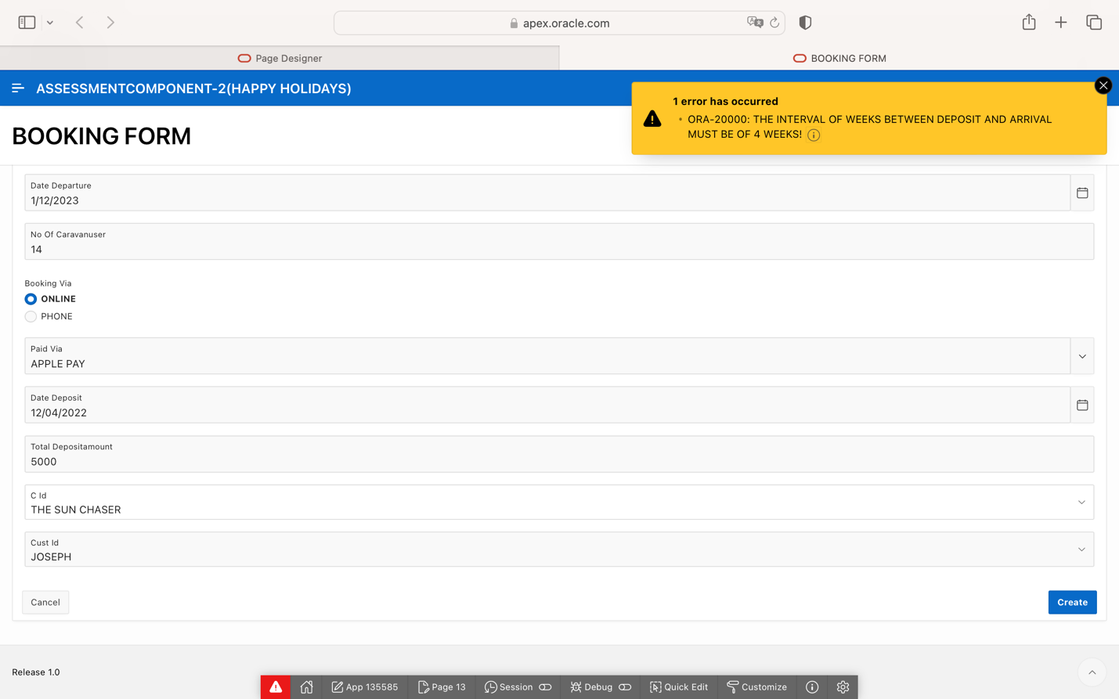

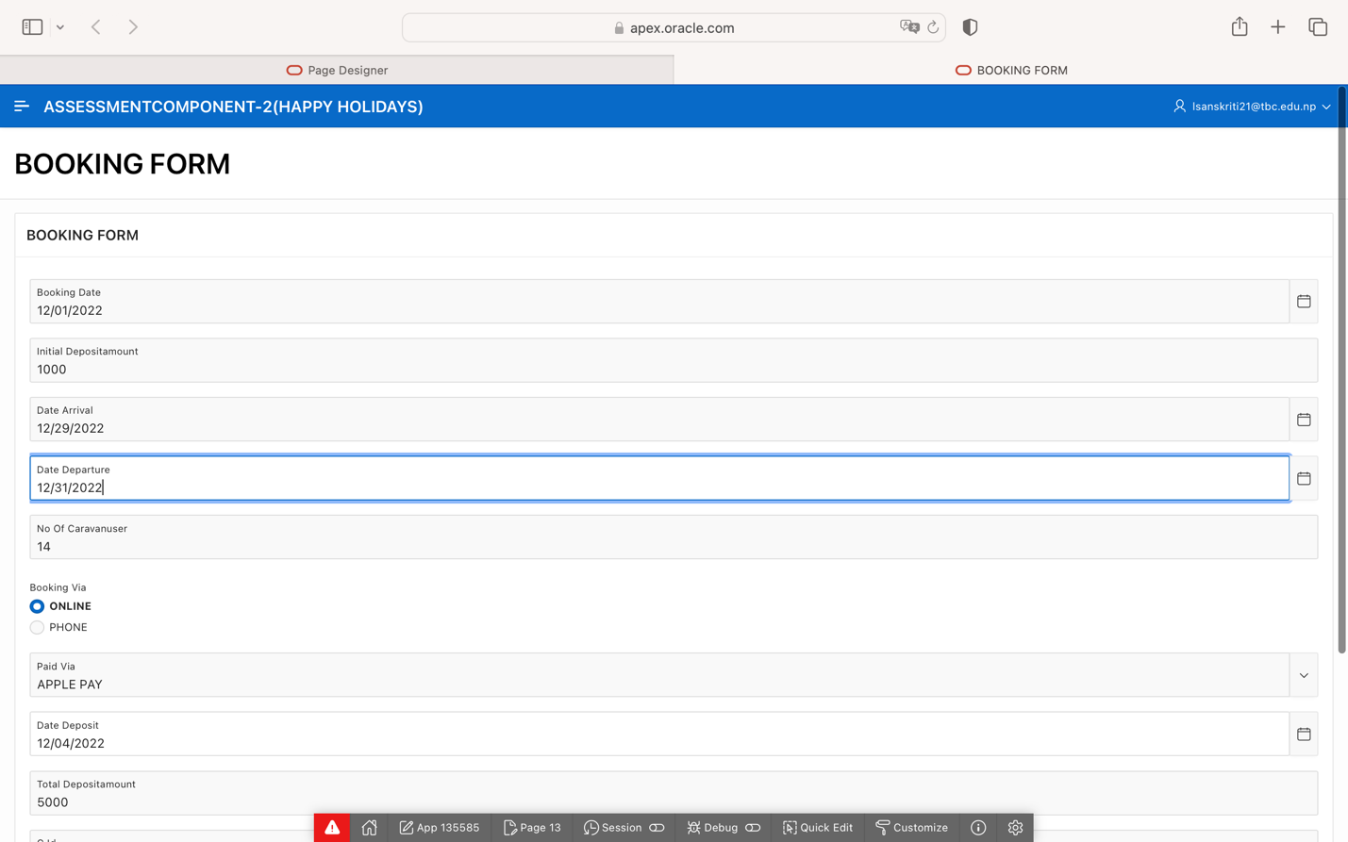

**TRIGGER FIRED DUE TO INVALID INSERTION:**

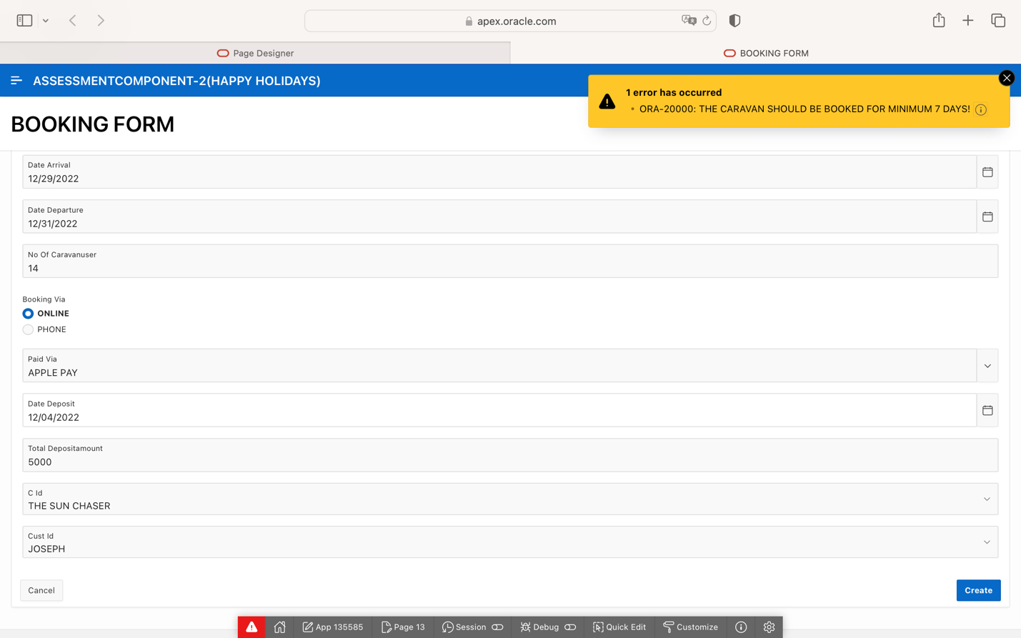

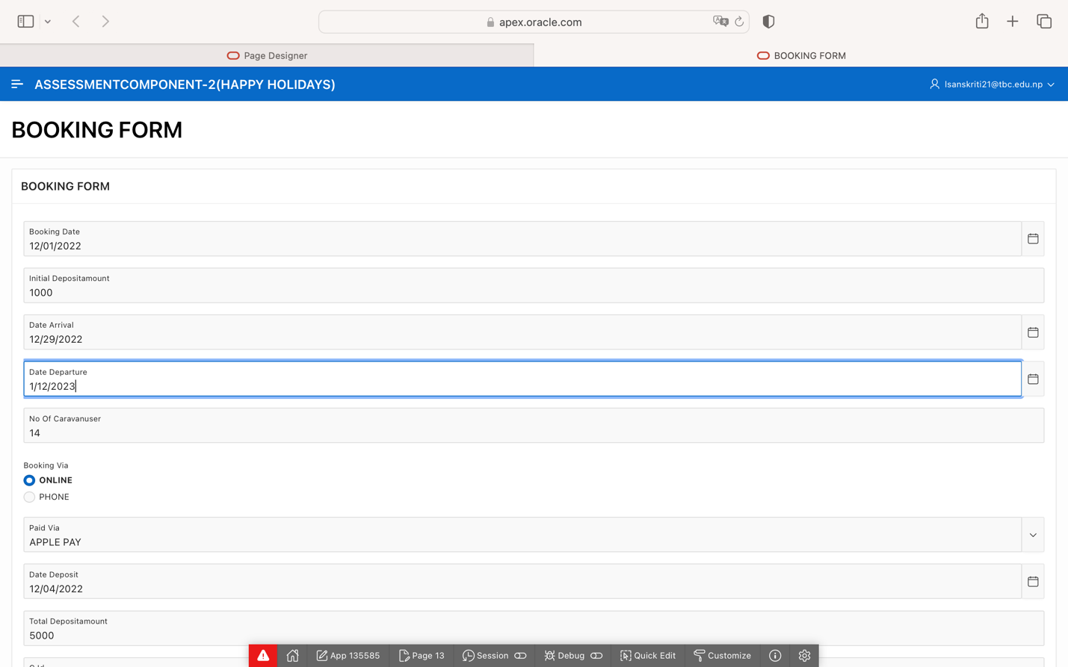

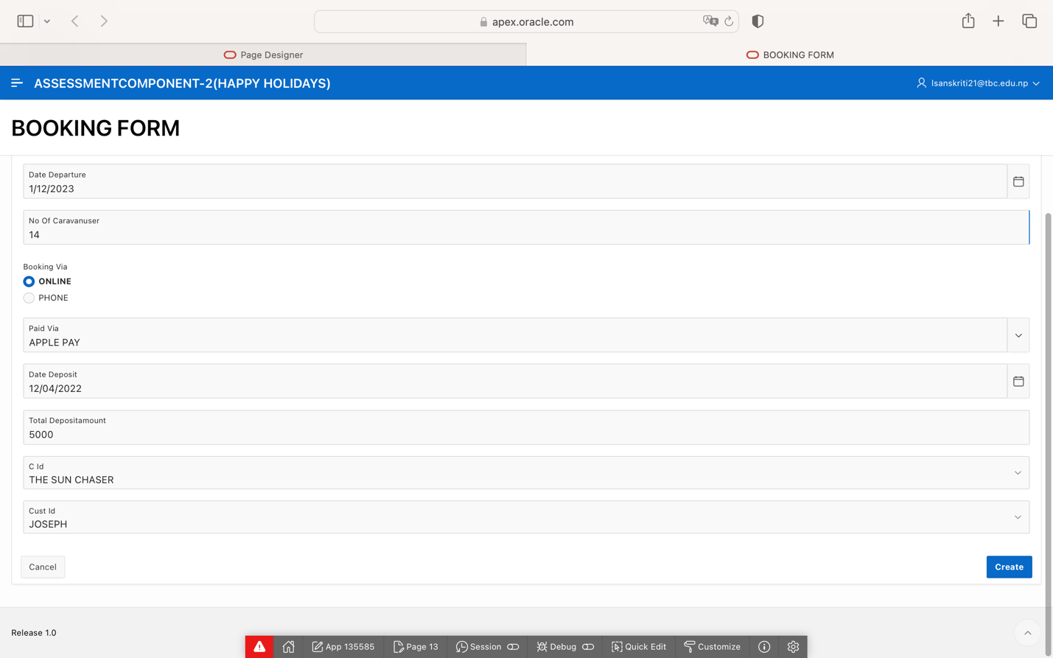

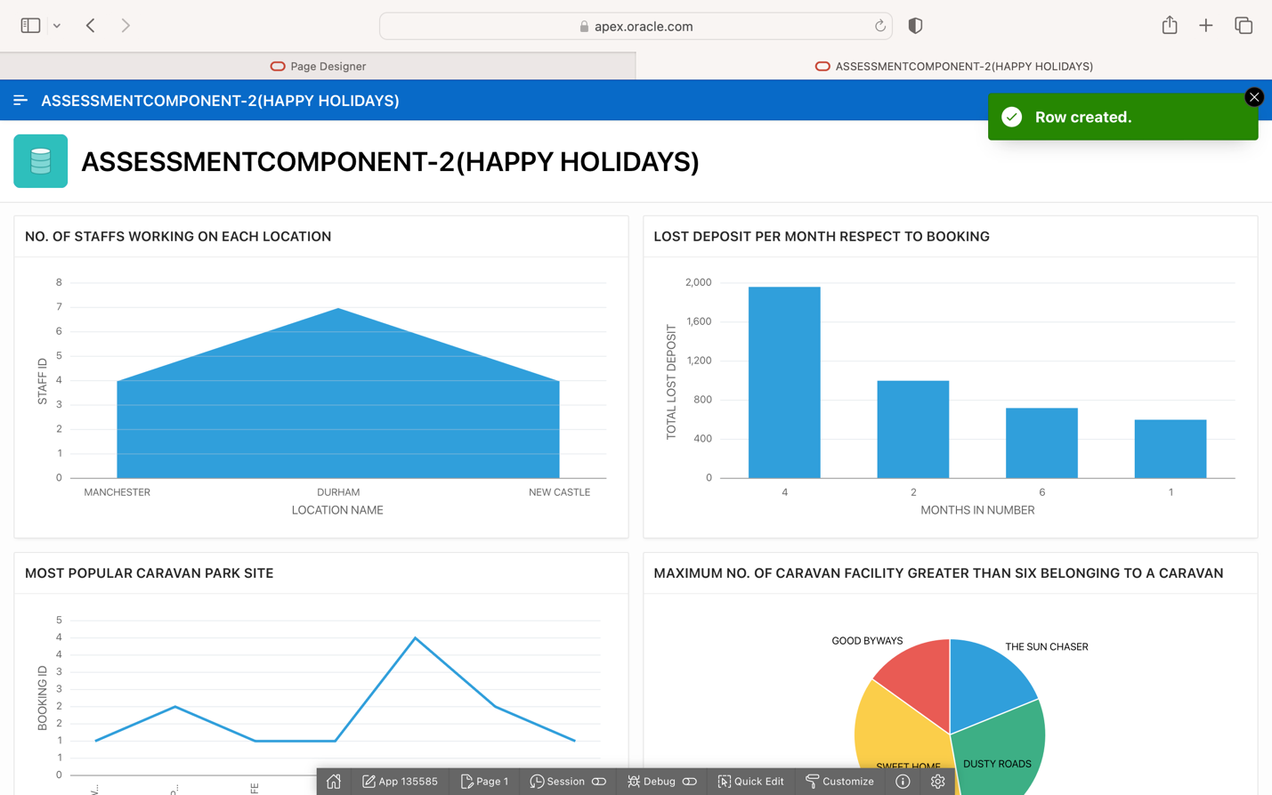

STAFF FORMS:

ON WEEKEND:

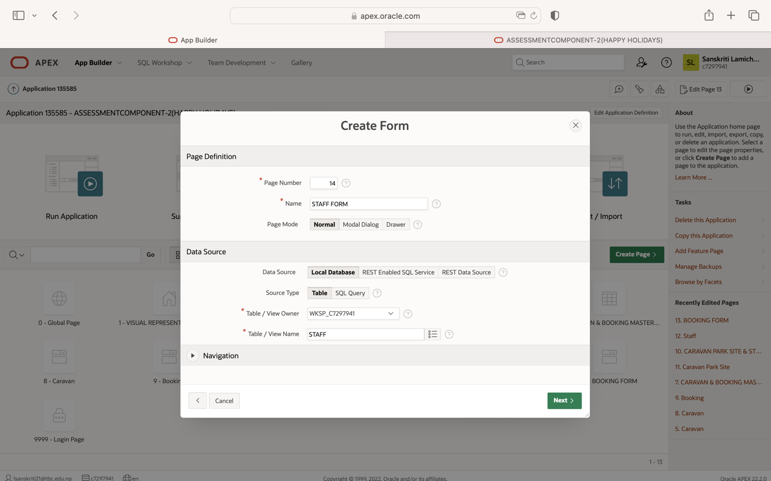

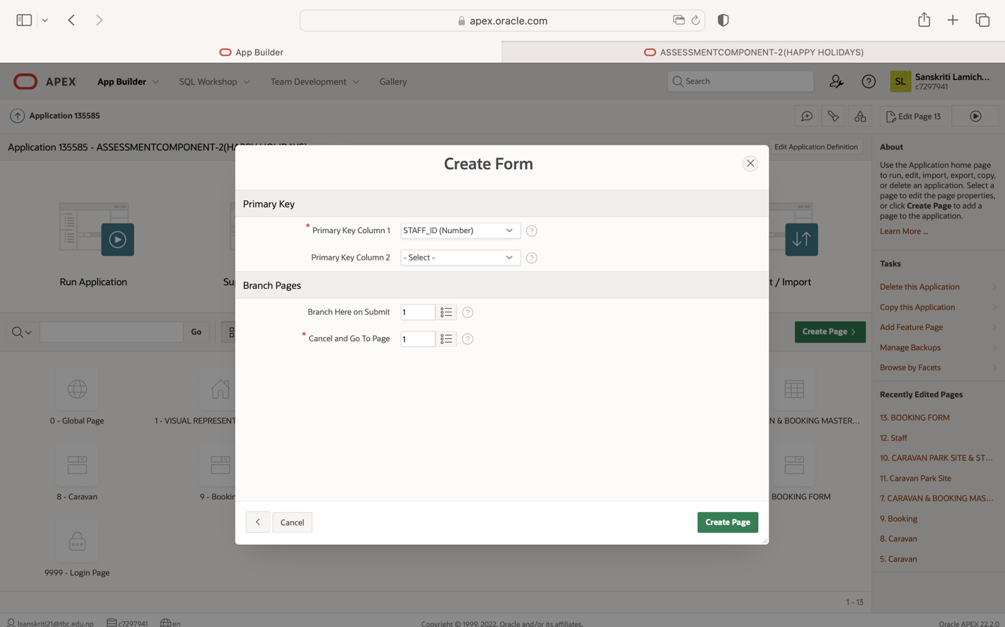

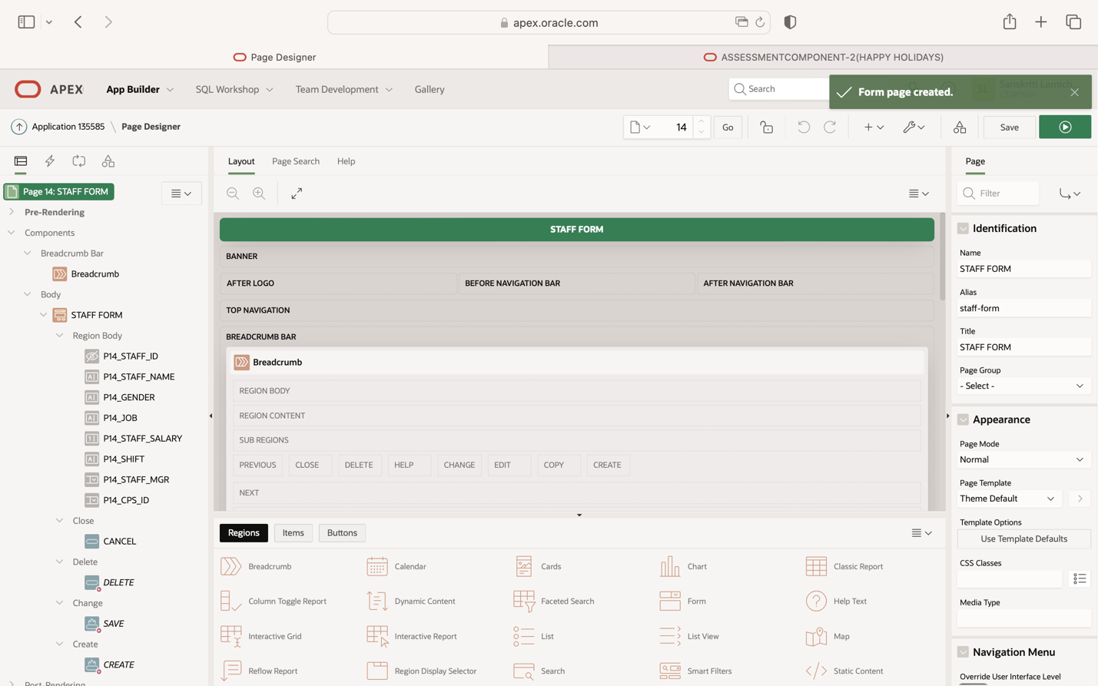

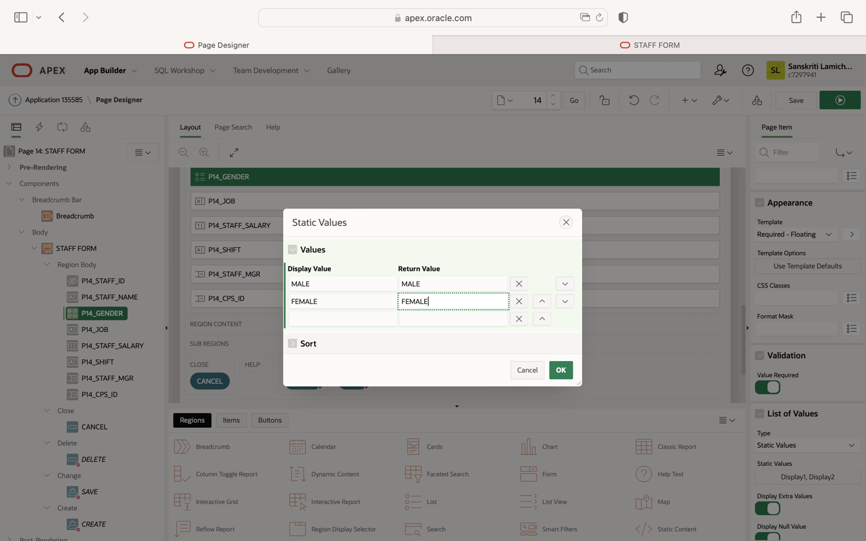

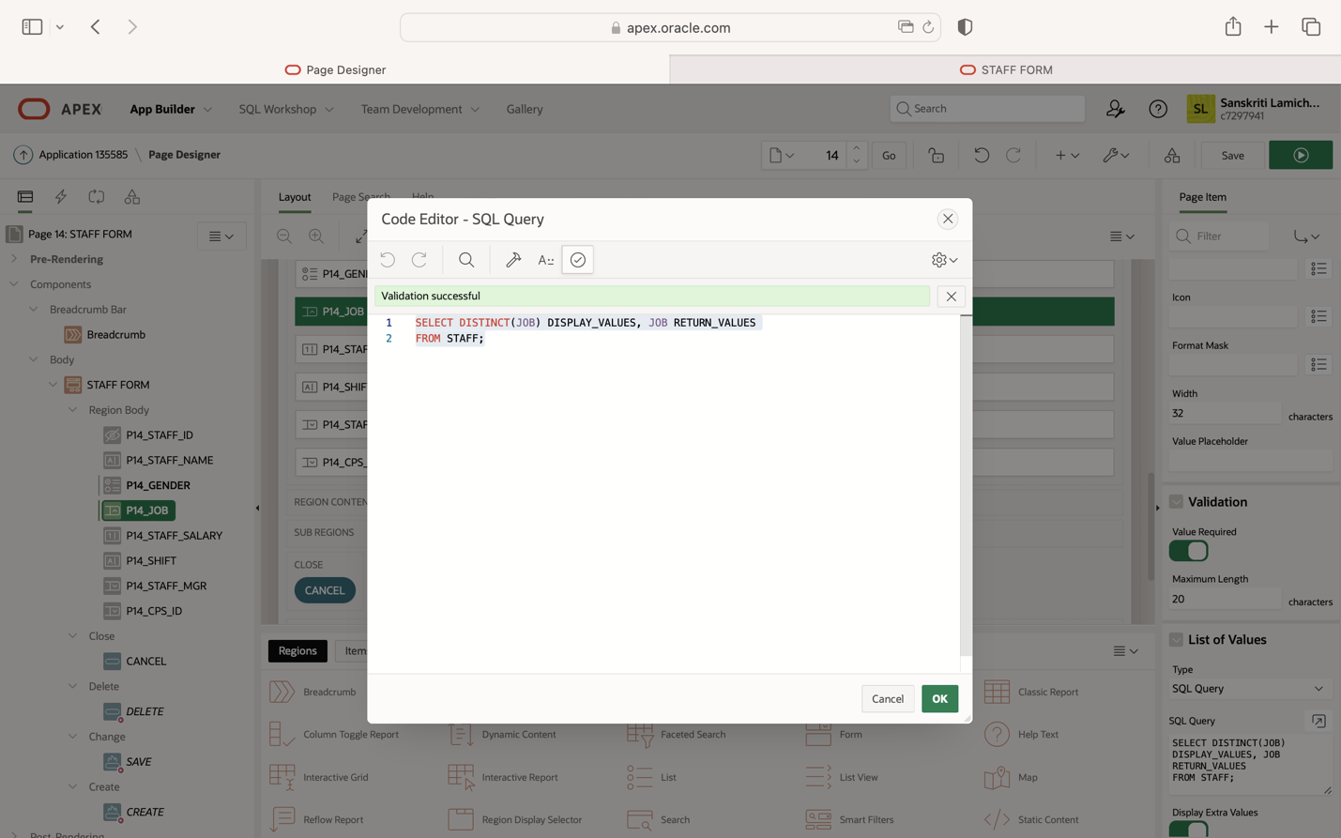

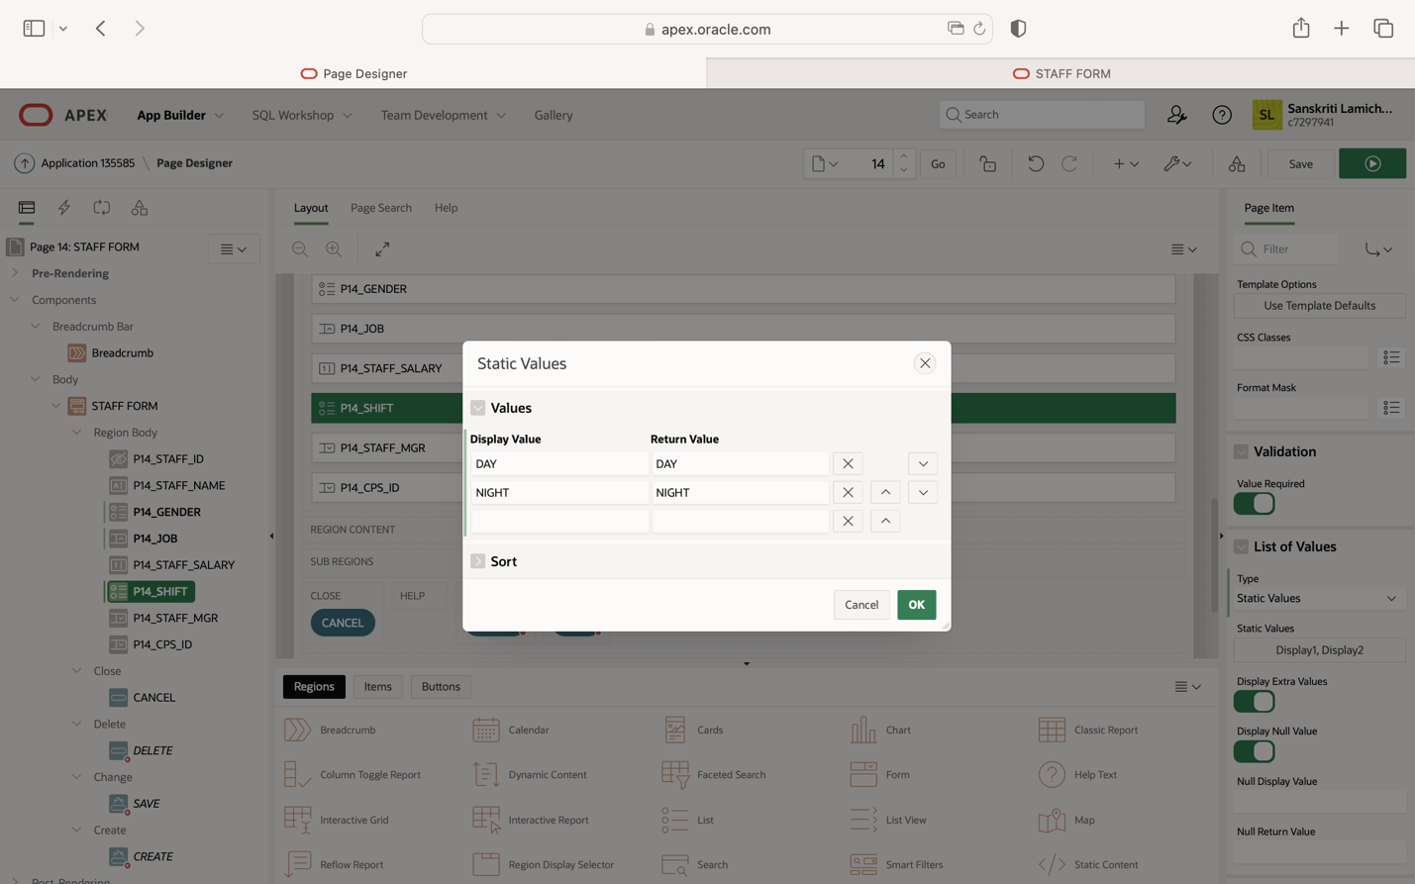

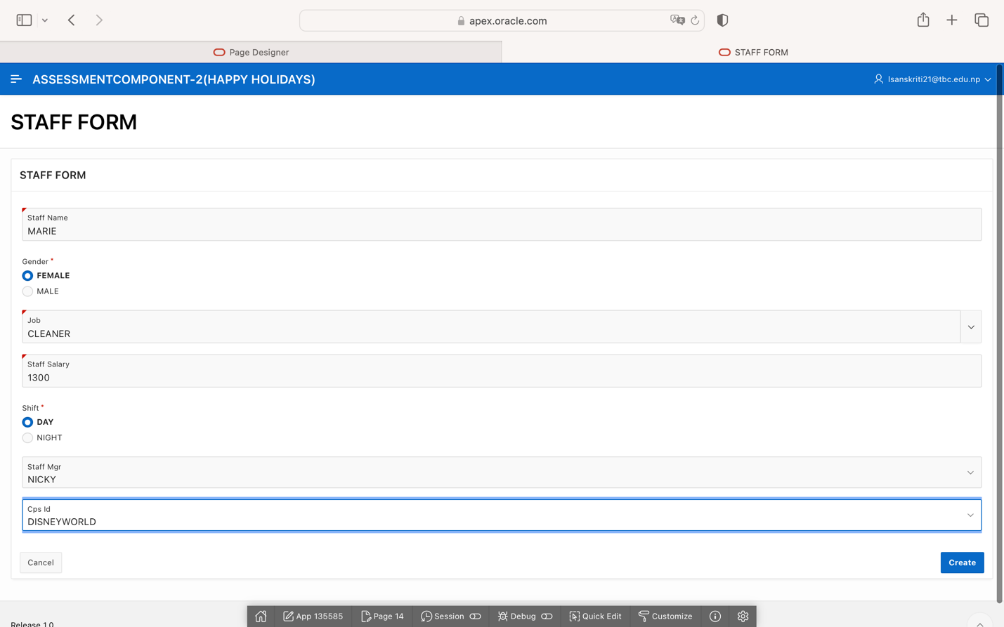

**TRIGGER FIRED DUE TO INVALID INSERTION:**

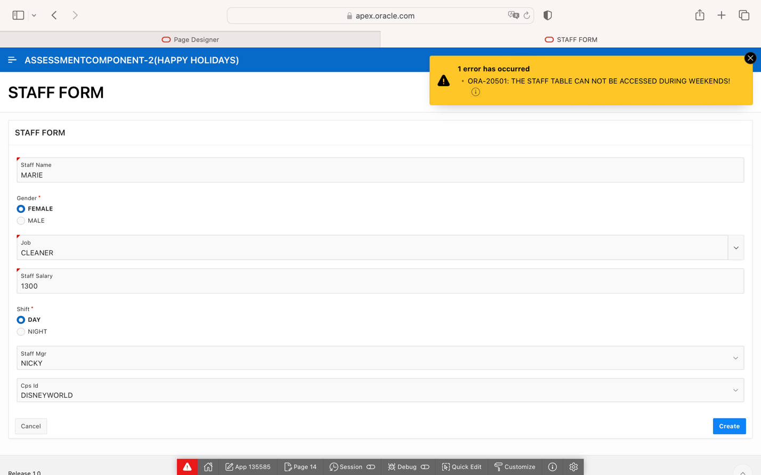

ON WEEKDAYS: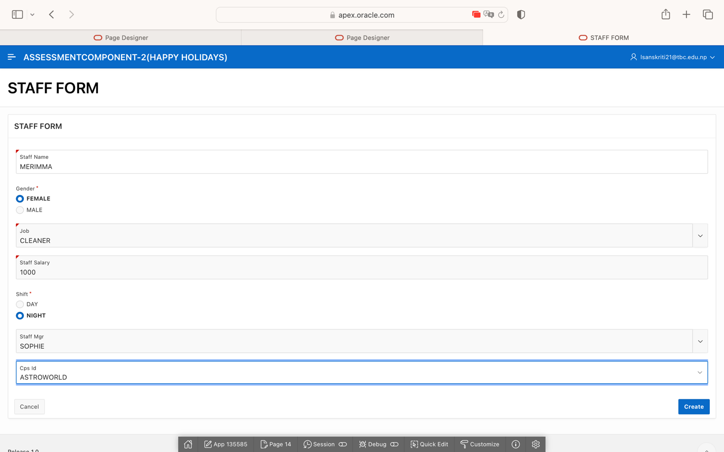

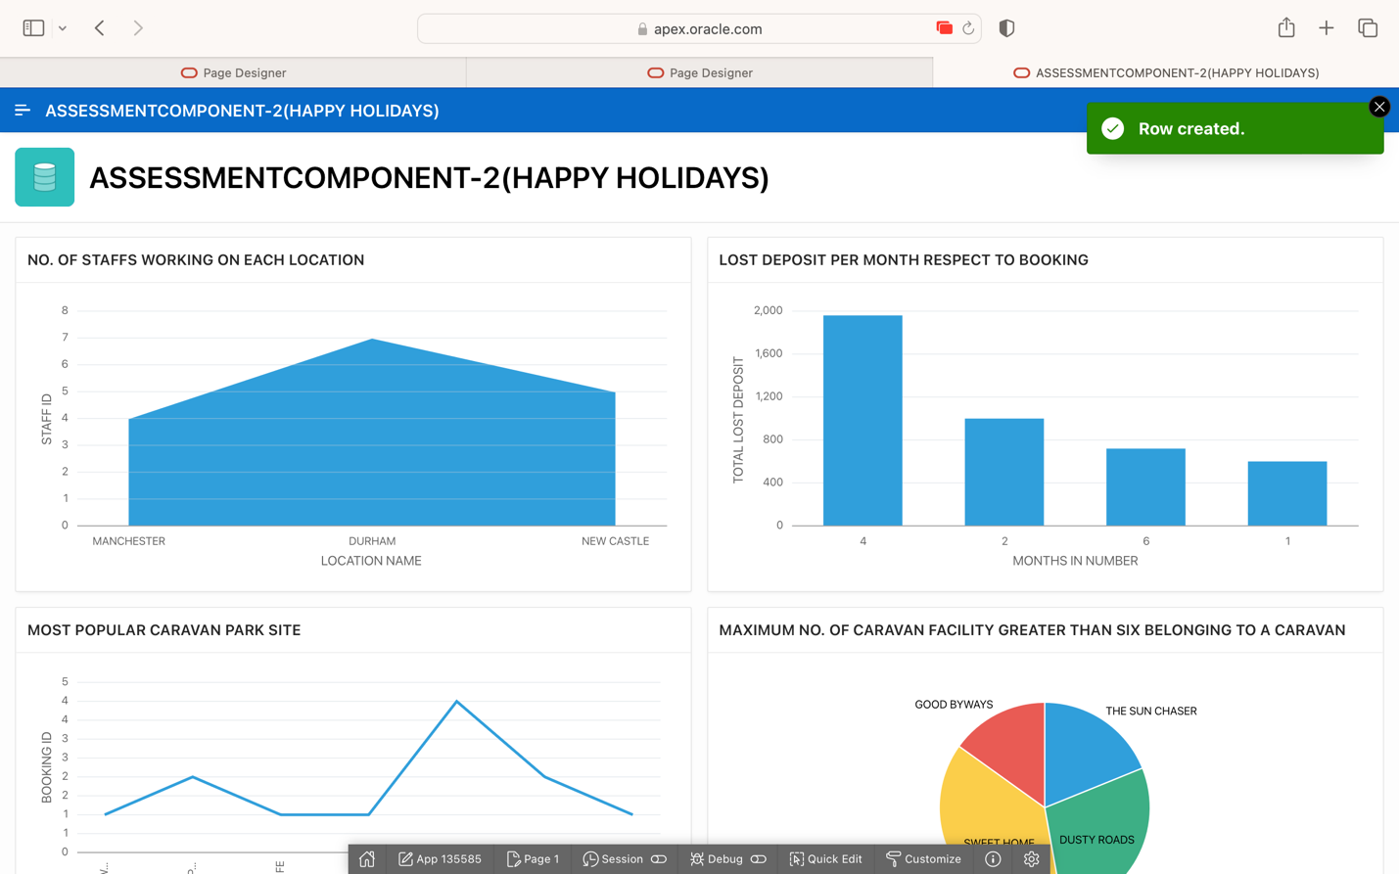

CUSTOMER FORM:

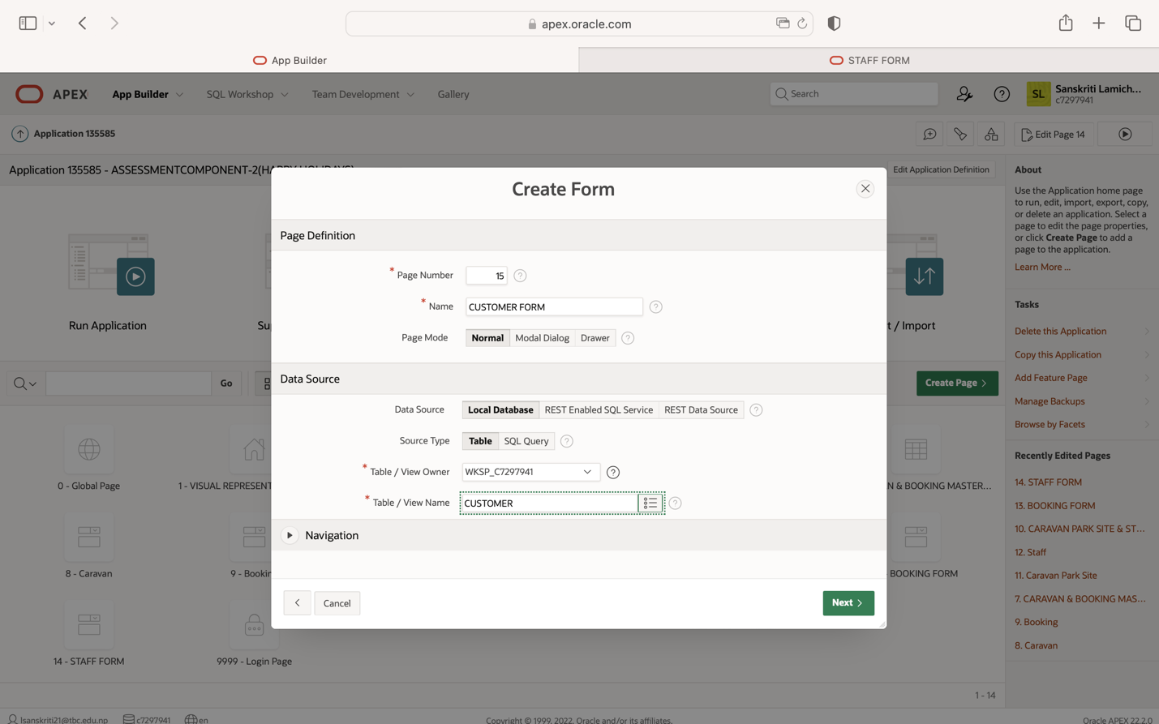

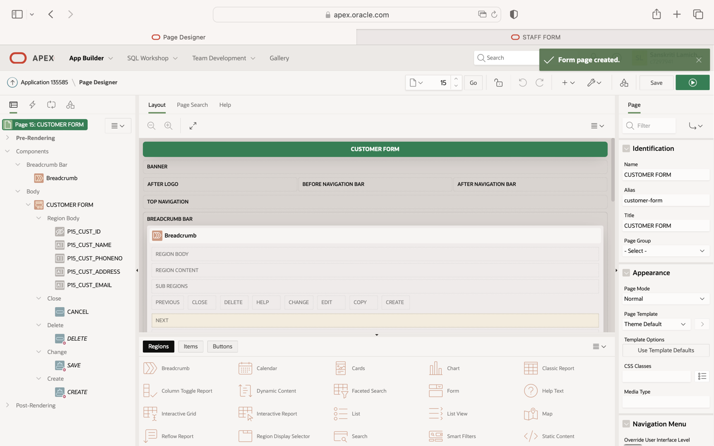

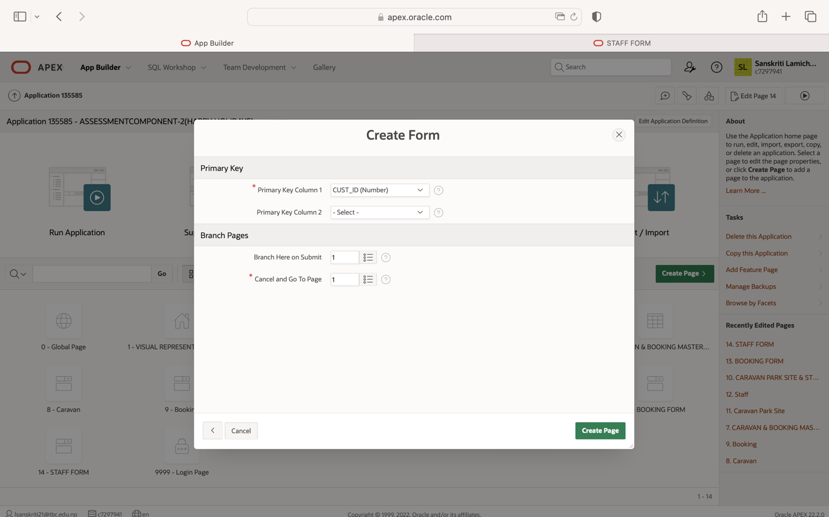

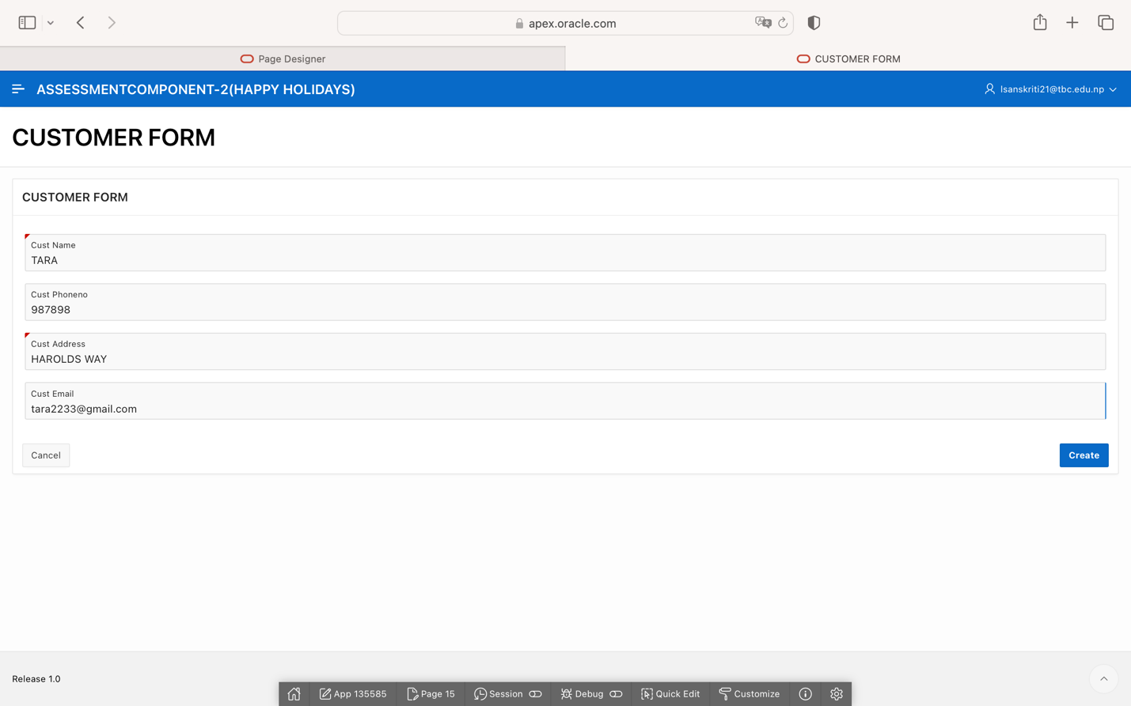

**TRIGGER FIRED DUE TO INVALID INSERTION:**

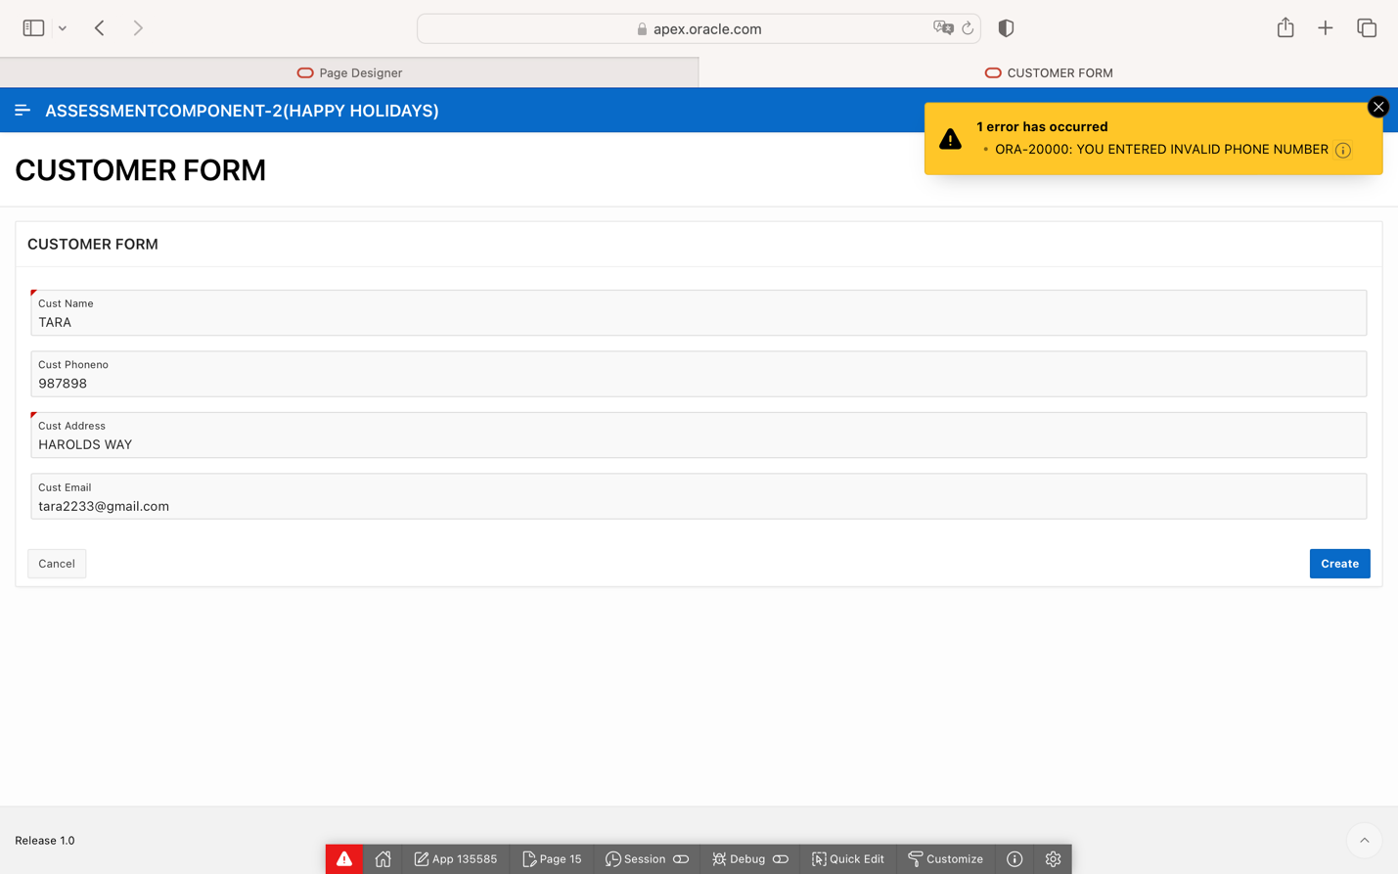

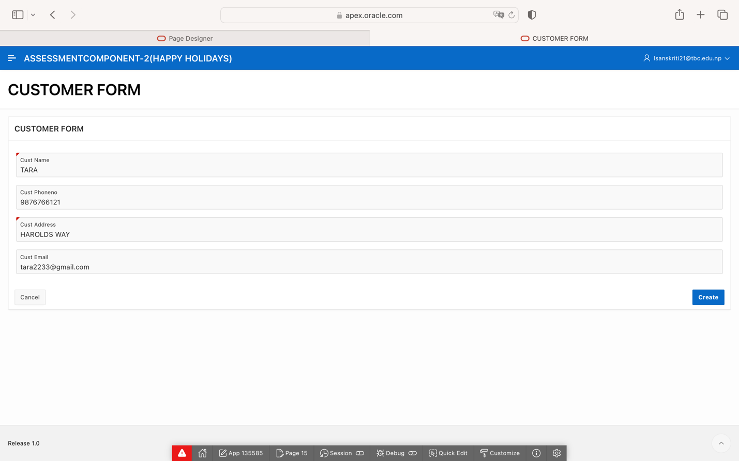

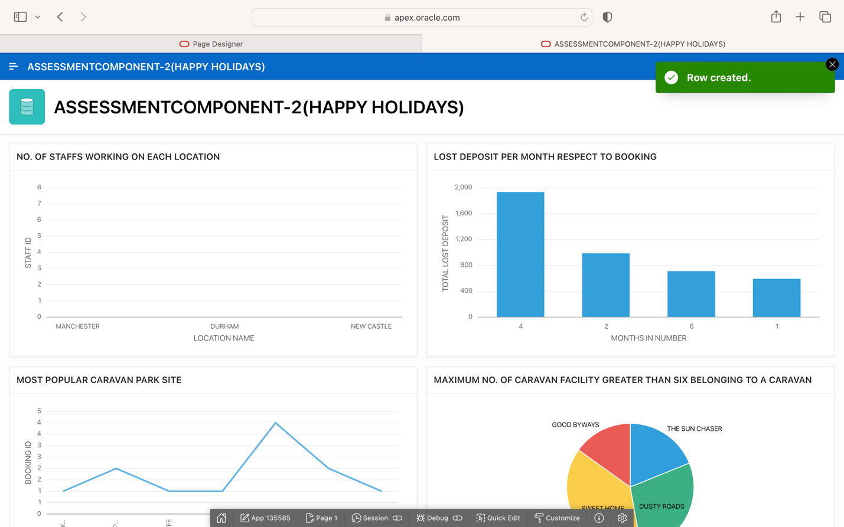

**DASHBOARD**

**VISUAL REPRESENTATION OF DATA IN DASHBOARD**

**CREATING DASHBOARD AND SETTING IT AS A HOME PAGE IN APPLICATION:**

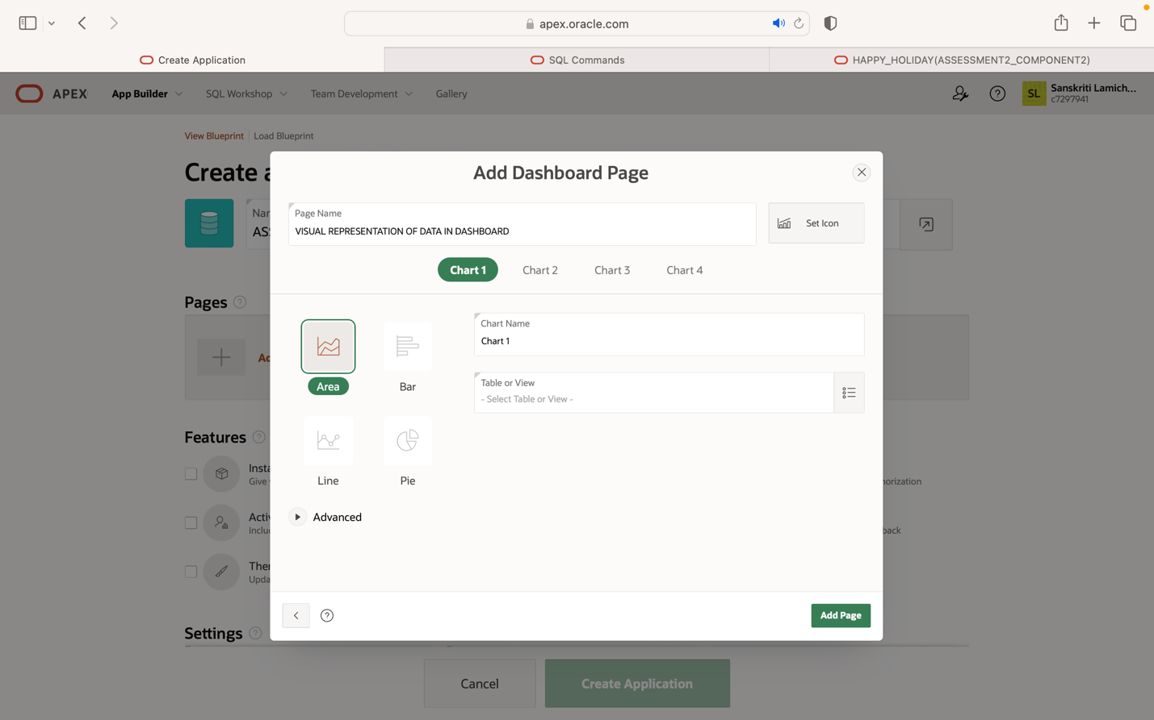

**FOR CHART1:**

* **NO OF STAFFS WORKING ON EACH LOCATION**

**SQL CODE:**

SELECT L.LOCATION_NAME,C.LOCATION_ID,COUNT(STAFF_ID)

FROM STAFF S

JOIN CARAVAN_PARK_SITE C

ON S.CPS_ID=C.CPS_ID

JOIN LOCATION L

ON L.LOCATION_ID=C.LOCATION_ID

GROUP BY L.LOCATION_NAME,C.LOCATION_ID;

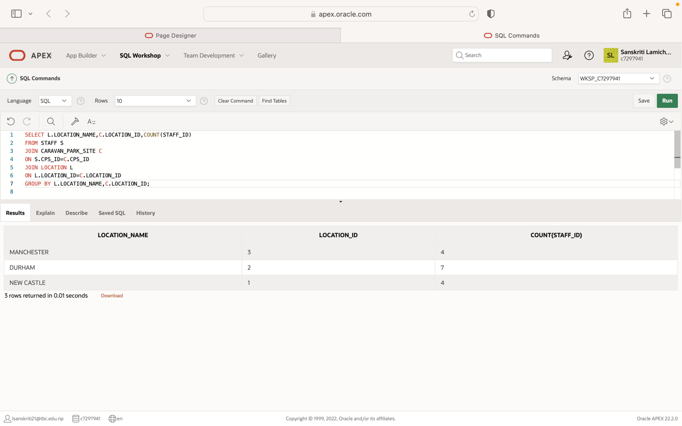

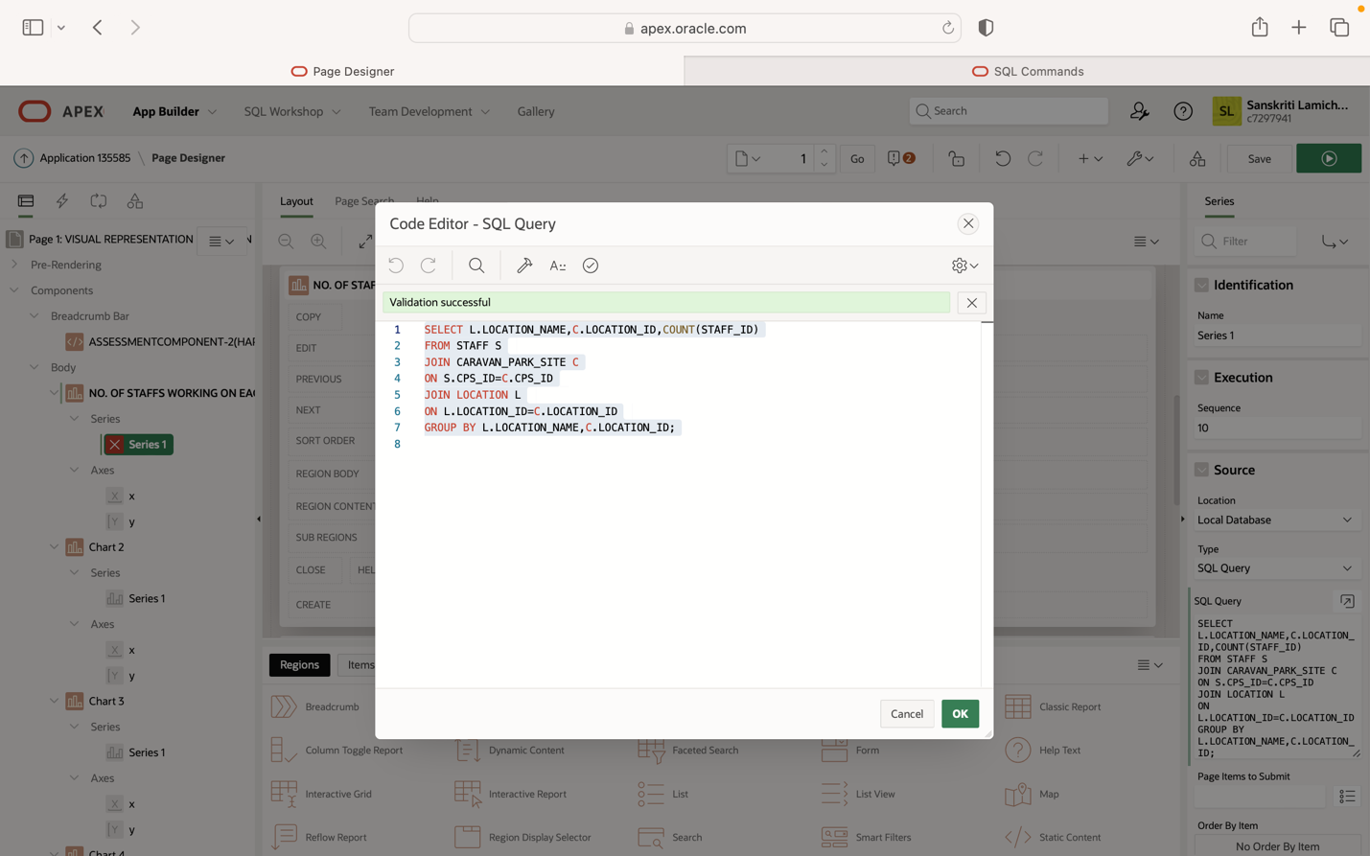

**FOR CHART2:**

* **LOST DEPOSIT PER MONTH RESPECT TO BOOKING**

**SQL CODE**

SELECT EXTRACT(MONTH FROM BOOKING_DATE) AS MONTH,SUM(TOTAL_DEPOSITAMOUNT)

FROM BOOKING

WHERE BOOKING_DATE=DATE_DEPOSIT OR ABS(DATE_DEPOSIT-DATE_ARRIVAL)<4

GROUP BY EXTRACT(MONTH FROM BOOKING_DATE)

ORDER BY SUM(TOTAL_DEPOSITAMOUNT) DESC;

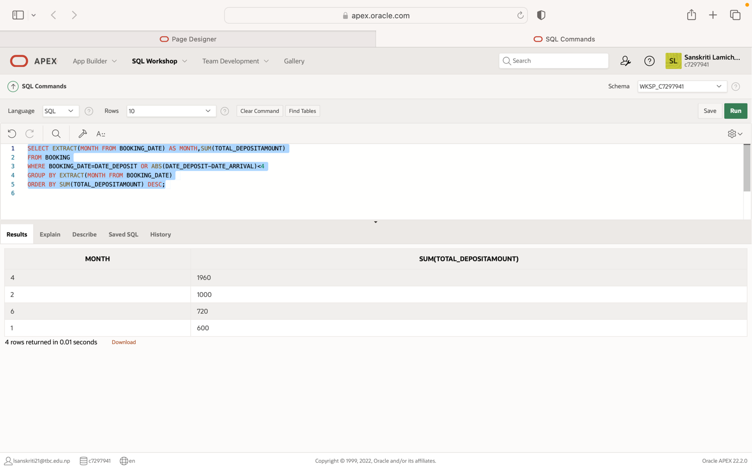

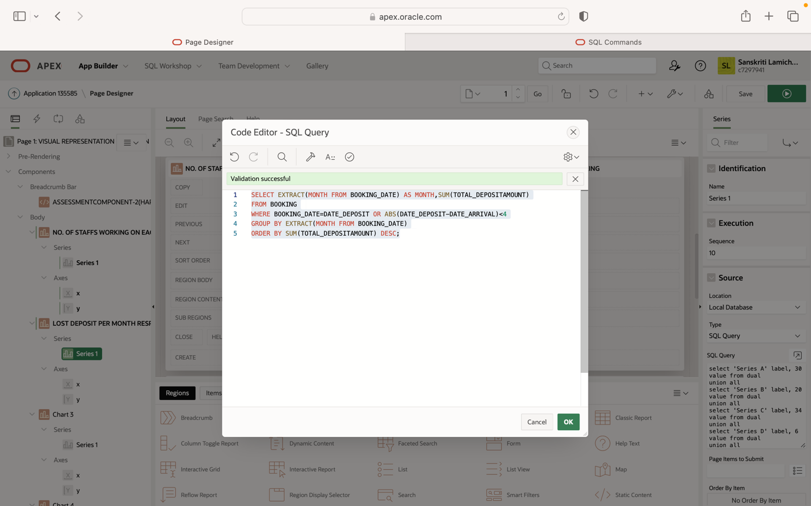

**FOR CHART3:**

* **MOST POPULAR CARAVAN PARK SITE**

**SQL CODE**

SELECT CPS_NAME,COUNT(BOOKING_ID)

FROM CARAVAN_PARK_SITE cps

JOIN CARAVAN c

ON cps.CPS_ID=c.CPS_ID

JOIN BOOKING b

ON b.C_ID=c.C_ID

GROUP BY CPS_NAME;

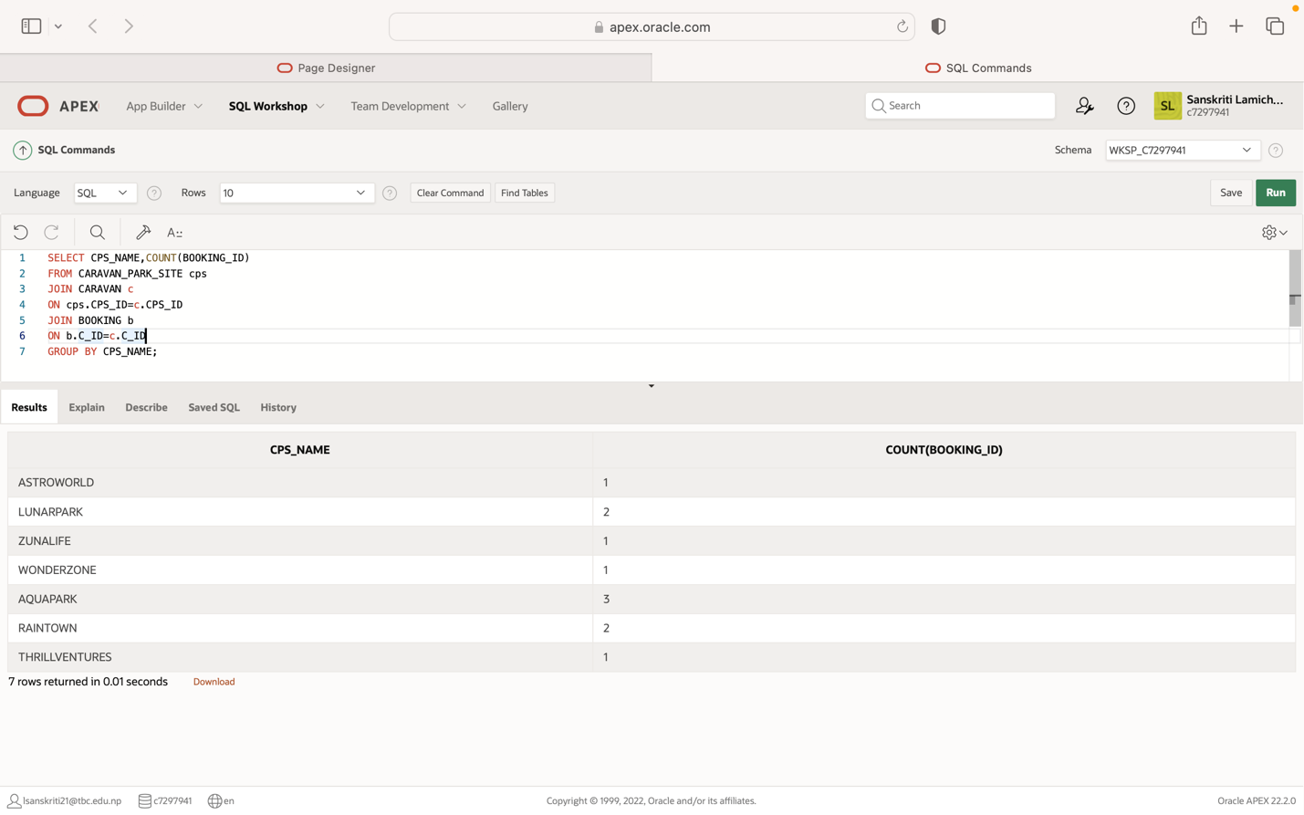

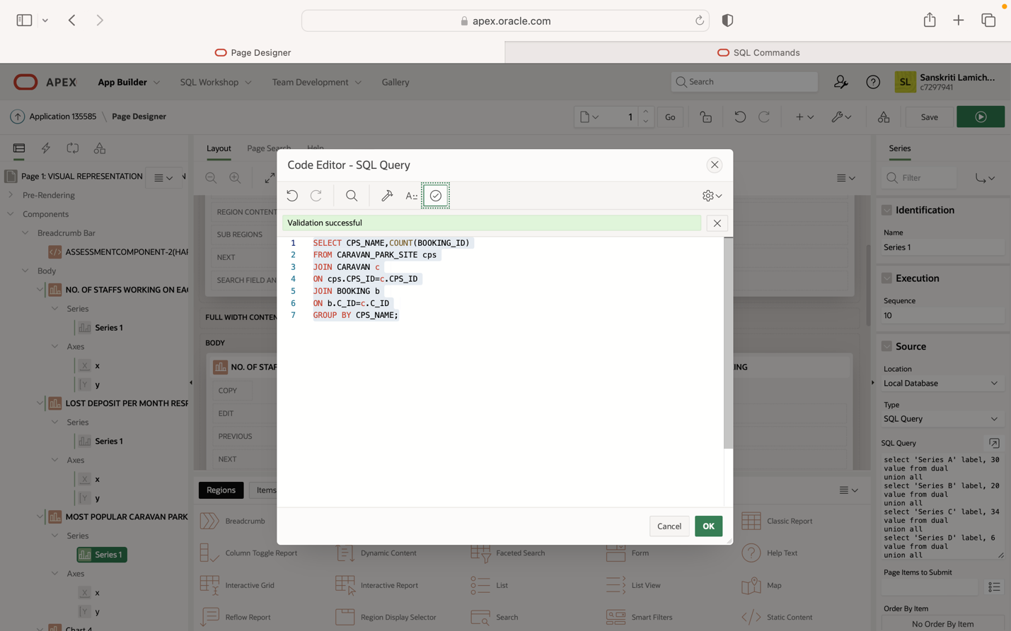

**FOR CHART4:**

* **MAXIMUM NO. OF CARAVAN FACILITY GREATER THAN SIX BELONGING TO A CARAVAN**

**SQL CODE:**

SELECT MAX(NO_OF_CFACILITY),C.C_NAME,C.C_ID,CF.CFACILITY_NAME

FROM C_FACILITY CF

JOIN CARAVAN C

ON C.C_ID = CF.C_ID

GROUP BY C.C_NAME,C.C_ID,CF.CFACILITY_NAME

HAVING MAX(NO_OF_CFACILITY)>6;

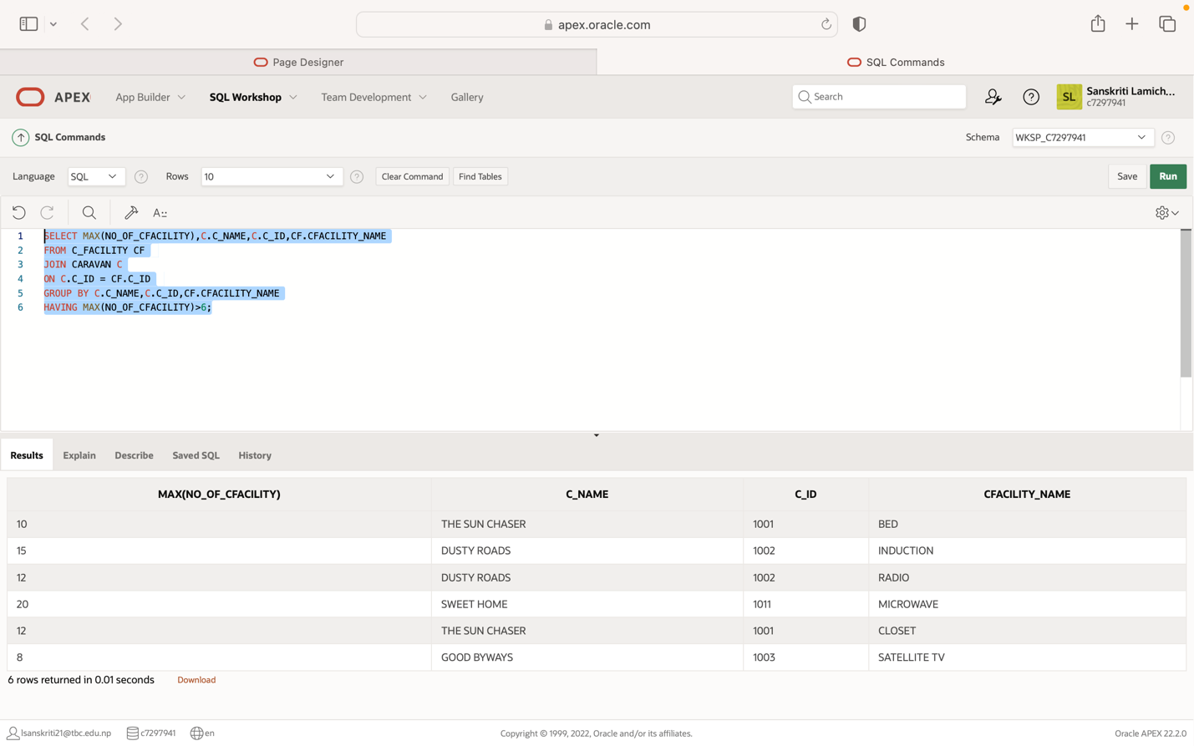

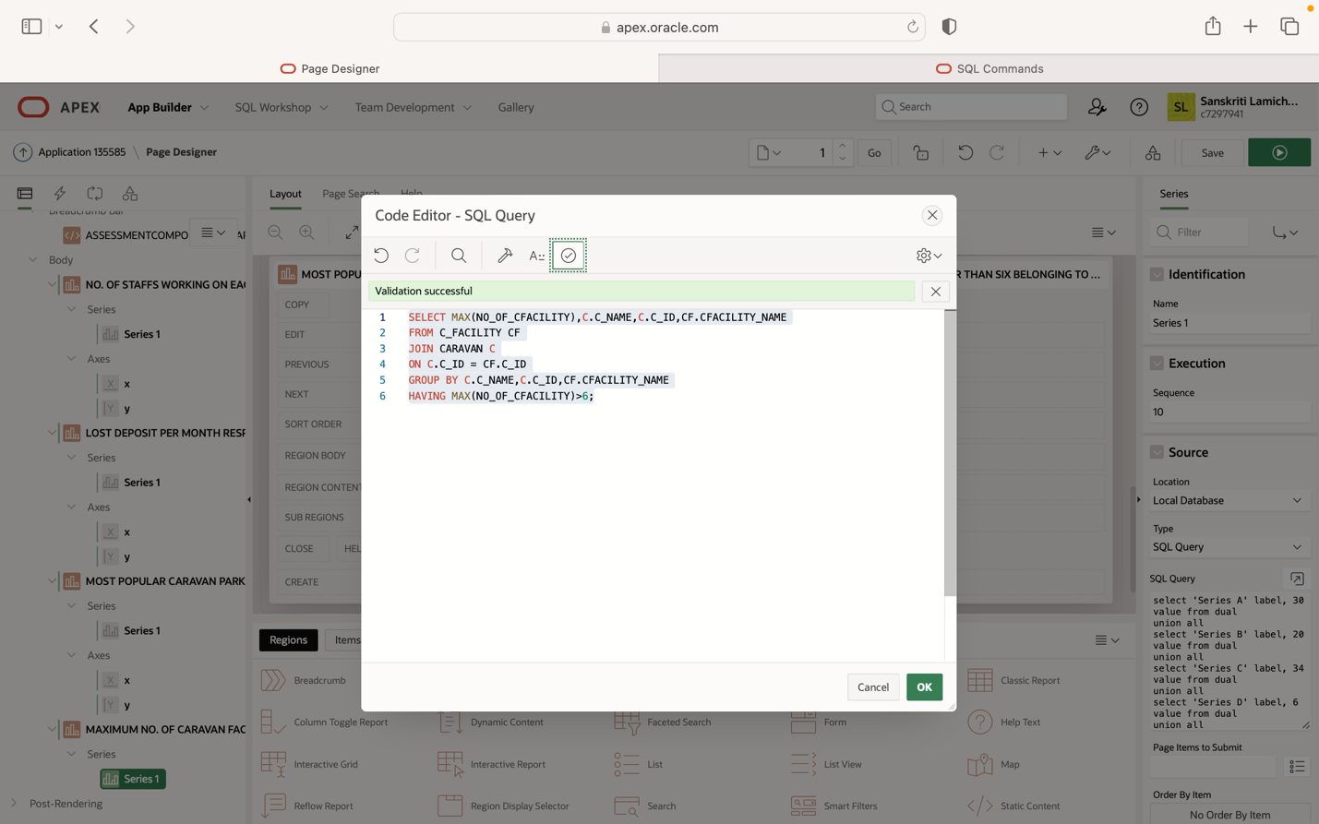

**AFTER CREATION OF DASHBOARD:**

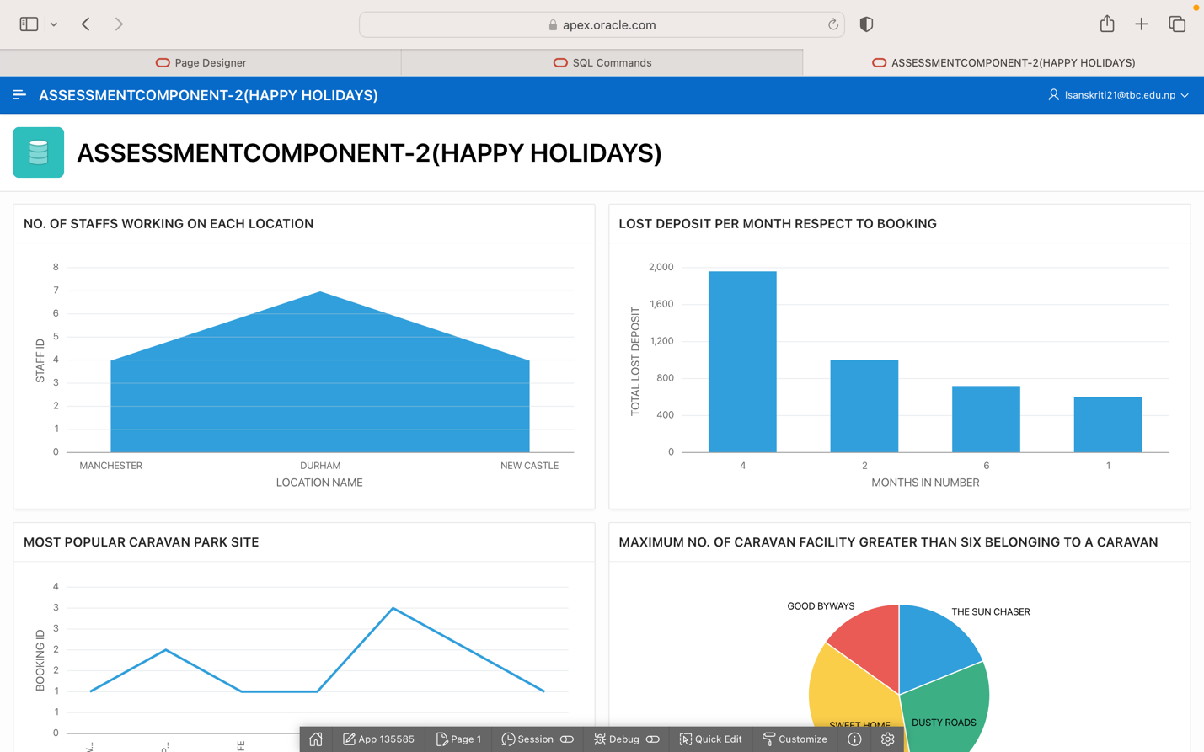

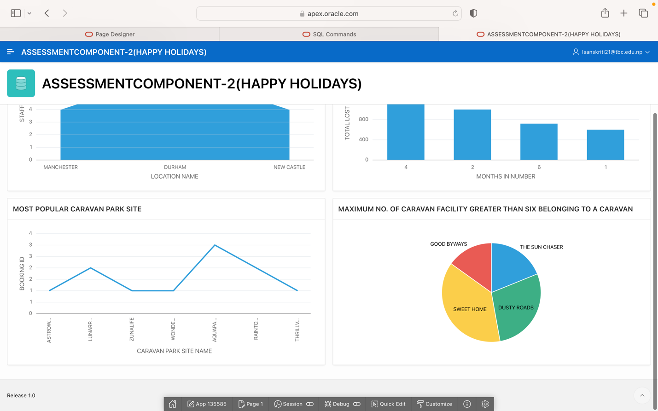

**(EXPLORING ORACLE APEX APPLICATION FEATURES)**

**CARDS**

1. FOR DETAILS EACH EMPLOYEE WORKING ON EACH LOCATIONS

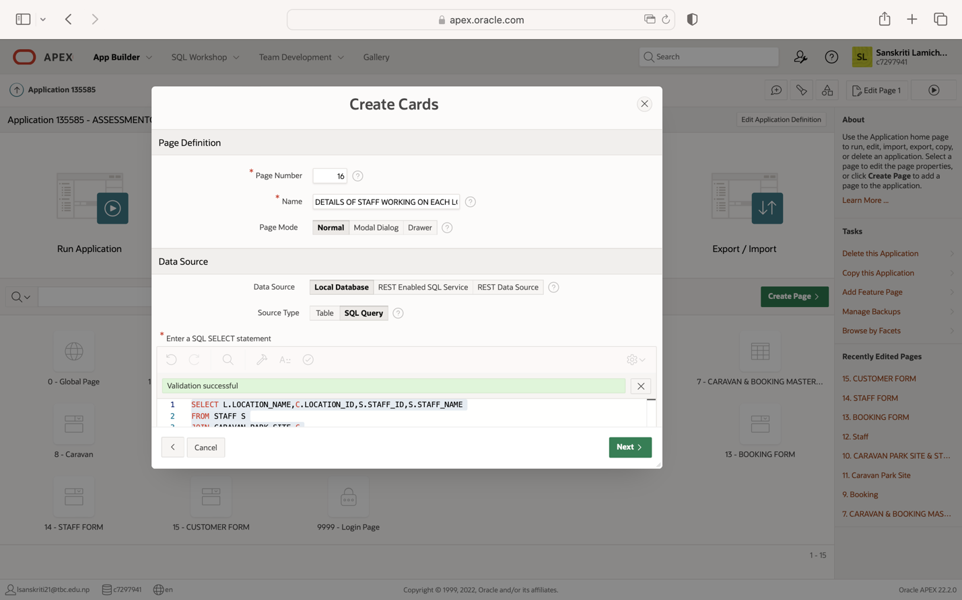

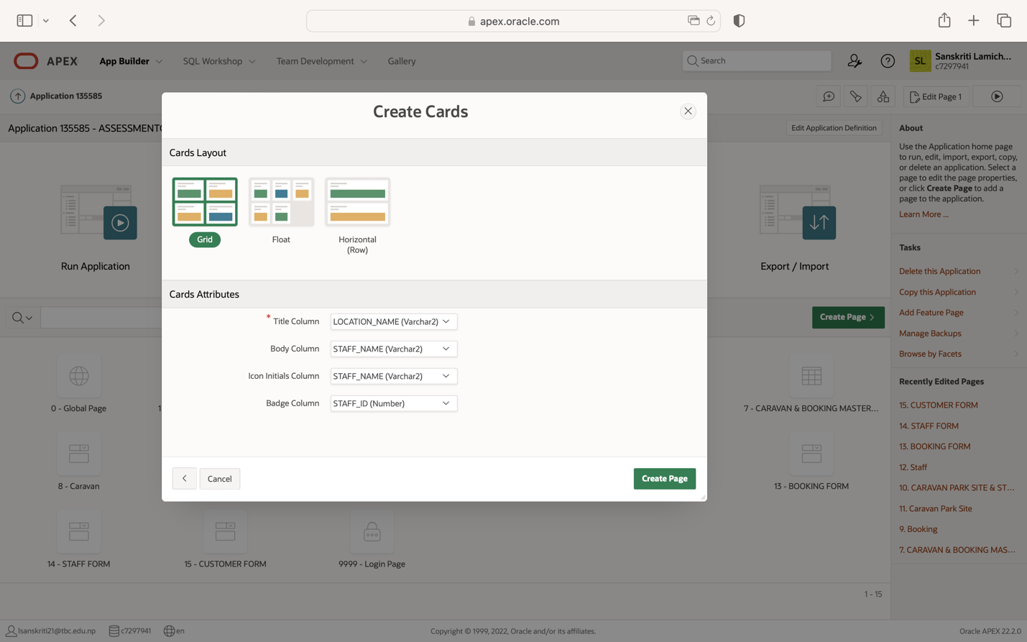

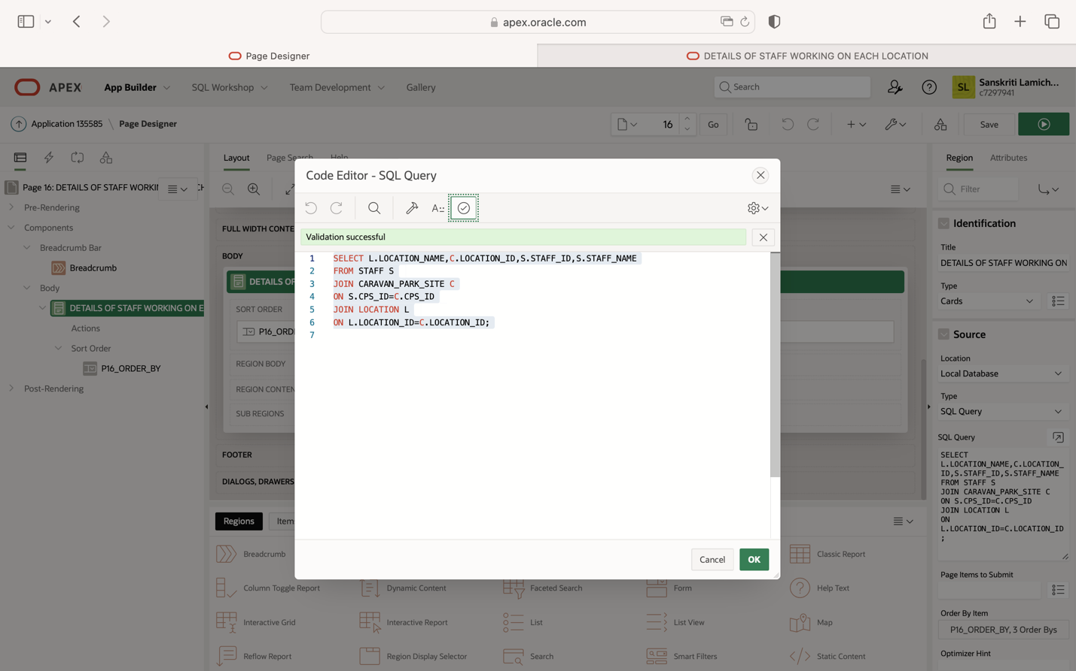

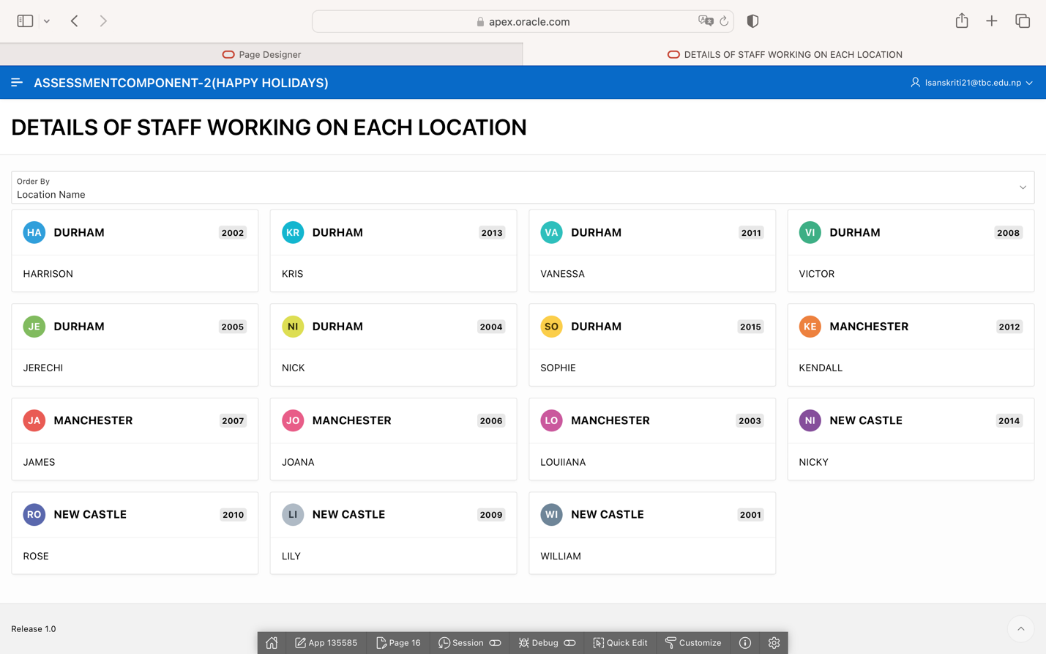

1. LOWEST RENTAL TARIFF FOR EACH CARAVAN

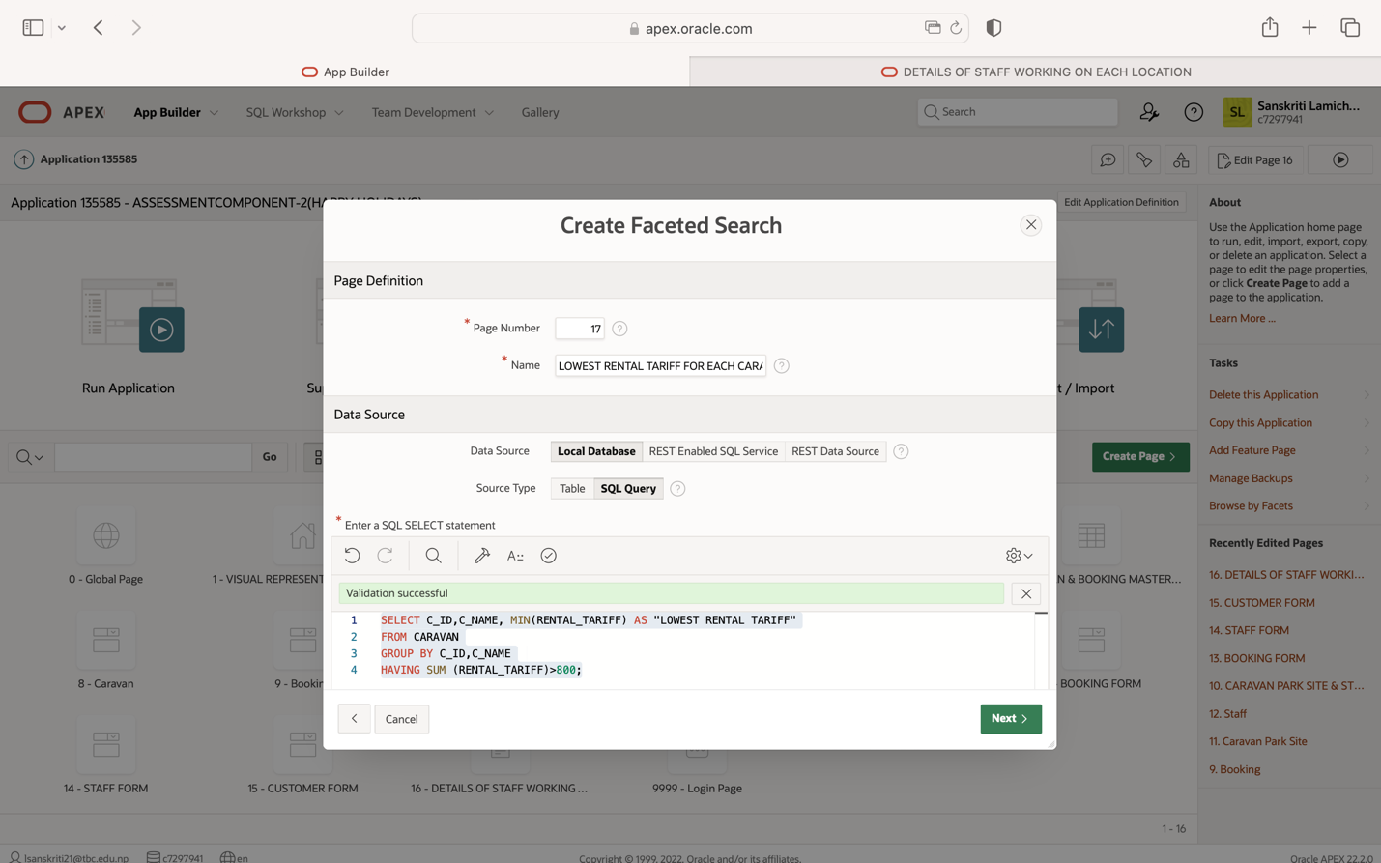

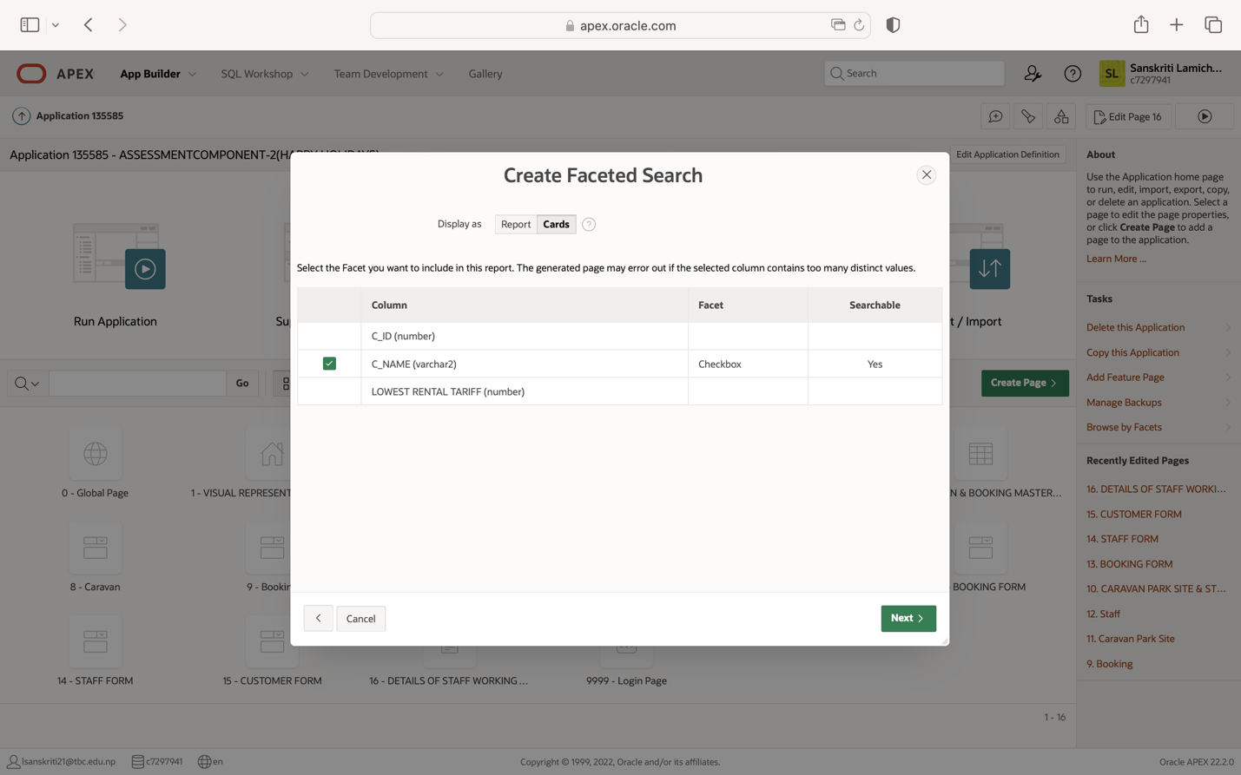

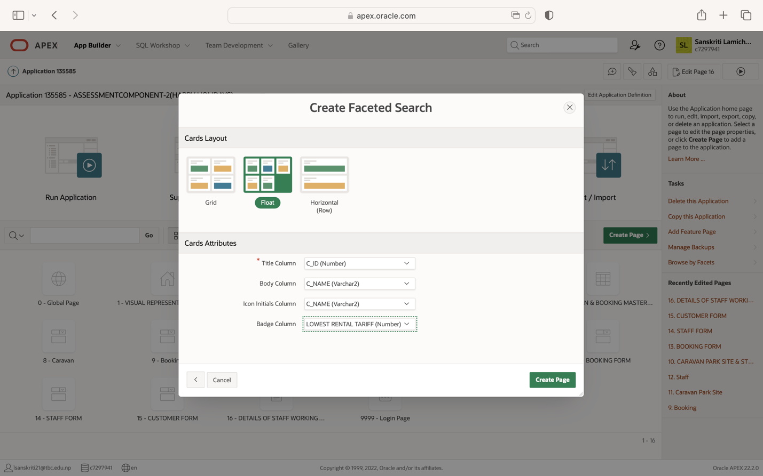

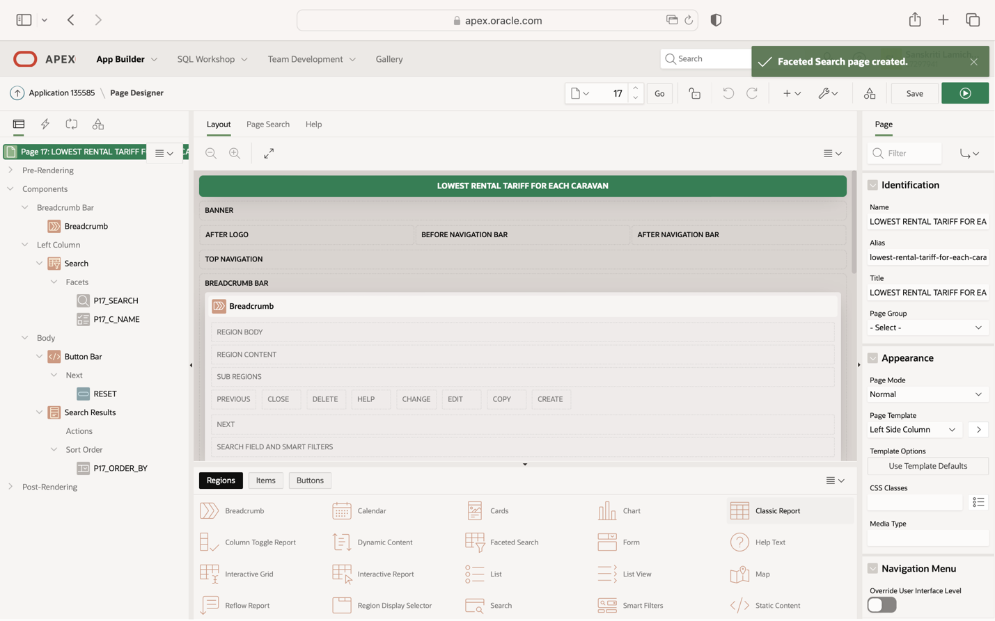

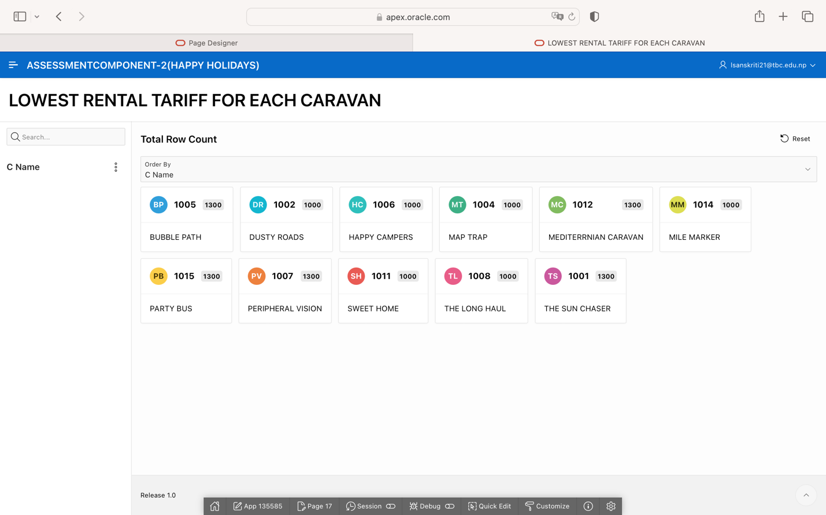

**CALENDAR**

CARAVAN BOOKED ON PARTICULAR DATES

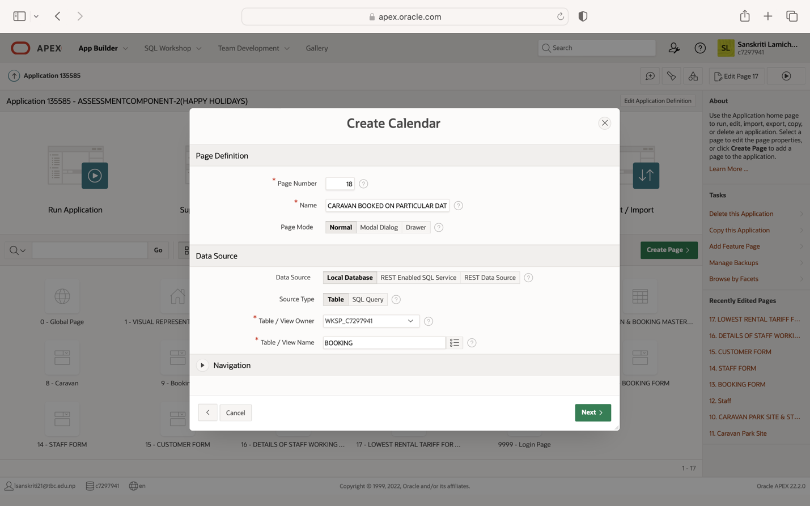

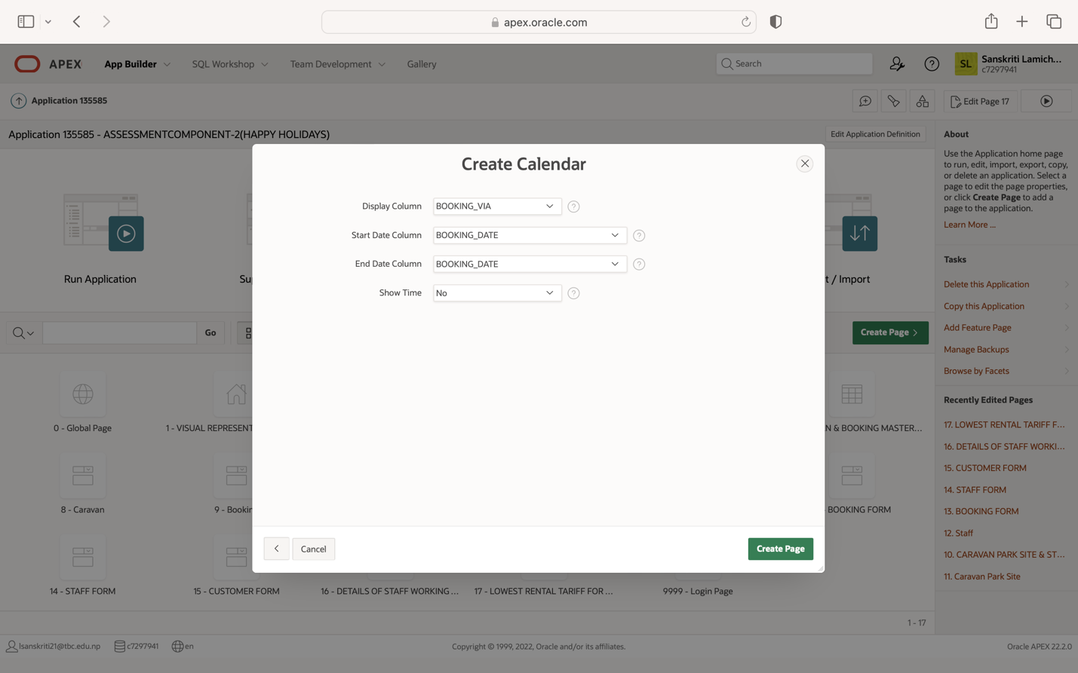

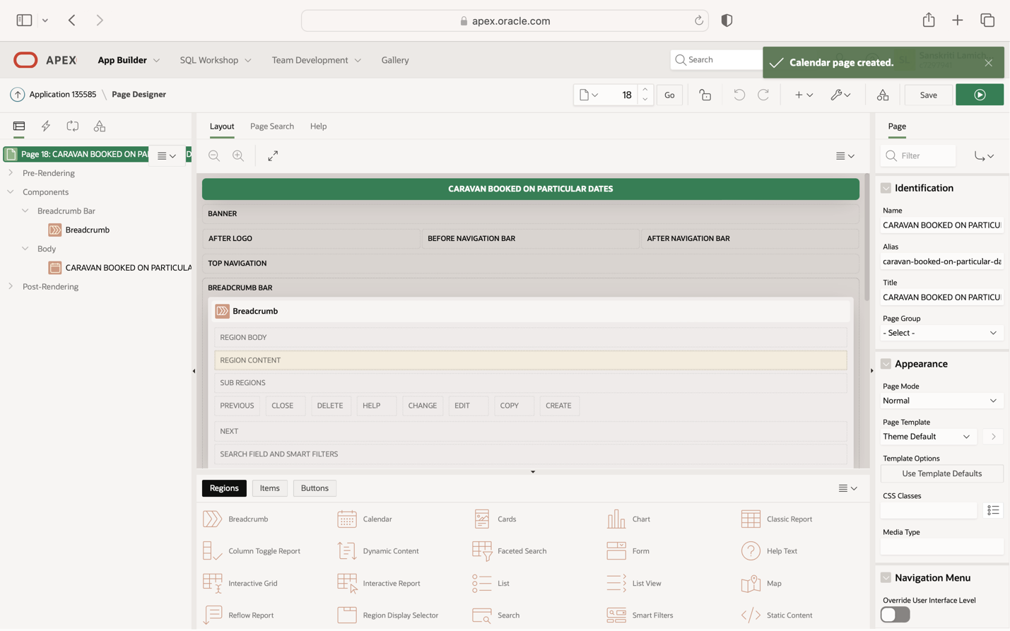

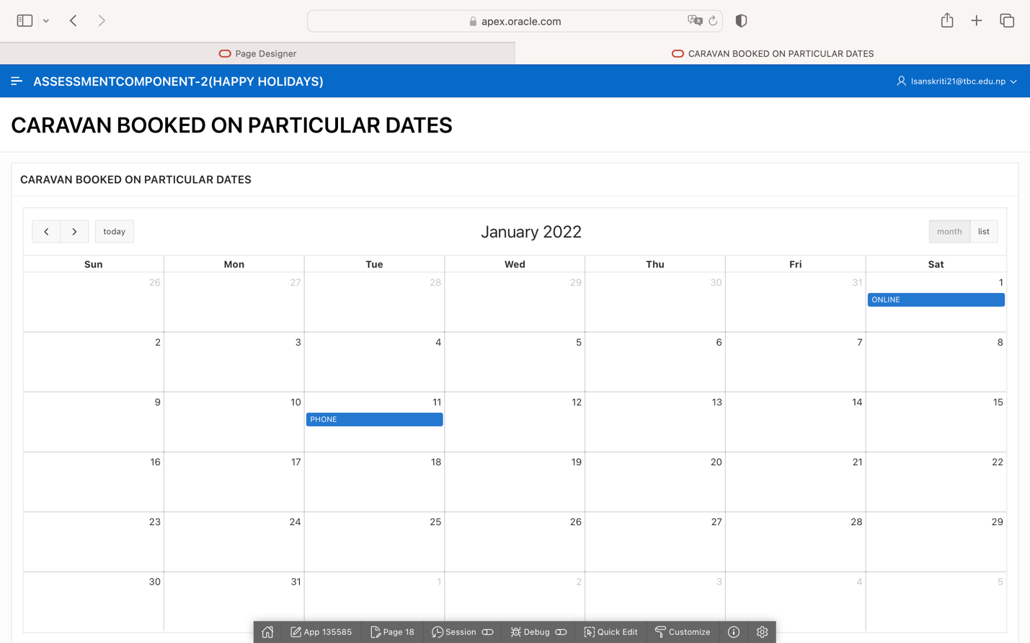

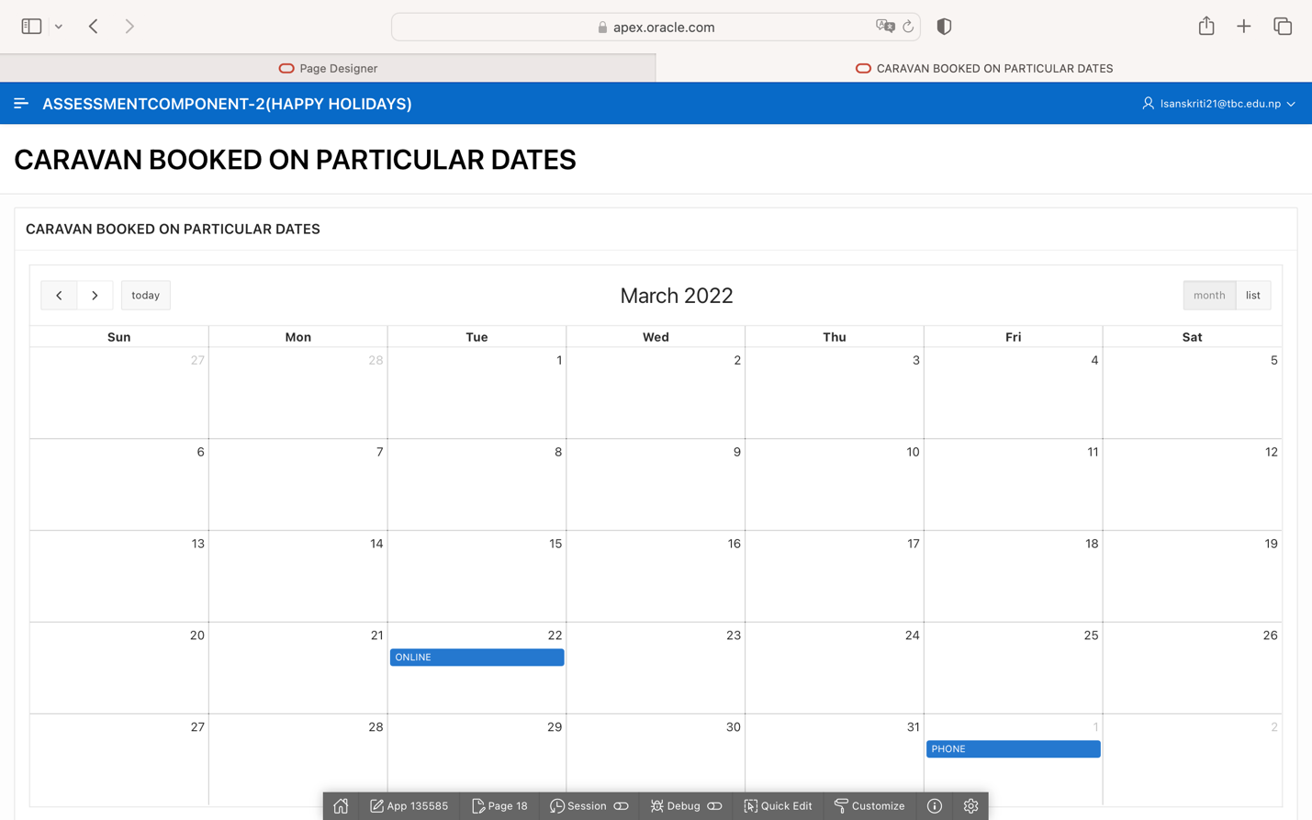

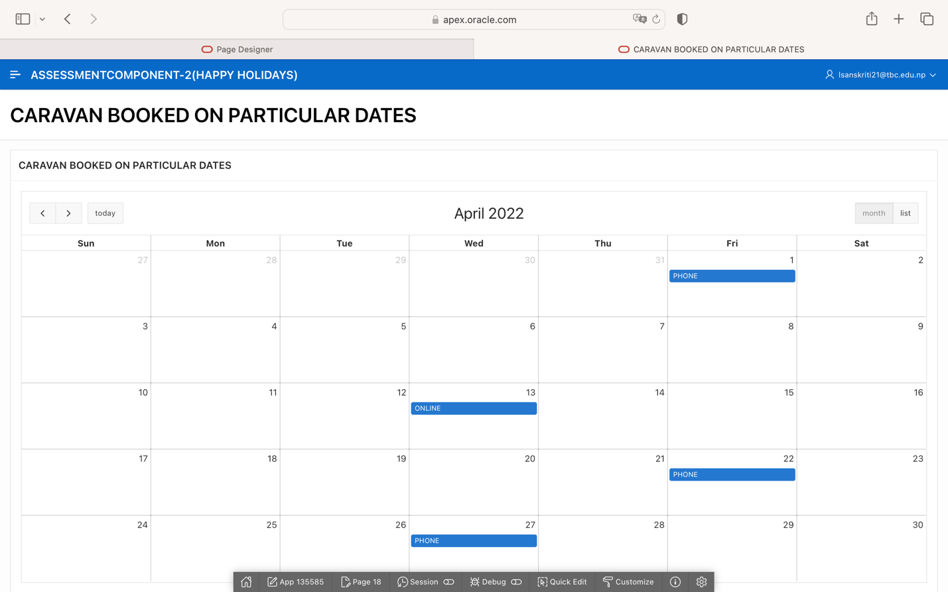

**TABLE AUDITING (FOR CUSTOMER, STAFF, OWNER)**

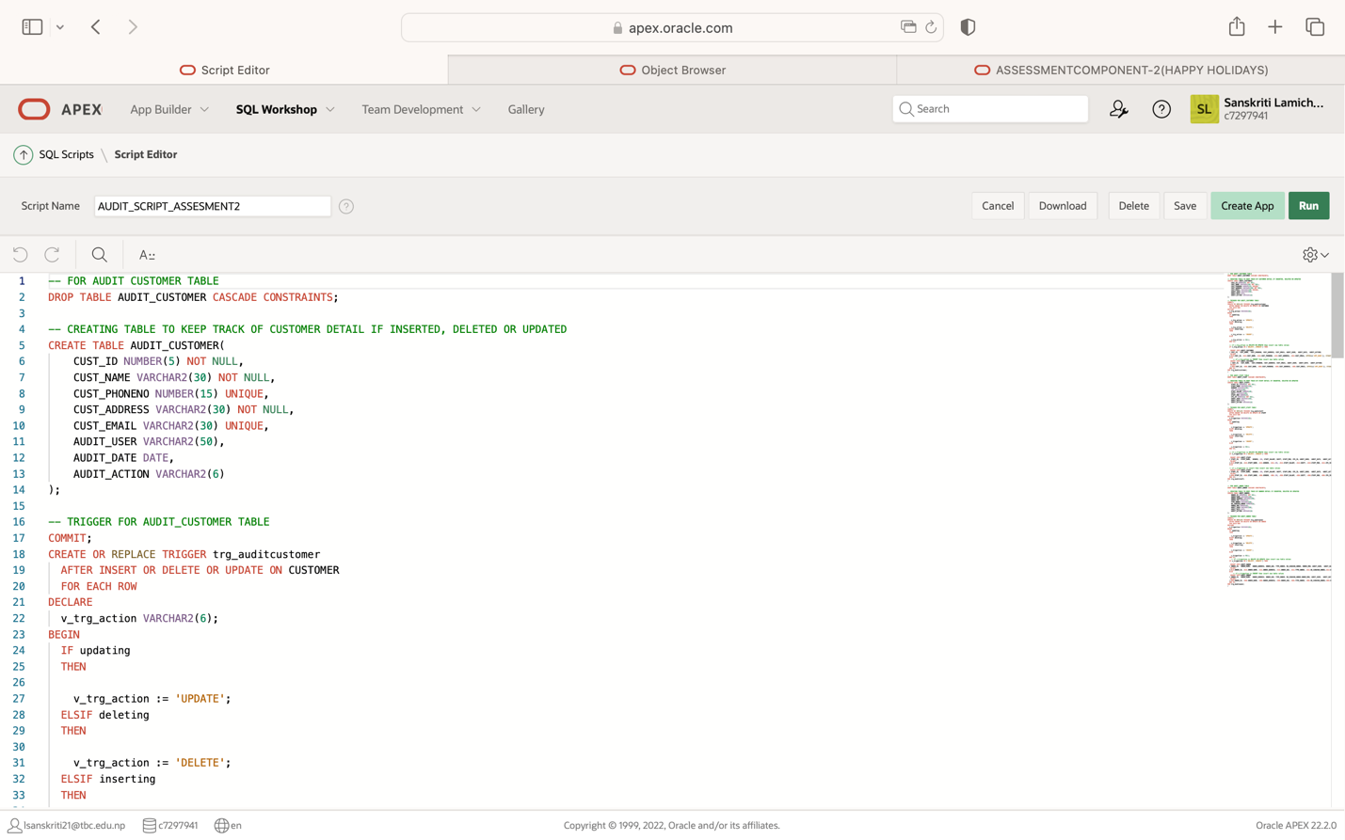

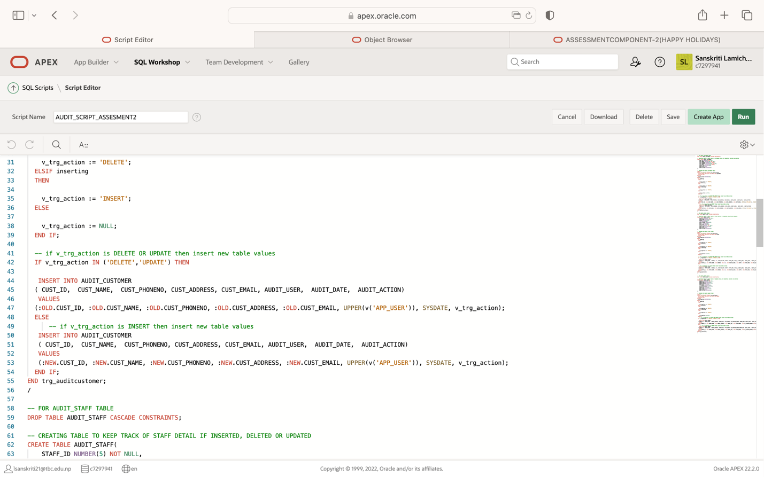

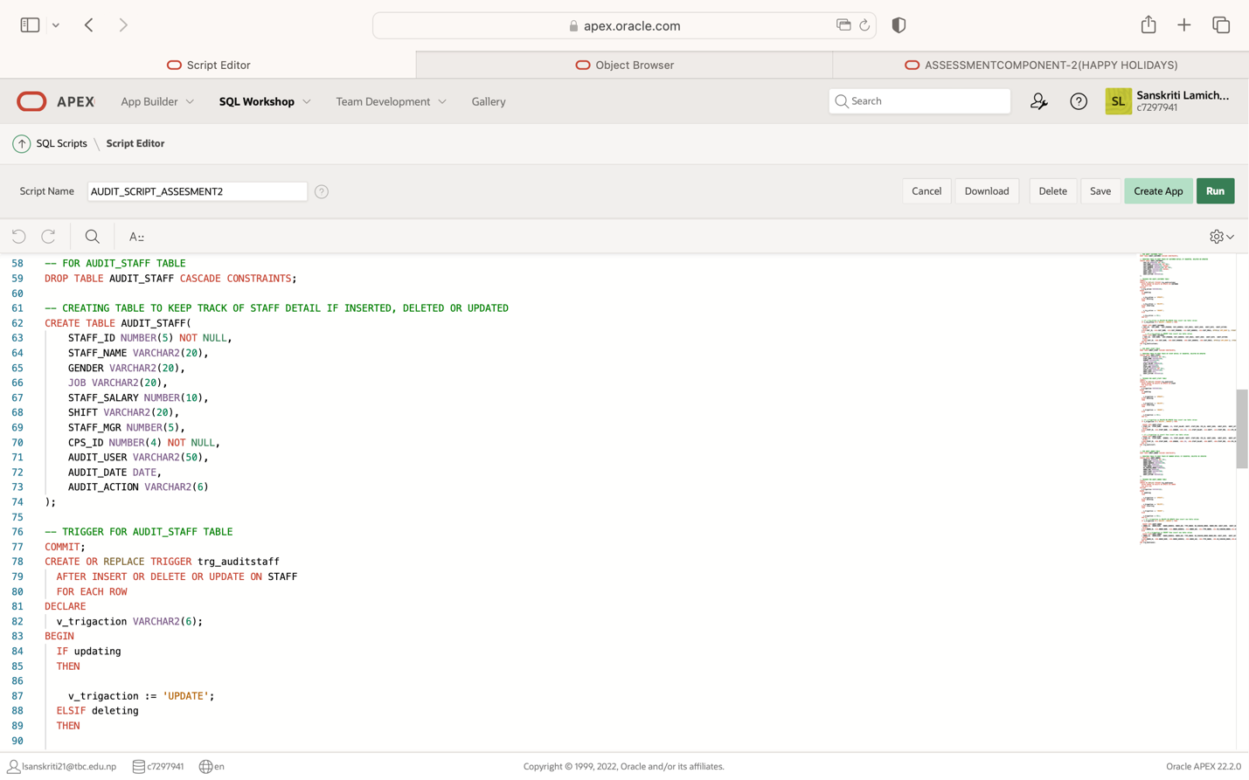

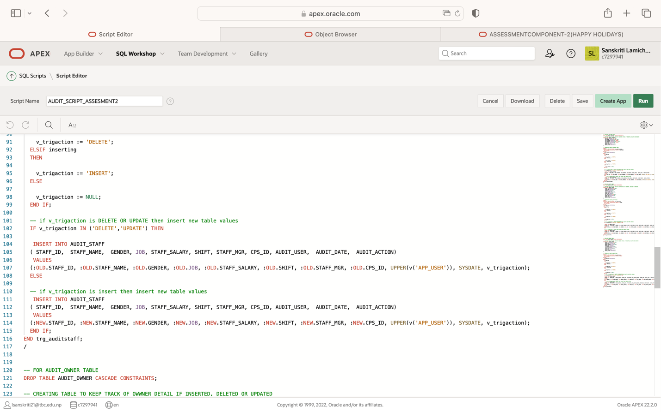

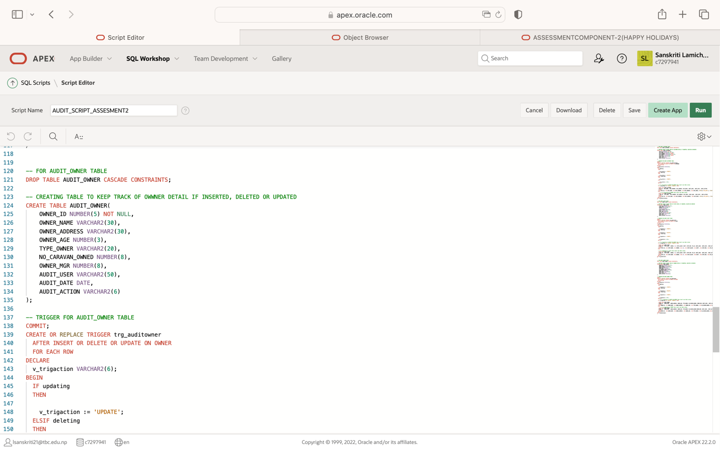

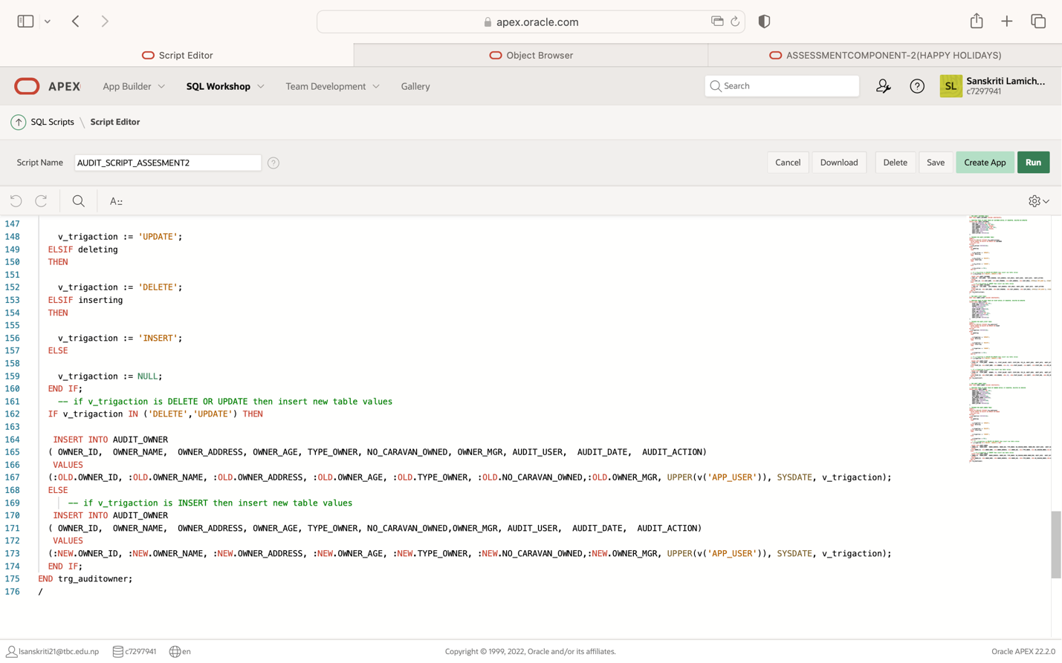

**CHECKING ERRORS IN AUDITING TRIGGERS:**

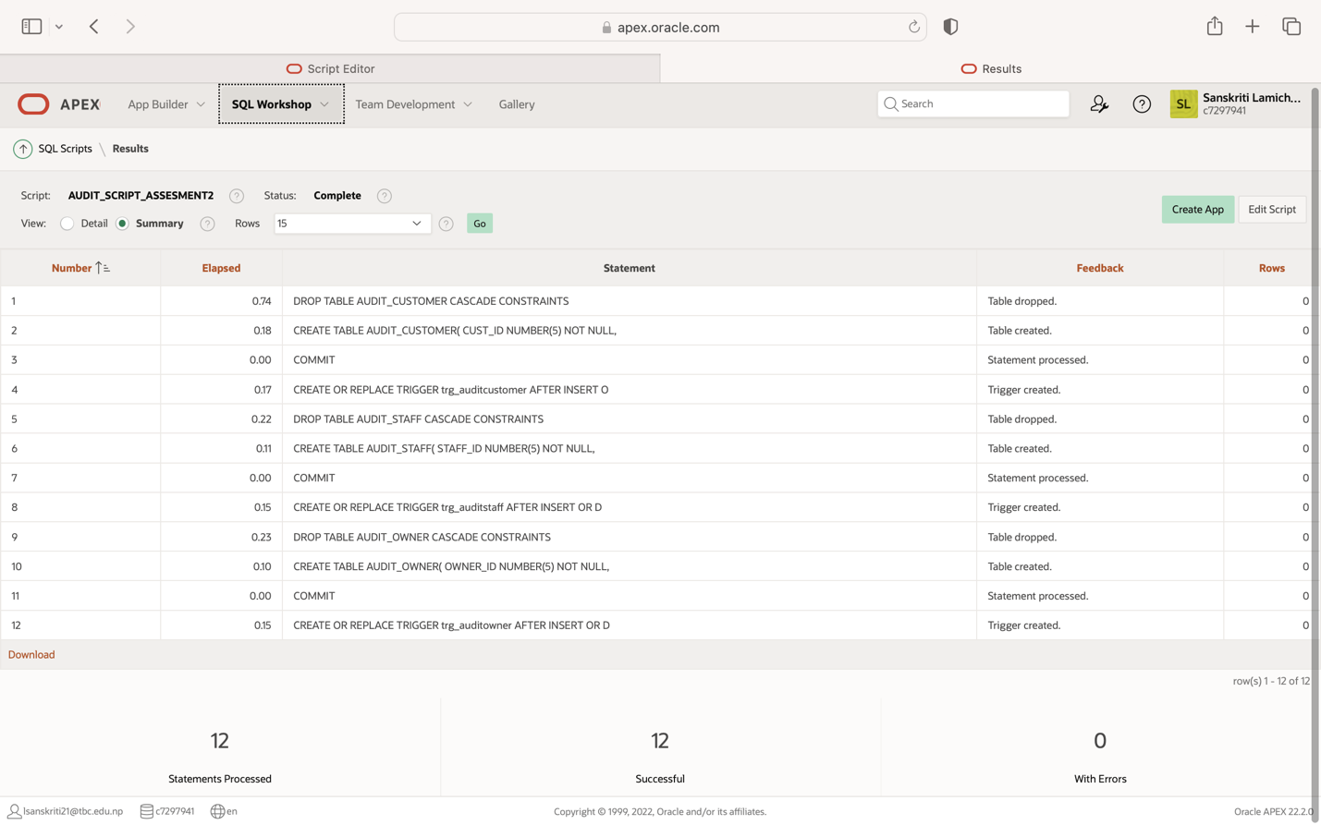

**AUDIT_CUSTOMER TABLE TO KEEP TRACK OF DELETED, UPDATED AND INSERTED ROW OF DATAS:**

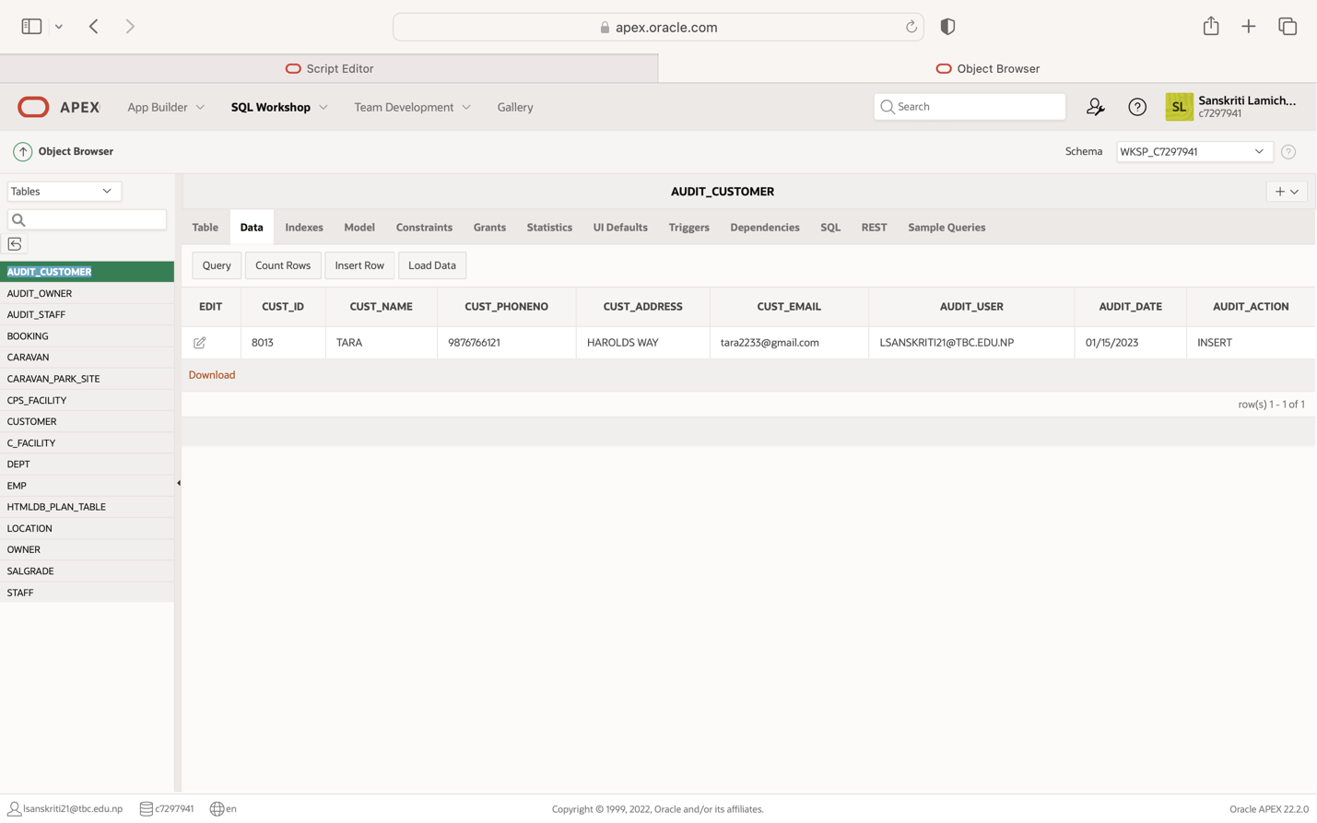

**AUDIT_OWNER TABLE TO KEEP TRACK OF DELETED, UPDATED AND INSERTED ROW OF DATAS:**

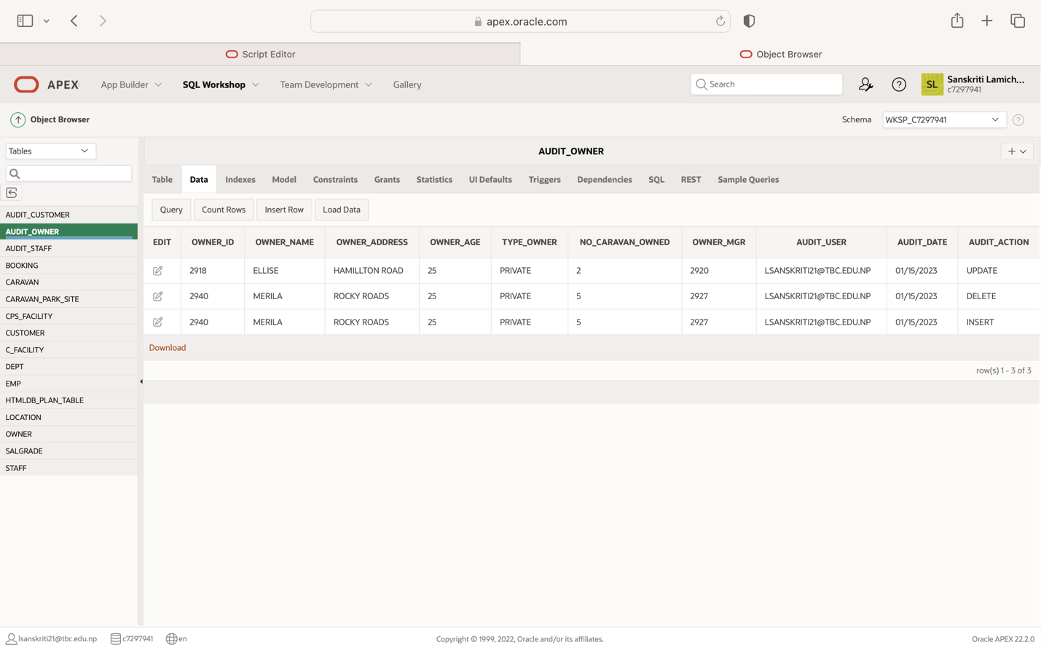

**AUDIT_STAFF TABLE TO KEEP TRACK OF DELETED, UPDATED AND INSERTED ROW OF DATAS:**

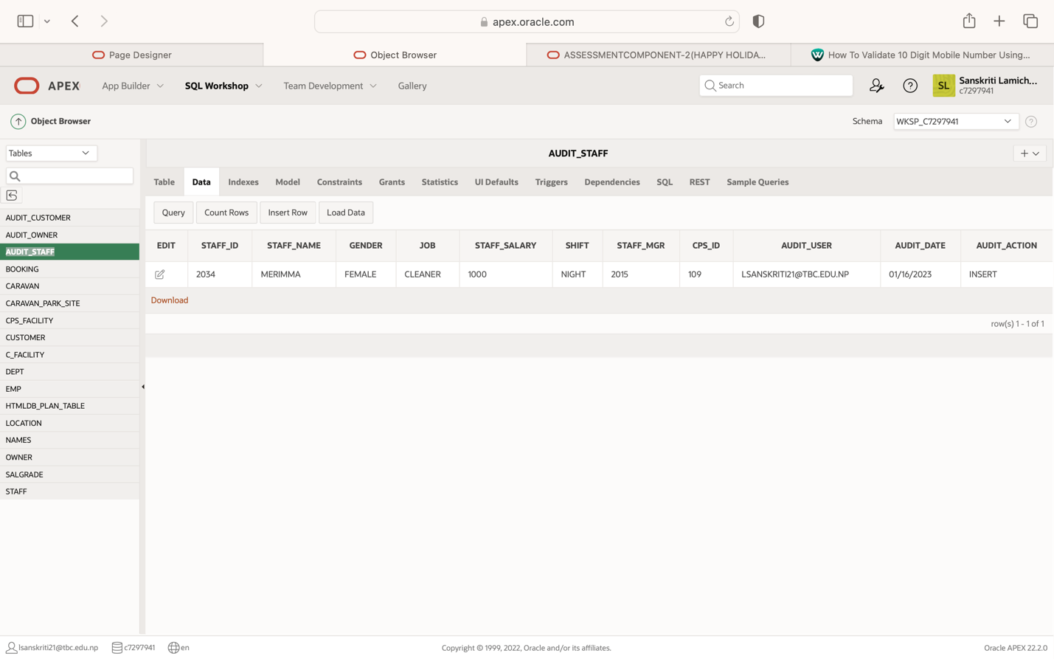

**JAVASCRIPT TO PERFORM DYNAMIC ACTION AND EMAIL VALIDATION OF CUSTOMER:**

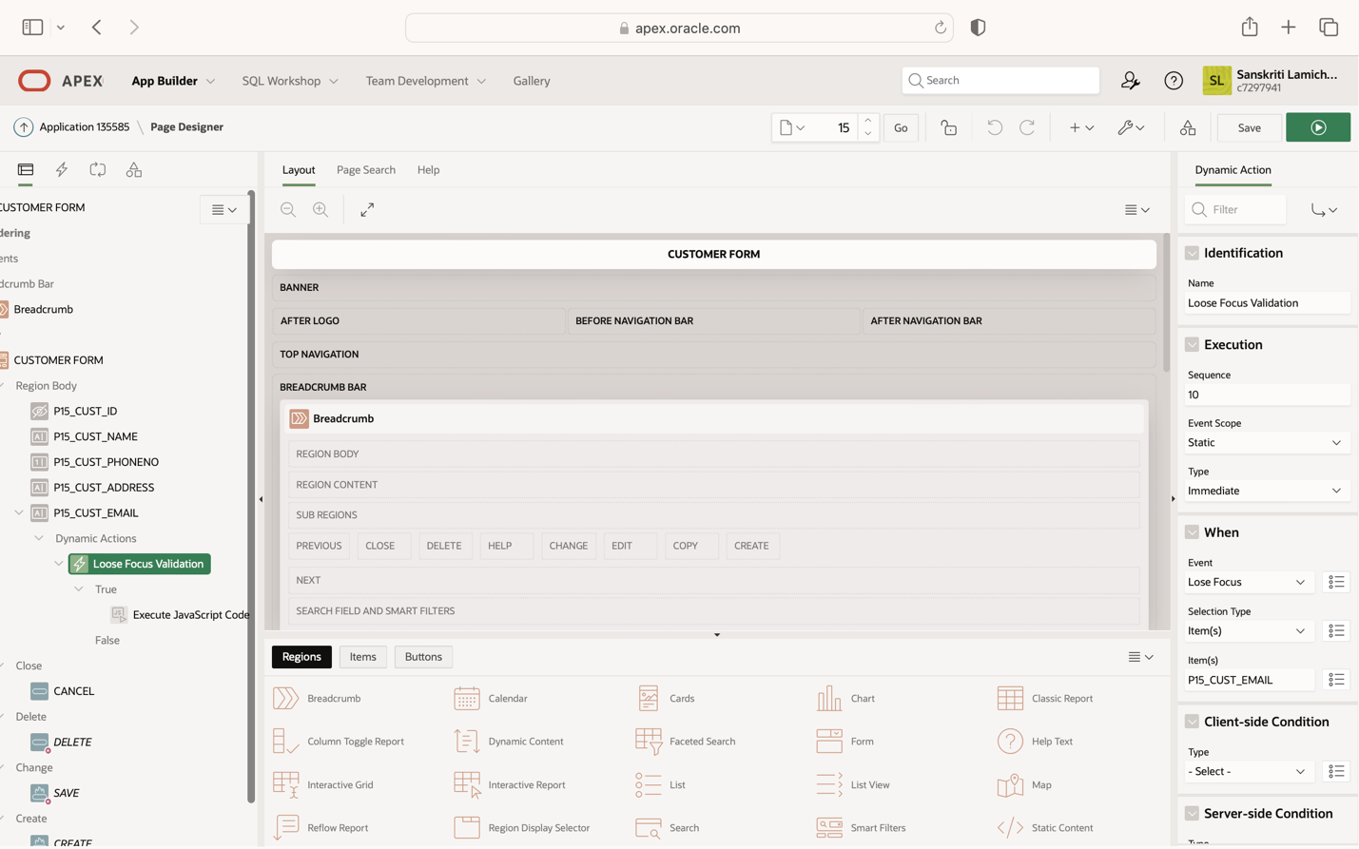

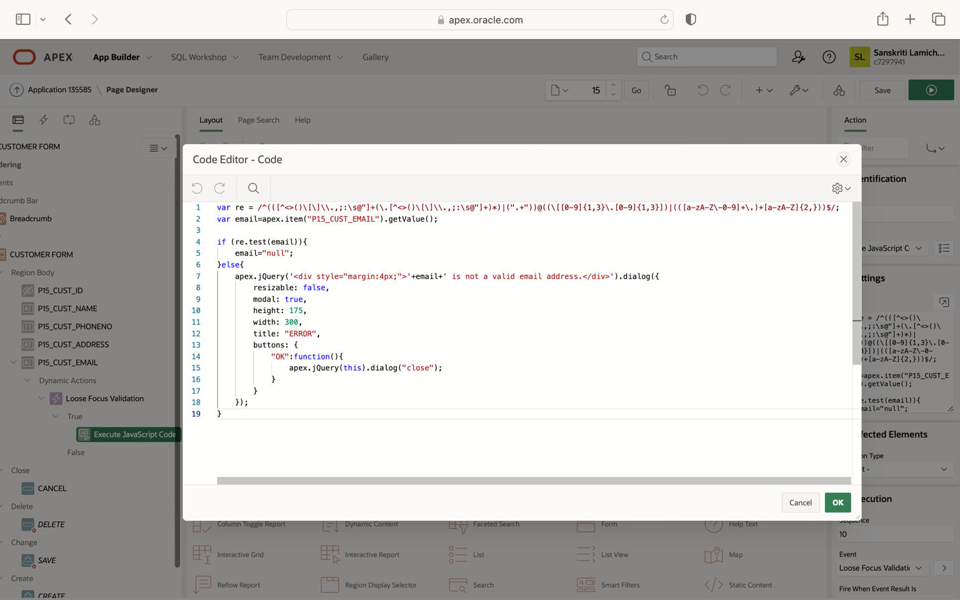

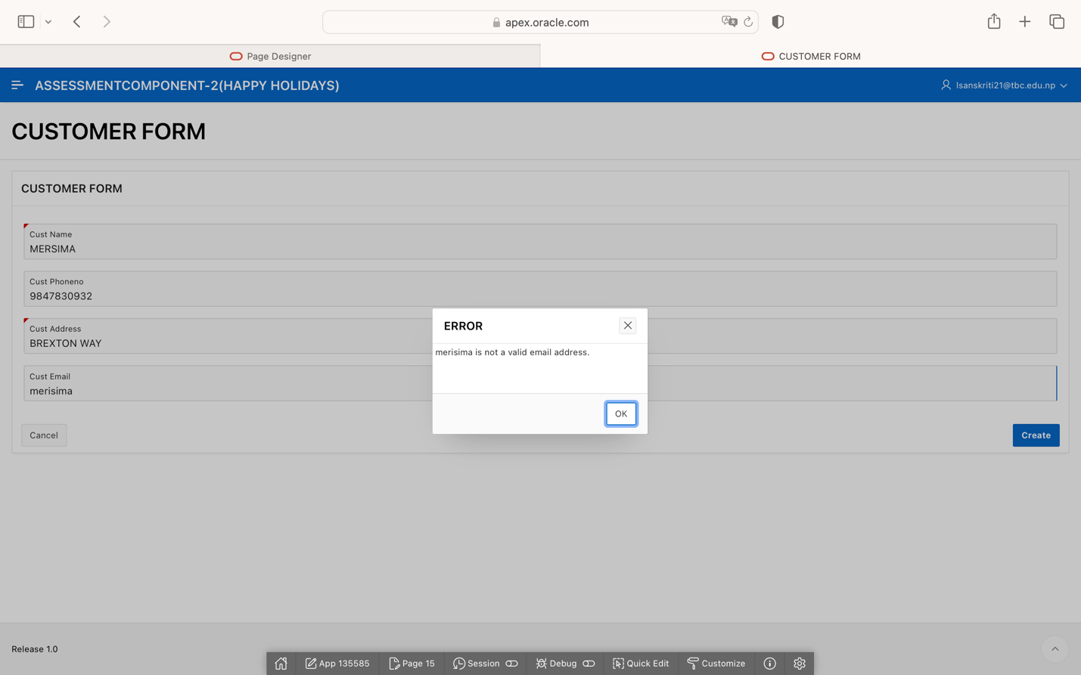

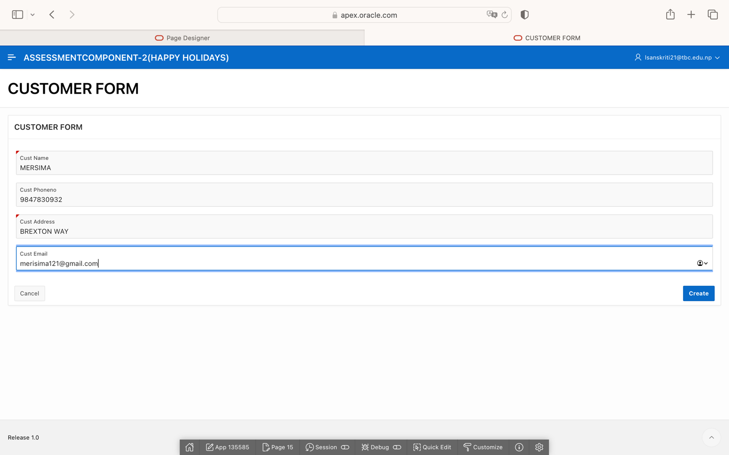

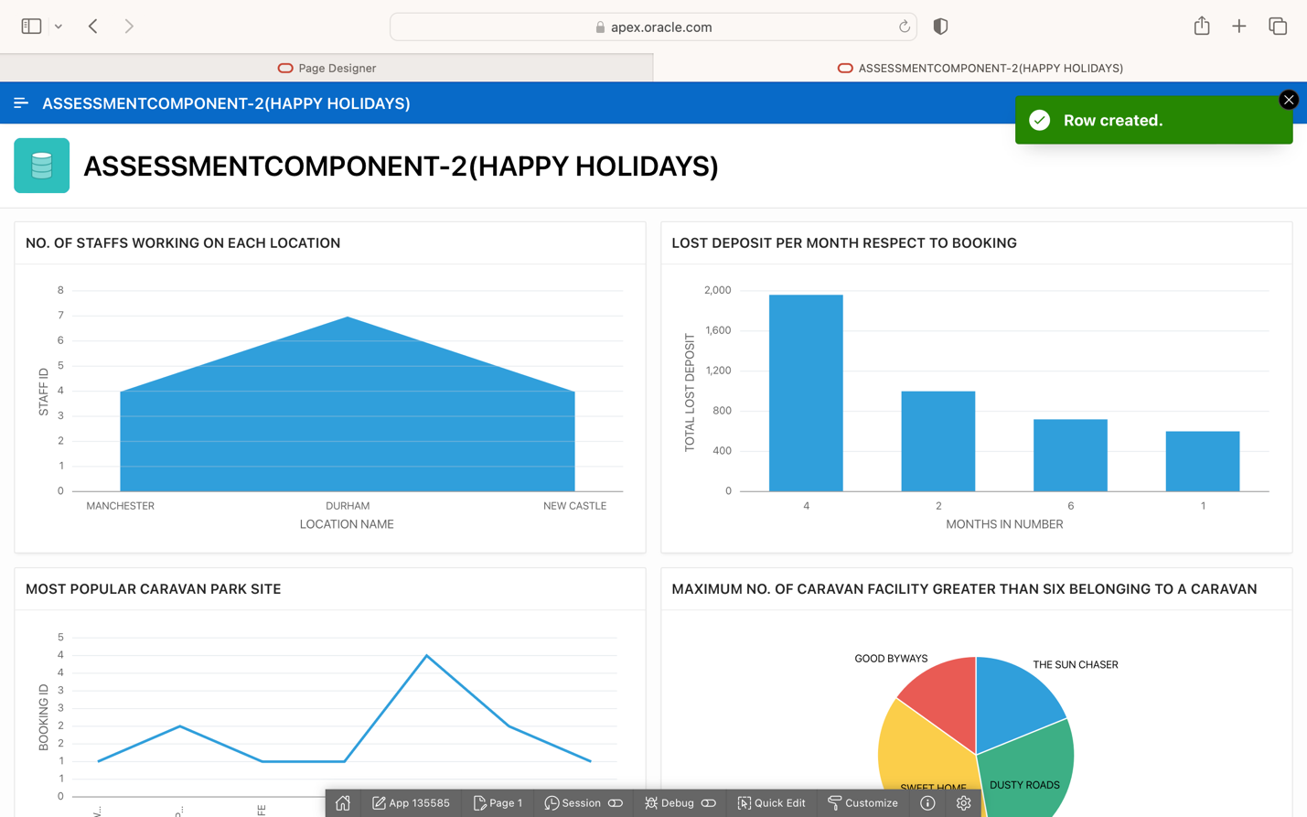

* **AFTER APPLYING DIFFERENT THEME ON APPLICATION AND CHANGING THE APP LOGO:**

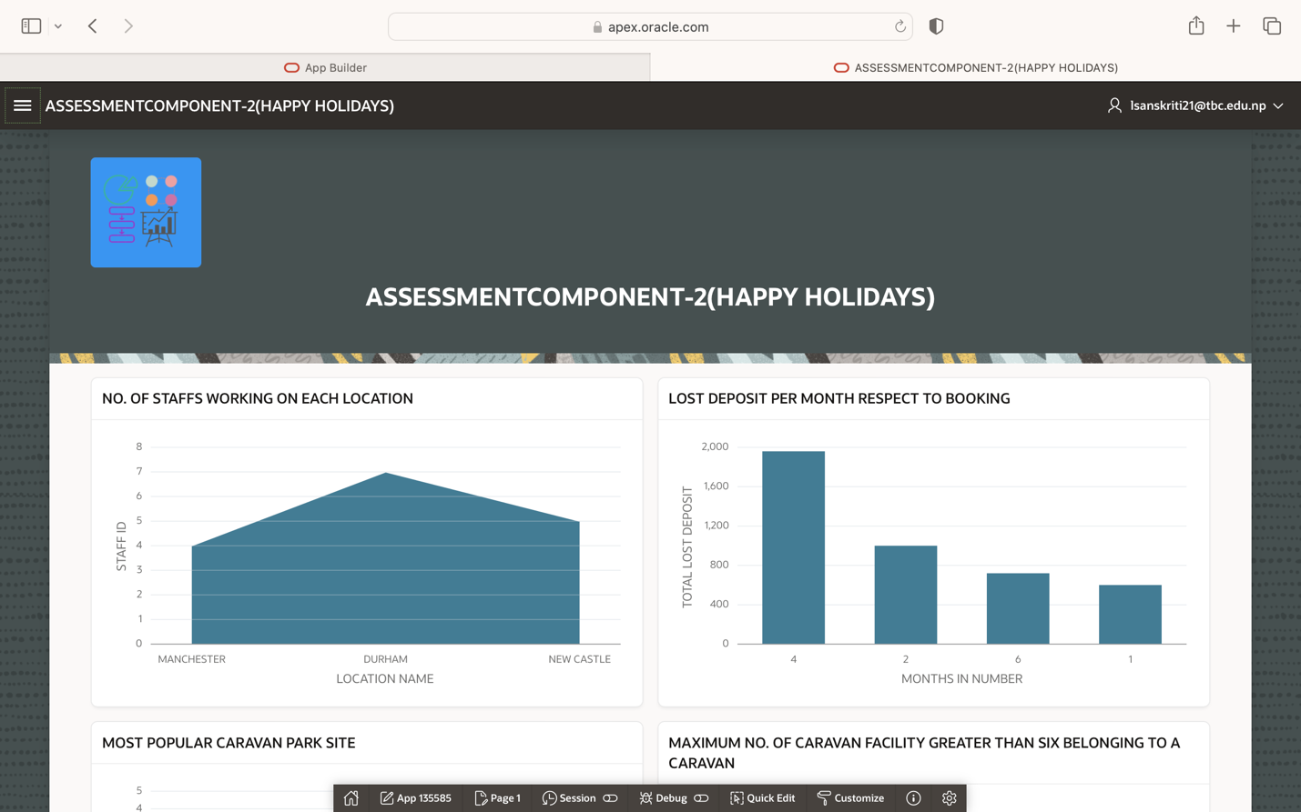

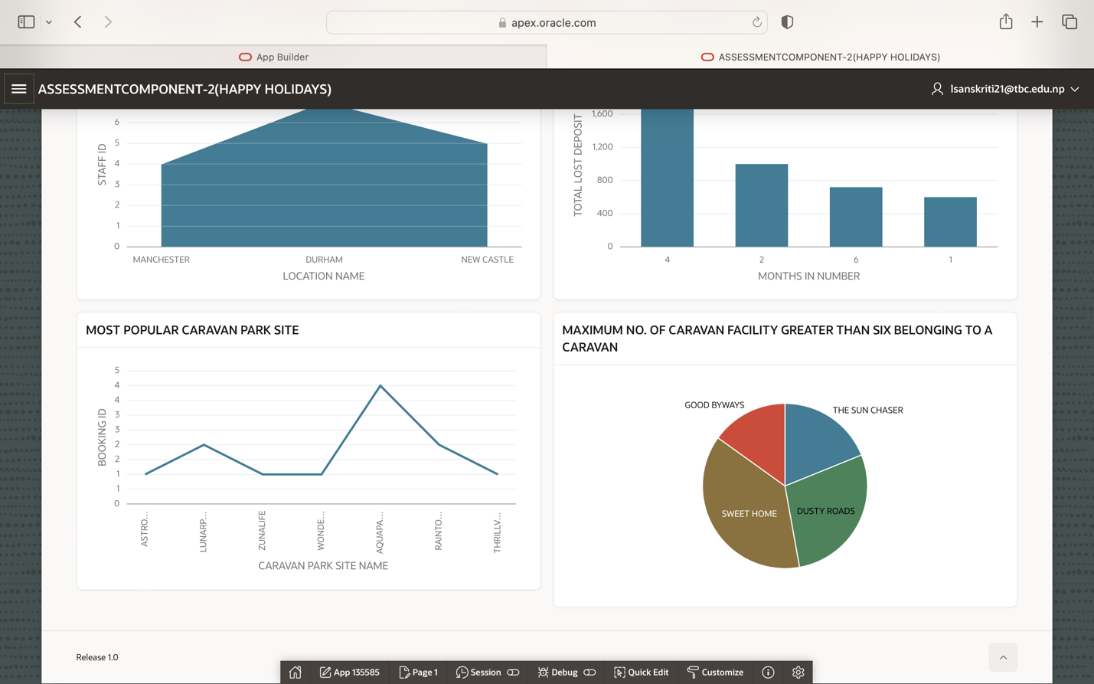

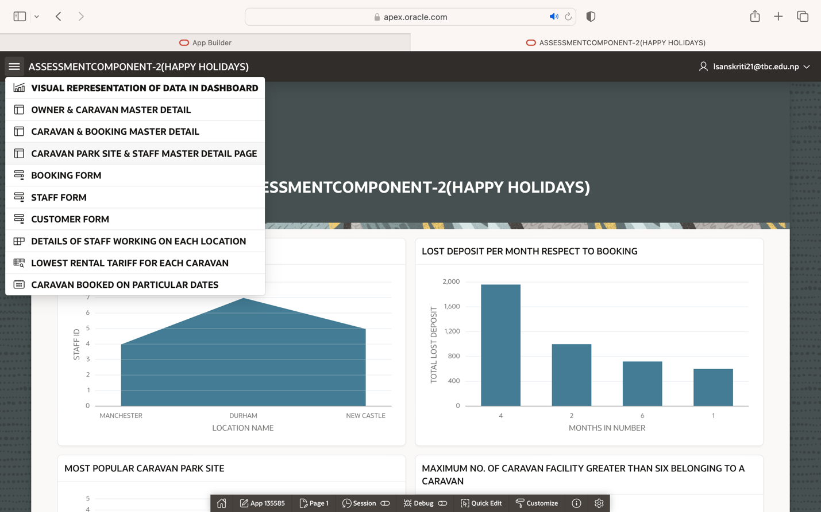

* **BIBLIOGRAPHY**

Database Documentation, n.d. *Database Documentation.* [Online]   
Available at: https://docs.oracle.com/en/database/oracle/oracle-database/index.html  
[Accessed 04 01 2023].

Ahmed, R. (2020). Oracle Apex 20 Full Stack Set For Beginners.

geeksforgeeks, n.d. geeksforgeeks. [Online] Available at: <https://www.geeksforgeeks.org/sql-tutorial/> [Accessed 9 1 2023].

# APPENDIXES

PL/SQL AND SQL CODE